Curriculum Vitae
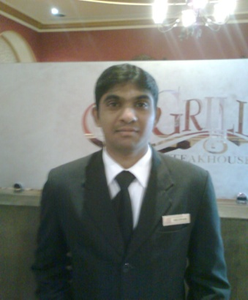
Mallesham
Tel: C/o 971504973598
E-mail: mallesham.378132@2freemail.com

OBJECTIVE

I Wish to work with esteemed organization where an opportunity never ends acquiring greater skills to perform my best

Education Qualification
s.s.c | From z.p.p.s secondary school
DGREE (B.com Hons) | From Lalit Narayan Mithila open University at Kameshwarnagar, Darbhang, Bihar

COMPUTER /Technical Qualification

- MS Office (Ms word, excel, power point)
- Computer Hard Ware
- Chip Level Repairing of Laptops & Desktops
- Microsoft Certified Professional MCSE & CCNA from Domain Network
- Zone, Hyderabad.
- Post Graduation Diploma in HEALTH & SAFETY ENVIRONMENTS (HSE)
- TALLY ERP 9.6.2

Work Experience

I had been work as Cleaning Supervisor from 22 July 2004 to 25 September 2007 in the Diplomatic Club at Doha, Qatar

I had been work As a Restaurant Cashier from September 26 2007
to 19 September 2009 in The Diplomatic Club at Doha, Qatar

I had been worked as a Cashier (service crew) from 2012 to November 2014 in Al-Musbha Modern company at Saudi Arbia

Assistant Accountant Duties

Preparing sales invoices & the upkeep of an accurate accounts filing system.

Preparation and input of month end journal vouchers.
Inputting, matching, batching and coding of invoices.

Debtor and Creditor reconciliations.

Preparation of various reports for senior managers.

Responsible for financial accounts including budgets and cash-flow.

Conducting regular business reviews of financial performance.

Proactively identifying business improvement opportunities.

Fixed Asset accounting, reconciliations and depreciation journals.

Ensuring that information is accurately collated & entered into systems.

Preparation of weekly invoice and expense claim payment runs.

Assist in the preparation of monthly balance sheet account reconciliations.

Inputting of supplier invoices and employee expense claims to the ledgers.

Languages Known
 | Read |  | Write | Speak
Arabic | Poor |  | Poor | good
English | Good |  | Ex lent | Very well
Hindi | Good |  | Good | Well
Tamil | Poor | Poor |  | well
Telugu | Very well | Very well |  | Very well

PERSONAL PROFILE

Name : Mallesham
Date Of Birth : 02-03-1983
Gender : Male
Religion : Hindu
Nationality : Indian
Marital Status : Married

DECLARATION

I hereby declare that the particulars mentioned above are true to the best of my knowledge, information and belief.

(MALLESHAM)

