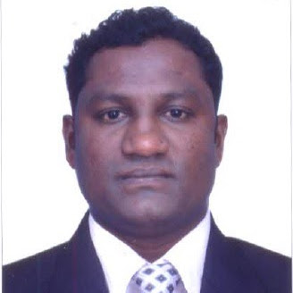

Yeshwant
Address: Deira, Dubai
(Mob.): C/o 971505891826
Email: yashwant.378257@2freemail.com

Career Objective:-

To work in a challenging environment, that enables continuous learning and development, where I can maximize my potential and contribute to the organizational growth.

Attributes:-

A confident and enthusiastic person with Self-motivation, an Extrovert, Proactive and Result-oriented with a keen eye towards perfection in delivering quality service, Good communicator, Problem solver, Maturity in thought and approach, highly Patient, Ambitious, Confident, Optimistic and Hard working.

Educational Qualification:-

- Graduate in B.Sc from Goa University Goa 2005.
- H.S.S.C.E. Science Shiroda Higher Secondary School Shiroda March 2002.
- High School Graduates at Smt Kamalabai Head High School Margao Goa March 2000.

Skills:-

- Proficient in MS Word, MS Excel, and Internet Explorer.
- Eligible for 2 Wheeler and 4 Wheeler Light Motor Vehicle Driving. (Indian License Issued)

PG. 2
- WORK EXPERIENCE:

➢ CHOWGULE INDUSTRIES PVT LTD FATORDA MARGAO GOA

Worked for CHOWGULES as Job Controller Body Shop
From: 11th June 2006 to 20th Nov 2010.
Job Description:-
- Preparation f manual estimates for all incoming accidental vehicle’s
- Assigning jobs to technicians as per their skills in order to have smooth work flow
- Ordering of parts which are required for vehicles
- Preparing daily shopfloor reports.
• Planning next day’s shop floor schedule.

    ➢ COASTAL HONDA (Division of Caculo Group)

WORKED FOR HONDA AS SALES COORDINATOR /CS REPRESENTATIVE
From 22nd November 2010 till November 2013
- Coordinating the sales team by managing schedules
- Filling important documents and communicating relevant information
- Team up co-workers to ensure proper customer service
- Identifying customer needs and directing them to an appropriate product
- Greet customers and determine their wants and needs
- Ensure high levels of customer satisfaction through excellent sales service
- Build productive trust relationships with customer

Worked for Honda as Body Shop Foreman
From November 2013 till 10th October 2017.

Job Description:-
- Preparation of manual estimates for all incoming accidental vehicles
- Online claim intimations.
- Getting surveys done for all incoming accidental vehicles.
- Doing assessments with surveyors.
- Preparing monthly Targets with Managers and working towards the same.

Major Achievements:-
- Joined as Body Shop Foreman at Coastal Honda and was promotes as Final Inspector.
- From Final Inspector achieved major position of Insurance Co-coordinator

Personal Details:-

Name : Yeshwant

Visa status : Valid till 25th May 2018

Gender : Male

Date of Birth : 28TH OCTOBER 1984

Place of Birth : Shiroda, Goa –India

Religion : Hindu

Languages Known : English, Hindi, Konkani & Marathi (Read & Write)

Nationality : Indian

Reference : To be furnished upon request.

Declaration: I hereby declare that the above information is true to the best of my knowledge.

Date
[YESHWANT]

