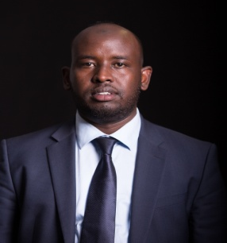
CURRICULUM VITAE

DR. ABDINASIR
C/o-TEL: +971501685421
Email: addinasir.378315@2freemail.com

PERSONAL DATA

Date of birth: 5th May 1983.
Marital Status: Married.
Languages: Fluent in English, Somali, Swahili and Arabic.
Gender: Male.
Nationality: Kenyan.
Religion: Islam.
EDUCATIONAL BACKGROUND

2010-2012: University of Nairobi.
(Masters of Business Administration in Strategic Management).
2003 - 2007: University of Nairobi.
(Bachelor of Pharmacy, B.PHARM)
1998 – 2000: Mandera secondary school
Jan 2001-Nov 2001: Balambala secondary school.
(KCSE-Obtained B plain 72 out of 84 points)
1990- 1997: Mandera arid zone primary school
(KCPE-Obtained 382/700 marks)
1994-2000: Madarasatul maahad nurul Islam (Islamic school)
(Obtained 2nd grade in primary, 1st grade in secondary)
PROFESSIONAL TRAINING and CERTIFICATIONS

- Registered Pharmacist in Kenya. Reg No. 2069
- Member Pharmaceutical Society of Kenya.
- ICDL: International Computer Driving License.
- Arabic by radio in Egypt through correspondence.
- Health Management Trainings.
- Continuous Professional development seminars.
PROJECTS

2007: scientific project on folklore use of indigenous plant by a community in Kenya as antimicrobial agent.
2008: scientific project on polypharmacy practice in the Armed Forces Memorial Hospital.
2012: Research project on Strategic Responses by Pharmaceutical companies to environmental changes in Kenya (available on Google search).

GENERAL SKILLS

- Strategic business management, brand positioning and market access.
- Patient counselling and prescription filling.
- General Skills: Microsoft Office.
- Driving.
WORK EXPERIENCES.

April 2002-Sept 2003: Attached to Towfiq Company Limited as salesman.
Jan 2008- Sept 2012: worked with the ministry of Medical Services in Armed Forces Memorial Hospital, Kajiado District Hospital, Maralal District Hospital.
Jan 2013-Now: Chief Operating Officer in Batalo Pharmaceuticals Limited and Ladnaan Hospital.

