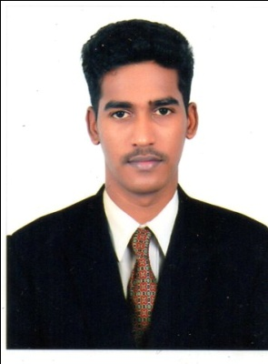
RESUME
B.Bala
C/o-Phone: +971503718643
E-mail: bala.378339@2freemail.com
Objective:
Seeking a position to utilize my skills and abilities in F&B Service.Department that offers, professional growth while being resourceful, innovative, flexible and willingness to learn.

Educational Qualifications:
- Completed Diploma in Hotel Management and Catering technology.
- Higher secondary in Tamil Nadu Education board.

Work Experience:
- Currently working in Radisson Blu Chennai since Apr 2017 – Till date
- Previously Worked with Accord Puducherry in
F & B Service, Since Oct 2013 to Dec 2016.
- Previously Worked with Ocean Spray as a Steward (Sep 2011 to July 2013)
- Previously Worked in Geethanjali Restaurant as a Steward (July 2009 to June 2011)

Training details:
- 6 Months in Hotel Express, Gujarat.

Proficiency in Languages
- English
- Tamil
- Hindi (to speak only)
Hobbies & Interests
- Listening music
- Sports (Cricket, Chess)
Duties and Responsibilities:
- Report to Restaurant Manager.
- Working in Multi Cuisine Restaurant and Bar.
- Responsible for the complete Guest activities right from the check in to check out from the restaurant.
- Taking care of D. bar and main bar Responsible for Top to Bottom Bar activities.
- Taking Bar inventory maintaining the beverage stock register.
- Making material requisition to purchase.
- Maintaining the guest database from the comments card.
- Up selling drinks and foods making more revenue to the organization.
- Responsible equipment inventory.
- Handing guest complaints and informing to superior to follow – up.
- Making sure that guest has completely met the expectations and makes the repeated business to the company.
- Taking the reservations and make good relationship with guest

Personal Profile:
Date of birth : 20/05/1992
Marital status : Single

Declaration
I hereby declare that all the above information is true to the best of my knowledge.

