**AMIEL**

C/o-Contact: +971501685421

E-mail: [amiel.378353@2freemail.com](mailto:amiel.378353@2freemail.com)

Address: Al Barsha, Dubai

**CAREER OBJECTIVE**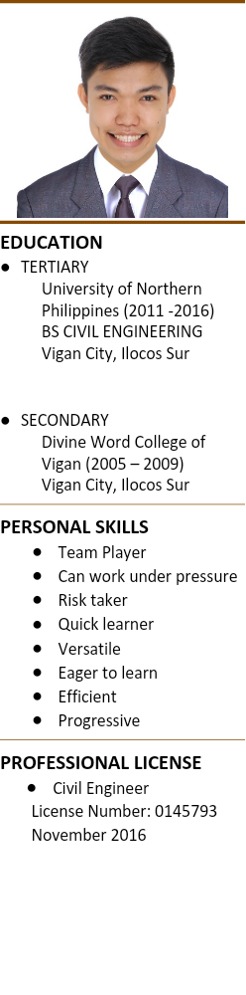

To learn new things, and to work in a growth oriented industry where I can integrate my skills to add constructively to the organization and myself, while looking for challenging assignments that offer career growth and seeking a challenging and stimulating suitable position in a reputable organization with significant growth potential.

**TECHNICAL SKILLS**

* Knowledgeable in Structural Design and Estimate
* Capable in Microsoft Office
* Basic knowledge in STAAD.Pro
* Knowledgeable in AutoCad, SketchUp and Lumion

**WORK EXPERIENCE**

* GAMMADION CONSTRUCTION, as project supervisor/site engineer and estimator - Successfully implemented project cost control procedures and project monitoring to ensure quality construction and safety. Established and implemented work schedules and adjusted them to meet project deadlines.  
  Ensured all site personnel used quality workmanship in accordance with plans and client needs.  
  Adjusted work schedules as needed in order to meet all project deadlines.  
  Read blueprints and plans and communicated them to workers.

**ACHIEVEMENTS**

* Placed 3rd in the “Student Research Congress 2016” (Science and Technology Cluster).

**SEMINARS ATTENDED**

* “Understanding Republic Act No. 9136, otherwise known as the Electric Power Industry Reform Act of 2001 and its Implementing rules and regulations”.
* NSCP 2015 LECTURE SERIES on updates of the NSCP, Volume I Buildings, Towers and Other vertical Structures, Seventh Edition (2015)

**CHARACTER**

*“I hereby certify that the above information given are true and correct as to the best of my knowledge.”*