BALAJI

Senior System Engineer

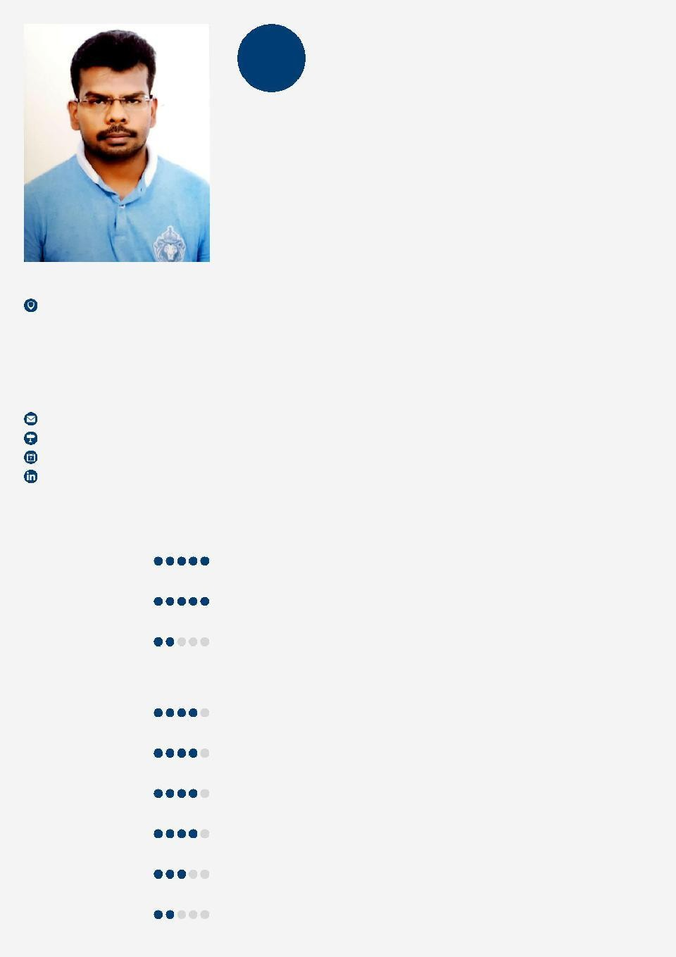

Personal Info

Mobile.
+971 501685421

balaji.378385@2freemail.com DOB: 1991-05-08

Languages

English Tamil Hindi
Skills

Windows OS ITIL
SharePoint Development/Maintenance

Knowledge Management

HTML VB.Net
Senior System engineer with experience of 3 Years 11 months with Intention to build a career with leading corporate. In addition, to use my skills and adaptability to obtain an engineering
or administrative position where I am constantly challenged. My greatest strength is my ability to work into a new environment and be functional immediately. I am quick to learn and adaptable to new situations and technologies

Experience

2013-01 - System Engineer / TSO

2014-07 HCL Technologies Ltd

Project : BT (BRITISH TELECOMMUNICATION) UK

• As a technical support officer I was providing support through inbound calls for Broadband and Dial Up services which includes both hardware and technical support for BT customers.
• Handle escalations from clients and provide detailed and structured root cause analyses (RCAs).
• Troubleshoot on end user's router and fix issues related to WAN.
Involves Troubleshooting, providing diagnosis and suggest/perform corrective or preventive maintenance actions on problems reported by clients.

• Escalate to subsequent support level.

• Customer service focus

• Ability to work effectively with international teams

• Achieved Star Performer Awards Thrice.

2015-03 - Senior system Engineer

2017-06 Cognizant Technology Solutions

Project 1 : Staples (US)

Period : 20, Mar 2015 - 13, Sep 2015

• Worked as L1 Technical support executive for retail stores and corporate functions.
• Troubleshoot issues faced by the users and tried to provide resolution on call.
• Analyzed the issue and assigned/escalated the issue to the next level team with the priority of the issues.
• Followed up the issue assigned and see to that the resolution is provided.

• Customer service focus

• Ability to work effectively with international teams

• Got appreciations from the client for exceptional support

Project 2: BARCLAY BANK UK (UK) Period: 23 Sep 2015 - 14 Jan 2016

• Worked as an Application support executive for a specific client application.
• Troubleshooting the issues with respect to the application and update clients with respect to the changes needed.
• Understanding the severity of the issue and suggesting changes needed for roll out of the application change.
• Handled and tracked different communication medium to get users issues. i.e. Inbound calls, emails, issue logs etc.
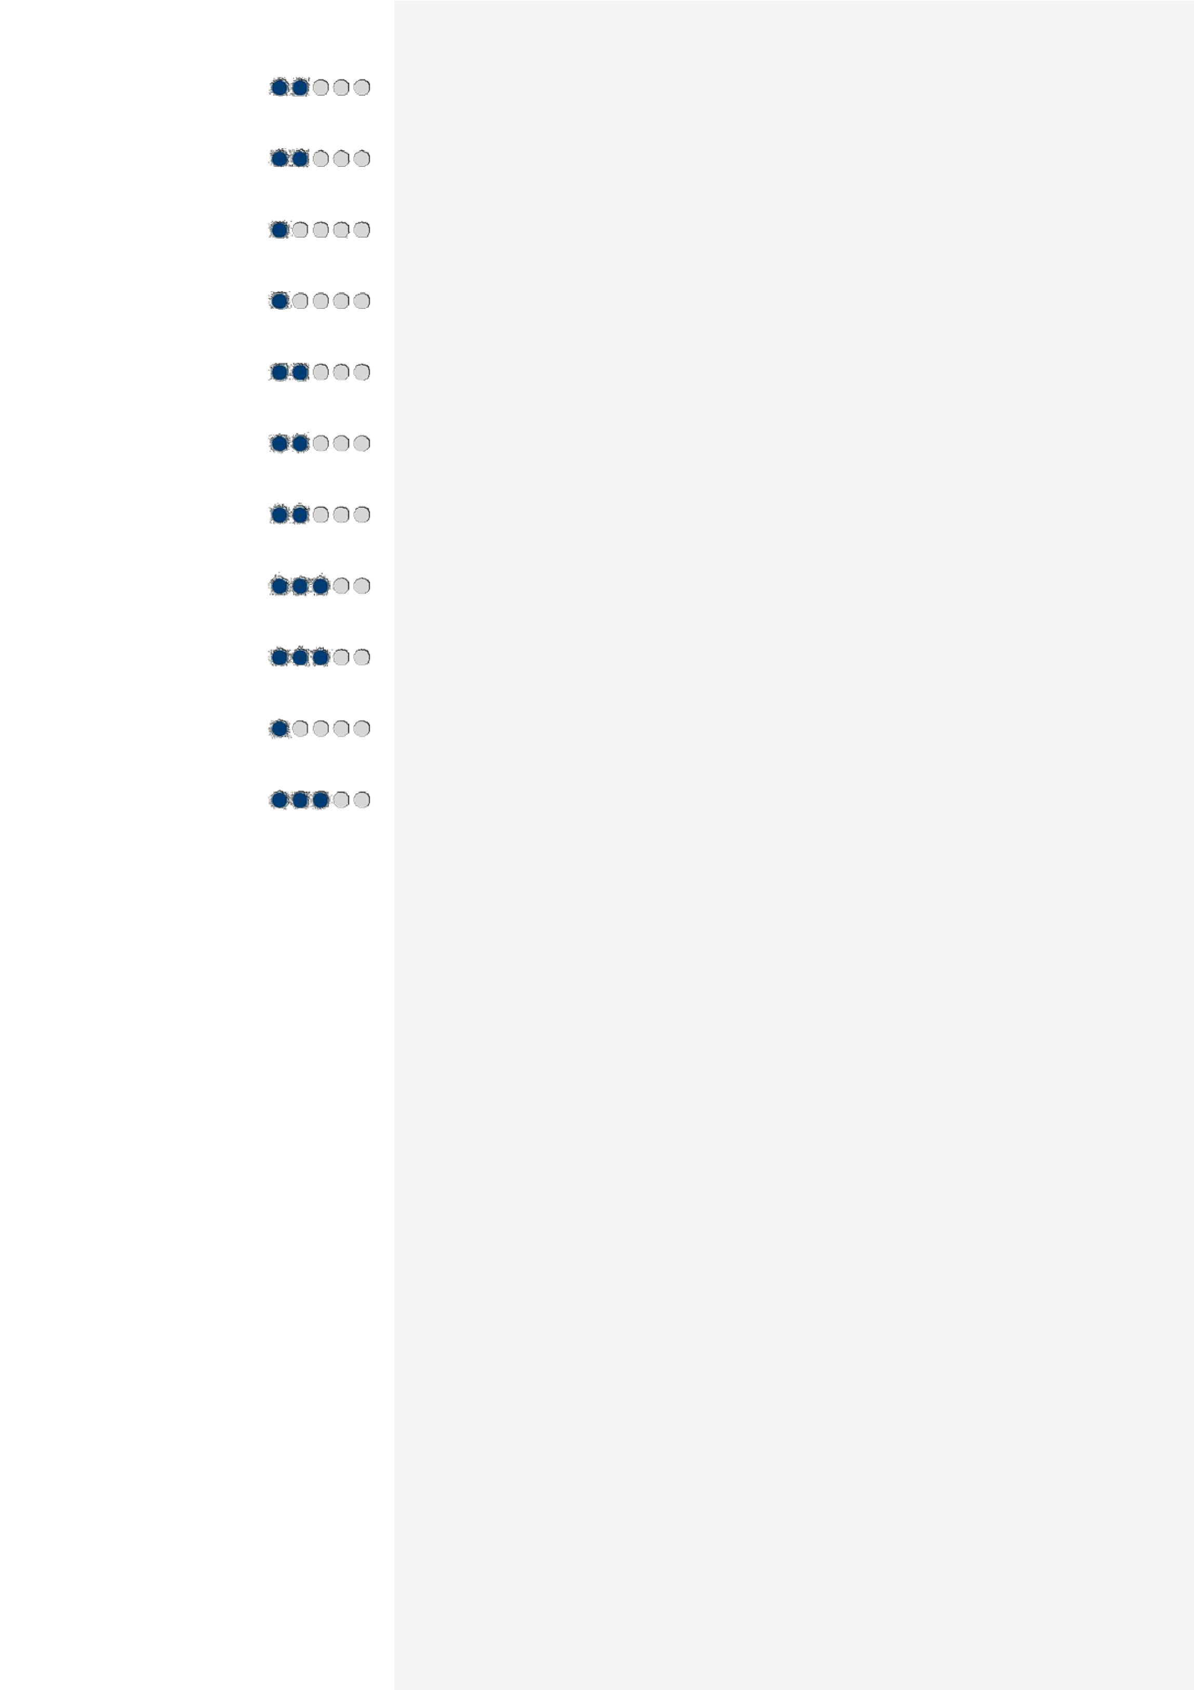SQL

Citirx Administration

Cloud

Block chain

Basics of DEVOPS Basics of Linux-Red hat
Front End Developer - HTML5 and CSS3

Change Management Basics of Networking Hadoop Basics
Change & Release Management
• Managed creation and updating of client DLs. Documented and tracked all
Incidents/issues without getting its SLA breached. Analyzing the root cause and Notifying the business team.

• Applied critical thinking to solve problems that did not have documentation and suggested in creating new Knowledge Base (KB) documents for the same.
• Gained knowledge on networking and change management. Worked along with the client's change management team directly for the rollout of the new application for the smooth transition from the old application to new. Developed and maintained entire SharePoint page for the clients for
the rolled out application.

Project 3: Swiss Re Reinsurance (SWISS) Period: 12 Mar 2016 - 22 Jun 2017

• Being part of SQA (Service Quality Assurance) team worked with our stakeholders and customers to ensure architectural fit and end to
end quality of solution design and implementation off in-house developed applications/solution and integration of 3rd party solutions.
• Acted as one of the stakeholder (SORT- Service operations readiness/ transition) as the part of SQA.
• As a part of SORT role is to ensure that the applications going into production are operationally ready and prepared for smooth transition from build phase to run phase
• SORT as one of the stakeholders of SQA embedded into the SQA process and provide a pivotal role, which ensures quality assurance of high standard.
• Being part of SQA worked from kick off phase to deployment phase of new/new release of existing application.
• Changed / updated existing SharePoint page for the SQA team and maintained the same.
• From scheduling kick off call to managing the requirements of different team such as development,testing,Operationsreadiness,automation,service transition was part of the role.
• Come up with Automation proposal to clients, which reduced time &

cost taken for a specified task.

Education

2008-05 - PRIST UNIVERSITY, B.Tech in INFORMATION
2012-04 TECHNOLOGY
• Passed in FIRST CLASS distinction with CGPA of 7.81/10.0.

• Acted as one of the coordinator in interactive technology club INFROTEC.

• Part of NSS (National service scheme)India

• Represented university as Football player

2007-06 - HSE (Higher Secondary Education)

2008-04 • Passed out with 60%

• Been part of science club.

• School NSS and football team.

2005-06 - SSLC

2006-05 Passed out with 61%

