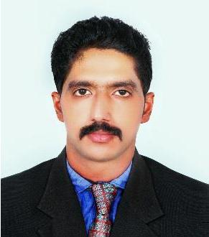

SANDEEP

DUBAI
Sandeep.378456@2freemail.com

Mobile: C/o 971502360357

SANDEEP

HARDWARE AND NETWORKING PROFESSIONAL

Intent to work in an extremely challenging environment that enables me to utilize my expertise to maximum, enhance my current knowledge and learn further to the depth of networks & IT security systems. Being one of those worked on Routing, Switching, Security, Helpdesk &Hardware willing to take on the most challenging of the projects that are based on the future technologies.

EXPERIENCE

ABOUT ME

Gender : Male

Date of Birth : 28\10\1989
MaritalStatus : Single
Nationality : Indian
LanguagesKnown :
English,Hindi,Malayalam,Tamil

PROFESSIONAL SKILLS

- Security-Firewall, IPS, IDS, Proxy, Routers and Switches

- Active Directory.

- Linux, Windows servers, Microsoft Operating systems

- Java, SQL, HTML, Oracle ,VB , VB.NET,

- IT Service Management, Pre sales

- Hardware , software installation and troubleshooting

- Network Switches, Hubs, Modems, Routers

Company Name | Crimson Technologies L.L.C ( Dubai)
Designation | IT Engineer
Duration | Present (From 2016 November )
Company Name | SNR E-Datas Pvt Ltd.
Designation | IT District Project Head
Duration | From May 2014 to April 2016
Company Name | Rural Shores Business Services Pvt.Ltd., India
Designation | It District Project Head
  Duration | From Dec 2011 to May 2014
  | Radiant Info Systems Pvt Ltd , Banagalore
Company Name
Designation | Junior IT Engineer
Duration | From Decenber 2010 to Nov 2011
Company Name | VRV Ventures Pvt Ltd
Designation | IT Support Engieer
Duration | From march 2010 to Nov 2010

PROFESSIONAL KNOWLEDGE

  - Network Firewall

  - Cisco Certified Network Professional(CCNP R&S)-Certified

  - Cisco Certified Network Associate. Cisco ID(CCNA)-Certified

  - Microsoft Certified IT Professional(MCITP)

  - Hardware & (C,C++,VB,VB.NET,JAVA,SQL,HTML,COBOL)

EDUCATION

- Bachelor of Computer Application(Bharathiar University, India)

- MBA (Information Systems Management )Graduating 2nd year

ABOUT ME

- A perceptive and self driven professional.

- Insightful knowledge in IT Infrastructure planning & implementation, network planning & implementation (LAN, WAN), Providing security solutions.

- Proficient in analyzing clients networks, designing, implementing and maintaining the corporate networks.

DECLARATION

I sincerely believe in team spirit and hard work .I hope the particulars in the attached resume are in line of your requirements and please rest assured: the details given above are accurate and so obviously credible.

Place : Dubai Sandeep

