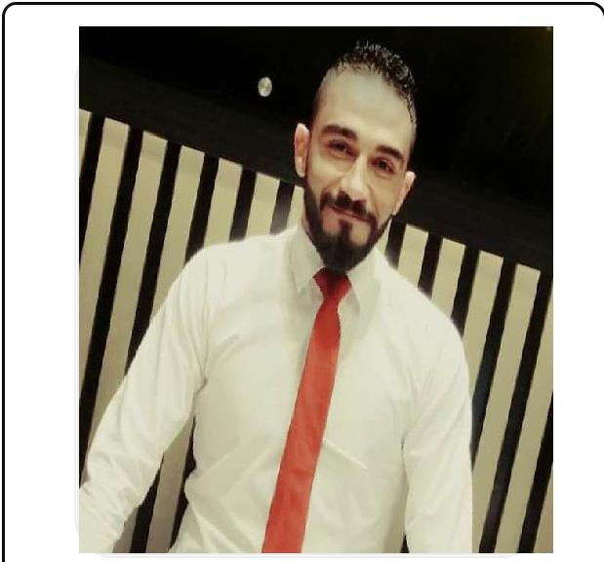

AMR

CONTACT DETAILS

Mobile: C/o 0505891826
E-Mail Address
Amr.378502@2freemail.com

Home Address

Sharjah

Curriculum
Vitae

AMR

OBJECTIVE

To obtain a job within my chosen field that will challenge me and allow me to use my skills and education for future growth and advancement.

PERSONAL DETAILS

Date of birth | : | 1/4/1989
Marital Status | : | Single
Military Services | : | Exempted
Nationality | : | Egyptian
Religion | : | Muslim
Driving License | : Valid (Personal) + Sudia Driving license

 |  | QUALIFICATIONS
 | 2012 | BACHELOR OF COMMERCE
 | "Overall Grade" | Department Of Accounting
 | Good | Kafr El-Sheikh University
 |  | WORK EXPERIENCE
 | 2014 – 2015 | CAREER POSITION
 |  | ACCOUNTANT AND DATA ENTRY AT DREAM
 |  | HOME FOUNDATION
 | In Egypt | FOR CONSTRACTIONS.
 | 2015 – 2016 | CAREER POSITION
 |  | ACCOUNTANT AND DATA ENTRY AT CANDY
 |  | STORE FOUNDATION FOR CHOCLOATE AND
 | In Saudi Arabia | SWEETS
 | 2016- 2018 | CAREER POSITION
 |  | HANDLING MARKETING, SALES PROCEDURES,
 |  | PURCHASES AS A SUPERVISOR DESIGNATION
 |  | AT CANDY STORE FOUNDATION FOR CHOCOLATE
 | In Saudi Arabia | AND SWEETS
 |  | TRAINING COURSES

Training Course in Program Electronic Accounting
Accounting Diploma Contracting
Training Course in Human Resources
Training Course in Time Management
Training Course in Customer Service
Training Course in Sales
Training Course in Business English Course
LANGUAGE SKILLS

ARABIC | Mother Tongue - Native Speaker.
ENGLISH | Good in (Reading, Writing, Listening and Speaking).
 | PERSONAL SKILLS
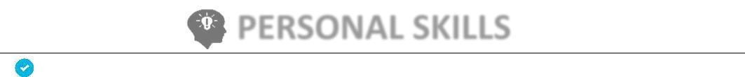

Communication Skills, High sense of responsibility.
Work under high pressure.
Learn new tasks quickly.
Team focus, Ability to work in teams.

Highly flexible and creativity.
Social presence.
Self-confidence.
Hard working.

COMPUTER SKILLS

Microsoft Office.
Microsoft Windows.
Internet as research tool and for browsing.
Bunkers Program

References are available upon request

"Amr

