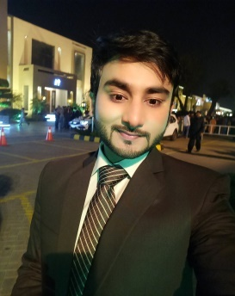
Azeem

Objective:
To secure position in a well reputed organization and provide professional services using my strong communication and organizational skills.

Personal Information

C/o 971502360357
Azeem.378524@2freemail.com

Date of Birth:
November 27, 1991

Professional Experience:
2015 – 2018

Organization: Mind Bridge
http://www.mindbridgebpo.com/
Designation: TeamLeader
Duties:
- Organizing and Managing Team
- Coaching and Training of CSRs
- Motivating Team to achieve quality standards
- Providing support and solutions to customers via phone and email
- Handling large volume of incoming calls/emails.

Skills &Expertise:
- Good IT and AdministrativeSkills.
- Commercial Awareness and a ProfessionalApproach.
- A high degree of Self-Motivation and a drive for Change and Improvement.
- An EnthusiasticPersonality and Resilience to deal with uncertainty.
- The Ability to build and maintain EffectiveRelationships
- Communicate well with a Variety of people.
- Good Planning, Organizing andTime ManagementSkills.
- The ability to Work well in a Team, in a Dynamic Environment.

Internship:
2013 - 4 weeks Internship at Ibrahim Fibers Lahore, Pakistan
- Observed the operations of Utilities
(Chiller, Boiler, Cooling Tower, Water Treatment)
- Studied the production process of PET (Textile Grade)
- Briefed about Spinning Unit and Auxiliary Units

Education:
Additional Skills:
- Expert Levelin MS Word, Excel, PowerPoint (All Versions)
- Excellent Communication Skills&AbilitytoPresentComplexInformationin easy to understandFormat
Proficiencies:
- Report Writing
- Relationship Management
- Public Relation Development
- Business Development
Languages:
- English: Expert level Speaking, Listening and Writing.
- Urdu: Native level Speaking, Listening and Writing.
- Punjabi: Native level Speaking, Listening and Writing.

