Accountant with 2 Years Professional Experience
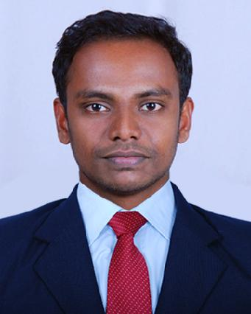

ARUN

Current Location: Doha, Qatar

Contact number: + 971504973598

Email: arun.378536.@2freemail.com

CAREER OBJECTIVE

To be associated with a progressive organization that gives me the scope to apply my knowledge and skill in Accounts/Finance and involve myself as a part of the team that dynamically works towards the growth of the organization.

WORK EXPERIENCE

- Accountant: Rich Dad B P O, Kerala, India (Aug 2015 – Aug 2017)

JOB PROFILE

  - Update and maintain accounting journals, ledgers and other records detailing financial business transactions

  - Prepare and review Vouchers, Quotation, LPO, Delivery note, Debit note, Credit note, invoices, Receipts, Payments and any other related documents

  - Ensure liquidity management strategies to maintain healthy cash flow availability

  - Reconcile of A/R and A/P, Prepare ageing report & Maintain list of accounts receivable and payable

  - Prepare Bank reconciliation & reconciliation of Debtors & Creditors

  - Reconciled inventory and altered journal entries to match general ledger with inventory system

  - Prepare & Maintain Salary, Leave Salaries & End of Service Indemnity provisions, Employee Loans & Advances and other benefits & final settlements etc

- Manage month-end close activities including the preparation and review of Adjustments & Closing entries

- Preparing various financial reports on timely manner includes T/B, P&L, B/S , Cash Flows & Aging Reports etc

- Manage Fixed Asset Register, and maintain all related documentations

- Liaison with management, auditors, Bankers & external parties

- Coordinates and assembles information for the annual audit and provides assistance to external auditors in the review of financial operations

- Performs other duties as assigned or required

EDUCATIONAL QUALIFICATION

- Bachelor of Computer Applications(BCA), M G University, India

- Certificate of International Financial Accounting

(Institute of International Accountants, India)

IT SKILLS

- Microsoft Office Packages

- Accounting packages – Tally ERP 9, Peachtree

- Confident to do any Accounting Software

PROFESSIONAL SKILLS

- Time Management

- Stress tolerance

- Leadership

- Honest

- Professionalism

- Knowledge of concepts & principles

- Quick learner

 | PERSONAL DETAILS
Date of Birth | : 19/03/1994
Gender | : Male
Nationality | : Indian
Marital Status | : Single
Religion | : Hindu
Languages Known | : English, Malayalam and Hindi
Visa Status | : On arrival Visa
 | REFERENCES

Reference can be provided on demand.

