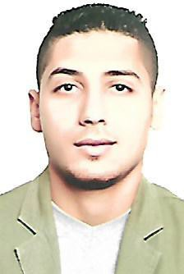Contactinformation
Full Name:Ashraf Address:–Deira- Dubai.
Phone Number: C/o 971503718643 Place of birth :BILQAS- EGYPT .DATE OF BIRTH:11/9/1993 .
Maritalstatus: Single. MILITARY service:DONE .

Educationalqualifications

- Bachelor oftourismand hotels.
- Appreciation :GOOD, from hotels studiesdepartment of Mansourauniversity.

Languages

- Arabic:Native Language.
- English:good ,speaking andwriting .

TRAININGCOURSES :

- I had trained on operasystem from facultyoftourism and hotels,Mansourauniversityfrom 1/7/2013 to31/7/2013.

Workexperience:

  - I worked as a captain and cashier at Cave Café in Mansoura for 5 months. ( from 10/3/2017 to 16/8/2017)
  - I worked as a waiter in addition to assistant captain in Mansoura University hotel for 7 Months. ( from 15/6/2012 to 1/10/2012) and ( from 15/6/2013 to 1/10/2013 )
  - I worked as a chief assistant in Hyatt Regency Sharm El-Sheikh hotel for 4 Months ( from 15/5/2014 to 6/9/2014)

I

Computerskills

- ComputerSkills : good .
- MicrosoftOffice : Word, Excel,Windowsand InternetBrowsing.

Otherskills

  - Abilitytohandle multiple-tasks.
  - ATeam Player.
  - Dealingwith different kinds of customers and handling their needssuccessfully&cheerfully.
  - Abilityto analyze and solveproblems.
  - Familiartoworking underpressure.

Interests

Surfingthe internet–communicationwithnewpeople.

II

