MUHSIN

MBA - FINANCE

CONTACT DETAILS

muhsin.378542@2freemail.com

C/o- +971 504973598

Al Karama, Dubai,

UAE

EDUCATION

Master of Business Administration

(MBA)

Visvesvaraya Technological University

(India)

2014-2016

Bachelor of Commerce (BCOM) Calicut University (India) 2011-2014

COMMERCE

Govt.HSS Kottayam Malabar (India)

2009-2011

ABOUT ME

Father name

Abdul

CAREER OBJECTIVE
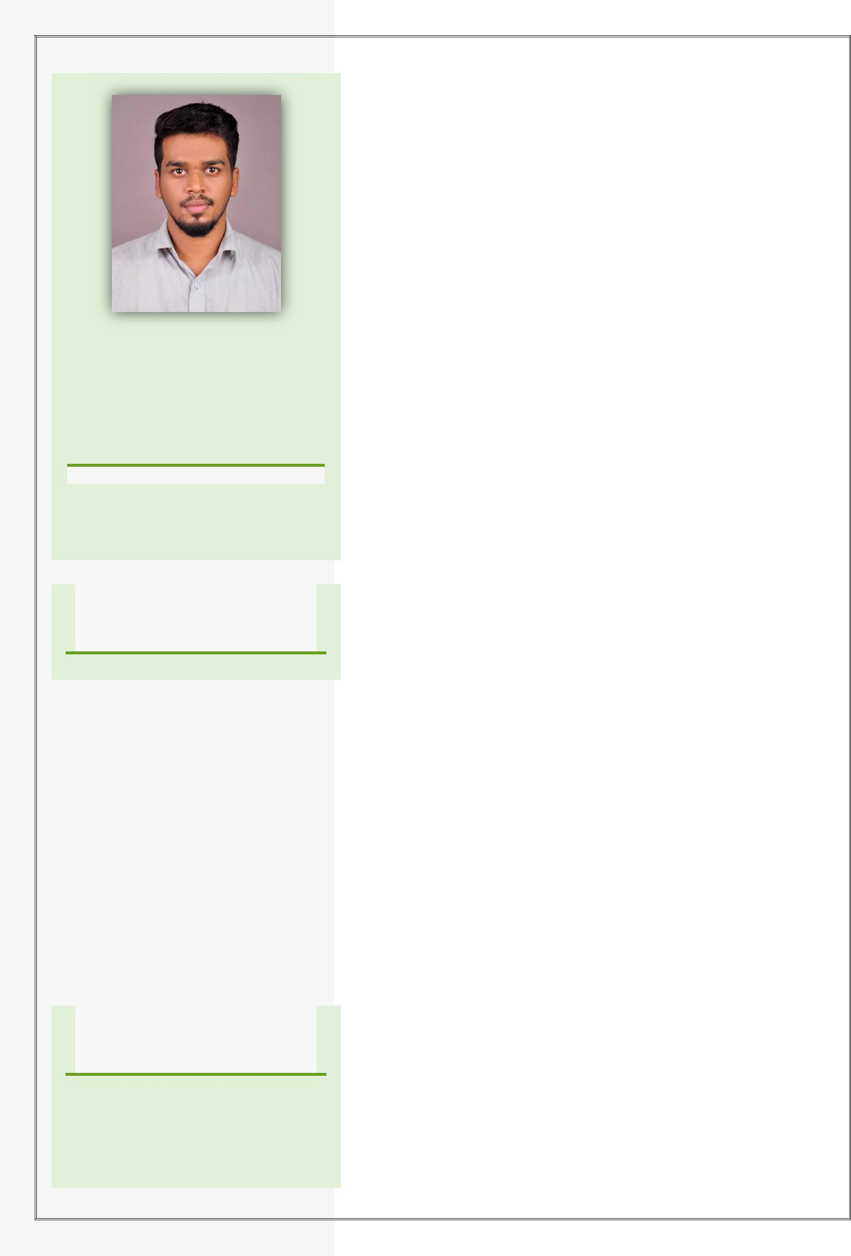

To give my level best to the institution I work with. To work with the organization that provides a friendly environment with good career opportunities in accounts, tax, and other commerce related fields and provide service to the organization, at my best level through sheer dedication and hard work.

PROFILE SUMMARY

A highly motivated accountant with 1 year experience in India in the FMCG company and TAX Consultancy firms. Specialized predominantly in Accounts, Preparing VAT Summary, Gst and Individual tax works etc.

WORK HISTORY

Accountant & Admin ,

SNCO Group

Calicut, India – Feb 2017 to Jan 2018

Responsibilities & Achievements

- Timely preparation and filing of statutory works like VAT, GST, etc.

- Proficient in preparation and filing of income tax returns.

- Accounts work of various clients in diversified sectors Viz. service sector, trading, real estate, etc.

- Successfully co-ordinated of all Works of Clients in the Office.

- Maintaining overall Accounts & Banking matters of the SNCO Office.

- Adeptly completed all types of GST registrations.

- Preparation of the annual financial statements of clients.

Accountant,
Athicas Food Products

Bangalore, India – Aug 2016 to Jan 2017.

Responsibilities & Achievements

- Preparing the daily and monthly accounting reports and statutory works like VAT.

- Daily recording of financial transactions accurately.

- Producing sales invoices, credit notes and other related documents and co-ordinate in timely collection of

Passport Details

Nationality : Indian

Visa Status

Visit Visa

Languages Known

English

Hindi

Arabic (read, write)

Malayalam

Date of Birth

1th January 1994

Marital Status

Single

TECHNICAL SKILLS

- Working knowledge of Microsoft Applications (MS Excel, MS PowerPoint and MS word).

- Working Knowledge of accounting package Tally ERP.

PROJECT PROFILE

MBA – A Study on Receivable Management at Sulfex Mattress Company, Kannur

B.com – Financial Analysis of Mavoor Cooperative bank, Calicut.

revenue.

- Proper documentation and filing of supporting documents for journal entries

- Maintains customer confidence and protects operations by keeping financial information confidential.

- Co-ordination with stores for the daily update of stock register.

- Preparation of Bank Reconciliation Statements.

- Managing and Maintenance of Cash, Cheque, DD.

ACHIEVEMENTS

- Won several prizes in folk song and drama competitions at school and colleges.

- Participated in kho kho matches at school level.

- Member of district level committee of Kerala State Sunni Student Federation, a nonprofit organisation.

- Actively engaged in organising various events conducted by the above said organisation.

- Won cricket tournament cup at college level competition.

PERSONAL SKILLS

- Good organizing skill.

- Hardworking and Responsibility.

- Positive Attitude.

- Sincere and Punctuality.

DECLARATION

I hereby declare that the above written particulars are true to the best of my knowledge and belief.

Muhsin

