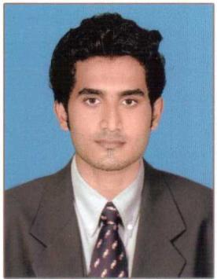
FARHAN

Mobile – C/o 971501685421
E mail – farhan.378553@2freemail.com
Kerala,INDIA.

____________

Objective: To achieve a challenging position in a globally respected company where I could apply all my skills and abilities for the development of the company and to furnish myself to be a better professional.

Profile Summary:

- 6 months of experience as Electronic and Instrumentatiom Engineering Trainee at THE WESTERN INDIA PLYWOODS Ltd. In India.

- Hold a Bachelor Degree in Electronic and instrumentation Engineering and have a practical experience in,.
- Have completed PLC, delta hmi programming,vfd at lngenious power and control system Pvt.Ltd.

- Have excellent communication skills in English & Malayalam.

- Problem solving abilities, excellent verbal and written abilities & deal with people friendly,

- Adaptable to any kind of difficult situation.
- Organized and capable of effectively setting priorities to accomplish tasks with stipulated deadline.

- Young, energetic, enthusiastic and self-motivated individual.
- Can work systematically and bring additional professionalism to the business.

- Can work under pressure and meet deadlines.

Work History:

Engineering(Electronic and Instrumentation) Trainee – December 2015- June 2016

( THE WESTERN INDIAN PLYWOOD Ltd.)

Job Profile as Trainee:

- Activities of Instrumentation dept. including Caliberation and documentation procedures as per ISO 9001.

- Caliberation of Pressure,Temperature gauge.

- Involved in Electrical maintenance jobs.

- Familiarization of PLC(Process Logic Control) System and VFDs(Variable Frequency Drives).

Industrial Training

1

- Worked as a trainee for 6 months at THE WESTERN INDIA PLYWOODS Ltd.

- Participated in various technical symposiums held at various colleges.

- Have successfully completed automation workshop training which covers allen bradley plc,vfd,scada-itouch for 4 days at COLLEGE OF ENGG. VADAKARA.

Academics Projects

- Final Btech Project: REALTIME LABVIEW BASED PRESSURE AND LEVEL CONTROL.

- Mini Project (3rd yr): ULTRASONIC OBSTACLE AVOIDING ROBOT.

Academic Credentials:

- Bachelor of Electronic and Instrumentation Engineering, CUSAT University, Kerala, India.

- Higher secondary school of Computer science,Kerala state board,India.

Technical Skills:

- Well Versed with MS-Dos, MS-Office at Application Level (MS-Word, Excel, and
- PowerPoint)

- Perfect Knowledge of E-mail and Internet Applications
- Have hands own experience in PLC (Allen Bradley ,Siemens, Delta, Gefanuc, ABB,Keyence)
- Delta HMI programming,

Personal Profile:
Nationality | : Indian
Date of Birth | : 25/08/1993
Marital Status | : Single
Languages | : English, Hindi and Malayalam.
Visa Status | : Visit Visa

Declaration:

I here by agree that all the information provided above is true to the best of my knowledge and belief.

1

