LYNA
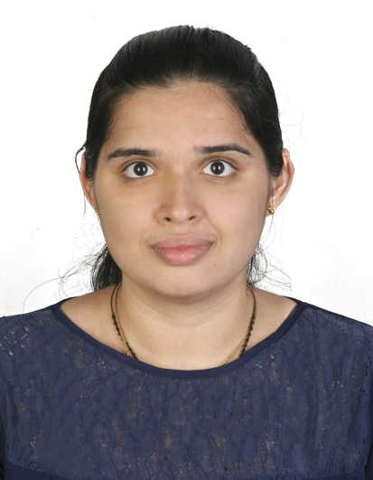
C/o-Mobile: +971-504973598
E-Mail: lyna.378582@2freemail.com

Professional Summary
Overall having 2 years of experience in HR Department: screening the profiles, coordinating and conducting the Interview, checking the CIBIL Report, releasing the Appointment Letter, conducting the Background verification and reference check for the selected candidates, arranging the joining formalities, maintaining the payroll data for new joiners, arranging the Internal Job Posting and updating the employee master file.

Core Competencies

- Ability to communicate effectively.
- Flexibility accompanied with an urge for learning.
- Disciplined dedicative.
- Hard working and self-confident.
- Good interpersonal skills.

Work Experience

Ujjivan Small Finance Bank Bangalore- India
Position: Officer-Talent Acquisition - Human Resource Department - (Mar 2016 – Dec 2017)
Responsibilities:
- Screening the profiles which have been received from company website, Naukri Source, through employee reference and consultancies.
- Conducting the aptitude test, coordinating and arranging the interview for the shortlisted candidates.
- Checking the CIBIL report and doing the reference check for the selected candidates.
- Announcing the interview result and releasing the appointment letter for the selected candidates.
- Joining Formalities and verification of the required documents to be collected.
- Arranging for the Post Joining Formalities.
- Initiation of BGV and closure on the reports through Third Party Vendors.
- Internal Job Posting, shortlisting and arranging for interview, issuing role change letter to the selected candidates and arranging for the replacements.
- Preparing the list of New Joiner’s for the purpose of including them to the respective departmental trainings.
- Coordinating with vendors for the office requirements as well conducting the meetings on the monthly basis.
- Cross checking the invoices and processing for the payments on the weekly/monthly basis.
- Answering phone calls, dealing with enquiries regarding HR procedures.
- Submitting the new joiner’s data for payroll team.

ADMIXS - Investment and Financing Company Mangalore- India
Position: Senior Finance Executive – HR & Finance Department (Aug 2015 – Feb 2016)
Responsibilities:
- Keeping track of customer mails and messages related to finance and investment.

- Perform day to day financial transactions including verifying, classifying, computing, posting and recording accounts receivable data.
- Identifying financial status by comparing and analyzing actual results with plans and forecasts.
- Maintaining Cheques, Checking all documents related to banking operations.
- Analyzing the finance related activities like Auditing, Payroll Verifications, Cheque Cross Checking.
- Maintaining Receivable and Payables day-to-day payment report, client follow-up and records.
- Arranging the records compile and analyze financial information to prepare financial Statement Comprising of monthly and Annual accounts.

Education Summary

2015 - Master in Business Administration, Karnataka-India

2013 - Bachelors of Commerce, Karnataka-India

Additional Qualification/Projects
Having an adequate knowledge in software programs such as:
- TALLY 9.0 VAT Enabled,
- Peach Tree,
- Front Page,
- DacEasy,
- Financial Management,
- Project: Financial Analysis,
- MS-Word, MS-Excel, MS PowerPoint.

Projects:
“Financial Performance Evaluation of Chemical and Fertilizers Industry, with specific reference to BASF India Ltd’’.
- The basic need of the study is to compare the BASF’s financial statement with the other companies of the same sector by using Ratio Analysis tool.
- Through this study I came to know that BASF India Ltd. Has satisfactory market position and have enough profits to cover its expenses.

Internship:
Internship in BASF India Ltd. Mangalore, for a period of 10 weeks.
- During the internship the payroll process was undertaken such as Update Employee Master File, Set Pay Period, Enter Time Worked, Enter Manual Period, Calculate Termination Pay, Calculate Pay and Review Reports.

Personal Details

Date of Birth : 25-July-1992
Nationality : Indian
Languages : English, Hindi, Kannada, Konkani, Tulu
Visa Status : Visit Visa.

