Accountant with 2.5 years of Professional Experience
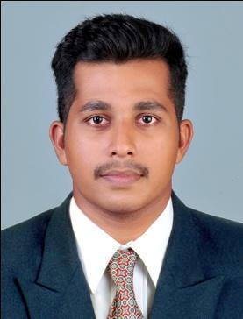

JIBIN

Mobile: C/o 0504973598

Jibin.378640@2freemail.com

Doha, Qatar

Objective

Seeking a challenging job in the field of Accounting & Finance with a reputed organization, to test my personal skills and the knowledge gained from my degree for the benefit of the organization.

Professional Experience

- Accountant

Thomas Mathew Associates(August 2017 to January 2018)

- Accountant

ACL Accountings Solutions(May 2015 to April 2017)

Job Profile

- Prepare, Reviews, investigates, and corrects errors and inconsistencies in financial entries, documents, and reports

- Reviews all invoices, Receipts, Payment Vouchers & Supplier documentations

- Ensure that availability of Funds in the Bank and maintain liquidity

- Manage Receivables and Payables by Preparing ageing reports, Calculating reimbursement bills, Tracking & Reconciling Receivables & Payable etc

- Maintain Bank reconciliation, Inter & Associated companies reconciliation

  - Reconciliation of debtors and creditors

- Review monthly inventory check and making report in every months, prepare reports of moving items and non moving items

- Handle Payroll & Employee Benefits, scheduling, Maintaining staff history and vacation detailing, Travel coordination and hotel reservation and keep a systematic filing of all correspondence with the employees

- Manage month-end close activities including the preparation and review of Adjustments & Closing entries

- Facilitate and complete monthly close procedures; prepare Trial Balance, Profit and Loss statements, Balance sheet and other reports as per management demands

- Maintaining asset register and ensure that every addition and disposal of assets are properly done

- Liaison with internal and external auditors, banks, regulatory agencies, suppliers and customers

- Assist and coordinate to schedules for periodical reviews , Internal audits

  - year-end audit with external auditors

- Provide time to time reports to the management & Ensure confidentiality and security of all financial files

Professional Qualification

- Bachelor of Commerce (B.Com)

M G University, India

- Certificate in International Financial Accounting (Institute of

International Accountants, Kerala-India)

- Certificate in Tally(Tax study centre) Kottayam, kerala

Professional Strengths

- Ability to work on own initiative and to tight deadlines

- Accuracy & Adaptability

- Strong Work Ethic

- Delegating skills

- Encouraging people

- Multi-tasking

Technical Skills

Tally ERP 9, Peach Tree

Microsoft Office

Confident to do any Accounting Software

Personal Profile

Date of Birth | : | 12-10-1994
Gender | : | Male
Nationality | : | Indian
Marital Status | : | Single
Language Proficiency | : | English, Malayalam and Tamil
Religion | : | Christian
Visa Status | : | Visit Visa

References

Reference will be provided on demand

