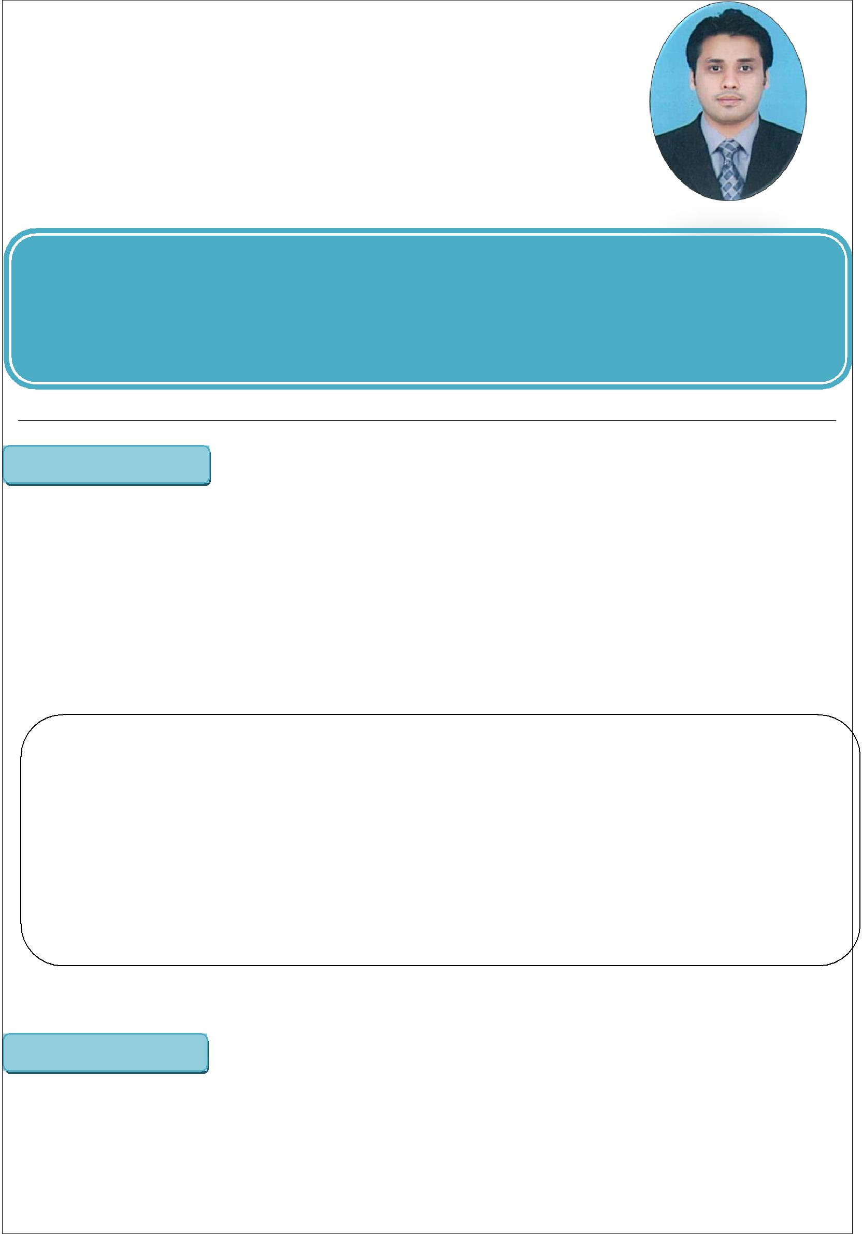
Rana

Email | rana.378660@2freemail.com
Address | United Arab Emirates.
Mobile | C/o 0505891826
 |  | OBJECTIVE

I successfully combined my studies with work and other commitments showing myself to be self-motivated, organized and capable of working under pressure. I have a clear logical mind with a practical approach to problem solving and a drive to see things through to completion. I enjoy working on my own initiative or in a team. In short, I am reliable, trustworthy, hardworking and eager to learn and have a genuine interest in

Customer Services, office administration, Sales PublicRelation.

PERSONAL DATA

Religion | : | Islam
Date of Birth: |  | 04th Mar, 1983
Passport Expiry |  | 14-Sep-2021
Marital Status |  | Married
No. Of Dependent |  | 4
Visa Status |  | Visit (Till 21-03-2018)
Nationality |  | Pakistani

ACADEMIC CAREER:

Certificate/Degree |  |  |  |  | Institute/Board |  | Year
B.Com |  |  |  | Scholars College of Commerce. |  |  | 2004
 |  |  |  | Shadman Lahore.
D.Com |  |  |  | Punjab Board of Technical |  |  | 2001
 |  |  |  | Education Lahore
MATRIC |  |  |  | Board of Intermediate and |  |  | 1999
 |  |  |  | Secondary Education Faisalabad.

LANGUAGE SKILLS

- Have certification of English Language from BETS Lahore.

- Well versed in English as well as in Urdu and Hindi.

PROFESSIONAL EXPERIENCE:

1-Faysal Barkat Islamic Bank Aug-2017 to To Date.

- Designation: Relationship Officer.

- Department: Liabilities

Responsibilities:
- Meet sales target of new clients, Volume, Bancassurance and Auto Finance.
- Deal in Account opening Department

1-Quaid E Azam Library Aug-2010 to July 2017.
- Designation: Public Relationship Officer.

Responsibilities:
- Handle all visitors in library in proper way.

- Arrange different events in library and look after all matters of events.

- Work on different periodicals issue by library.

- Attend meeting with higher management and give the support.

2-TELENOR Pakistan: August- 2006 to June-2010

- Department: CRD (Customer Relations Department)

- Designation: CRO (Customer Relations Officer)

Responsibilities:
- To take inbound calls of customers for the resolution of their problems.

- To up sell their products to the customers over the call.

- Resolve customer’s query with quality assurance and try to make them

Happy with our service
- To achieve Daily and Monthly Target along with quantity & quality assurance.

- Have worked in different departments of CRD on rotation basis.

- SAPPHIRE Textiles: 06-June, 2005 to 25-August, 2006

  - Department: Local Yarn Sales.

  - Designation: Officer Yarn Sales

Responsibilities:
  - To Make necessary Documentations of LC (Letter of Credit)

  - To Deal with Parties for Payments and deliveries.

  - To Generate Daily and weekly Payment Reports.

  - To Deal with banks regarding LC Documents

CERTIFICATION

- Have certification in Customer Services Excellence from Telenor Pakistan.

COMPUTERKNOWLEDGE

- Have certification in computer basics.

- Well Work on Seible (CRM), CXpress, Geneva, CAM (Telecom Software)
- Well work on MS Office (Word, Excel, PowerPoint)
- Good knowledge of Using Internet.

