 |  |  |  |  | WORK EXPERIENCE
 |  |  |  |  | Sept. 2015 – Sept. 2017 |  |  | Electrical Engineer
 |  |  |  |  |  |  |  | HCC –Houssam Contracting Co.
 |  |  |  |  |  |  |  | P.O Box 9915, Riyadh,King of Saudi
 |  |  |  |  |  |  |  | Arabia
 |  |  |  |  | Dec. 2010 – Jan. 2015 |  |  | Product Engineer
 |  |  |  |  |  |  |  | SRMCO - Saudi Refrigerator
 |  |  |  |  |  |  |  | Manufacturing Co., Ltd.
ENGR.JOEY |  |  |  |  |  |  |  | P.O Box 3315, Jeddah 21471, Saudi
 |  |  |  |  |  |  |  | Arabia
 |  | ADDRESS |  |  | Dec. 2008 – Aug. 2009 |  |  | Motor man
 | Sharjah, UAE |  |  |  |  |  |  | M\V Marie Schulte
 |  |  |  |  |  |  |  | Worldwide
CONTACT NUMBER |  |  |  |  | JOB DESCRIPTION
 | C/o 0501685421 |  |  |  | Electrical Engineer
 |  |  |  |  | - Maintains electrical system by providing electrical power & equipment.
 |  | E-MAIL |  |  | - Provide lighting by maintaining electrical fixtures
joey.378702@2freemail.com |  |  |  |  | - Provide support by responding to request for electrical problem.
 |  |  |  |  | -Inspect installations & observe operations to ensure compliance w/
 |  |  |  |  | design & equipment specifications & safety standards.
APPLIED POSITION |  |  |  |  | Product Engineer
 |  |  |  |  | -Responsible for design, research, prototyping, engineering
 |  |  |  |  | documentation, estimating and process improvement.
Electrical Engineer |  |  |  |  | Motor man
 |  |  |  |  | -Assistant of 3rd Engineer
 |  | OBJECTIVES |  |  | -Monitoring & recording the parameters inside & outside the ER.
 |  |  |  |  | -Responsible for the cleanliness & safety of personnel
 |  |  |  |  | SKILLS
To |  | practice |  | my | Good communication skills in English and Filipino
profession |  |  | in | a |  | Good interpersonal skills
 |  |  |  |  |  | ➢ Sense of responsibility
growing |  |  |  |  |  | ➢ Accurate
 |  |  |  |  |  | ➢ Efficient
company/industry in |  |  |  |  | Knowledge on Auto CAD
a | position |  | utilizing |  | EDUCATIONAL ATTAINMENT
my |  | education |  | with | TERTIARY : |  | 2006 - Bachelor of Science in Electrical Engineering
wide exposure in the |  |  |  |  |  |  |  | Batangas State University - Camapus II
field |  | of | electrical |  |  |  |  | Alangilan, Batangas City
 |  |  |  |  | SECONDARY : |  | 2000 - High School Diploma
works and functions, |  |  |  |  |  |  |  | Padre Vicente Garcia Memorial Academy
management |  |  |  | and |  |  |  | Rosario, Batangas
 |  |  |  |  | PRIMARY : |  | 1996 - ElementaryDiploma
employee |  |  | relation.
 |  |  |  |  |  |  |  | Itlugan Elementary School
 |  |  |  |  |  |  |  | Itlugan, Rosario, Batangas
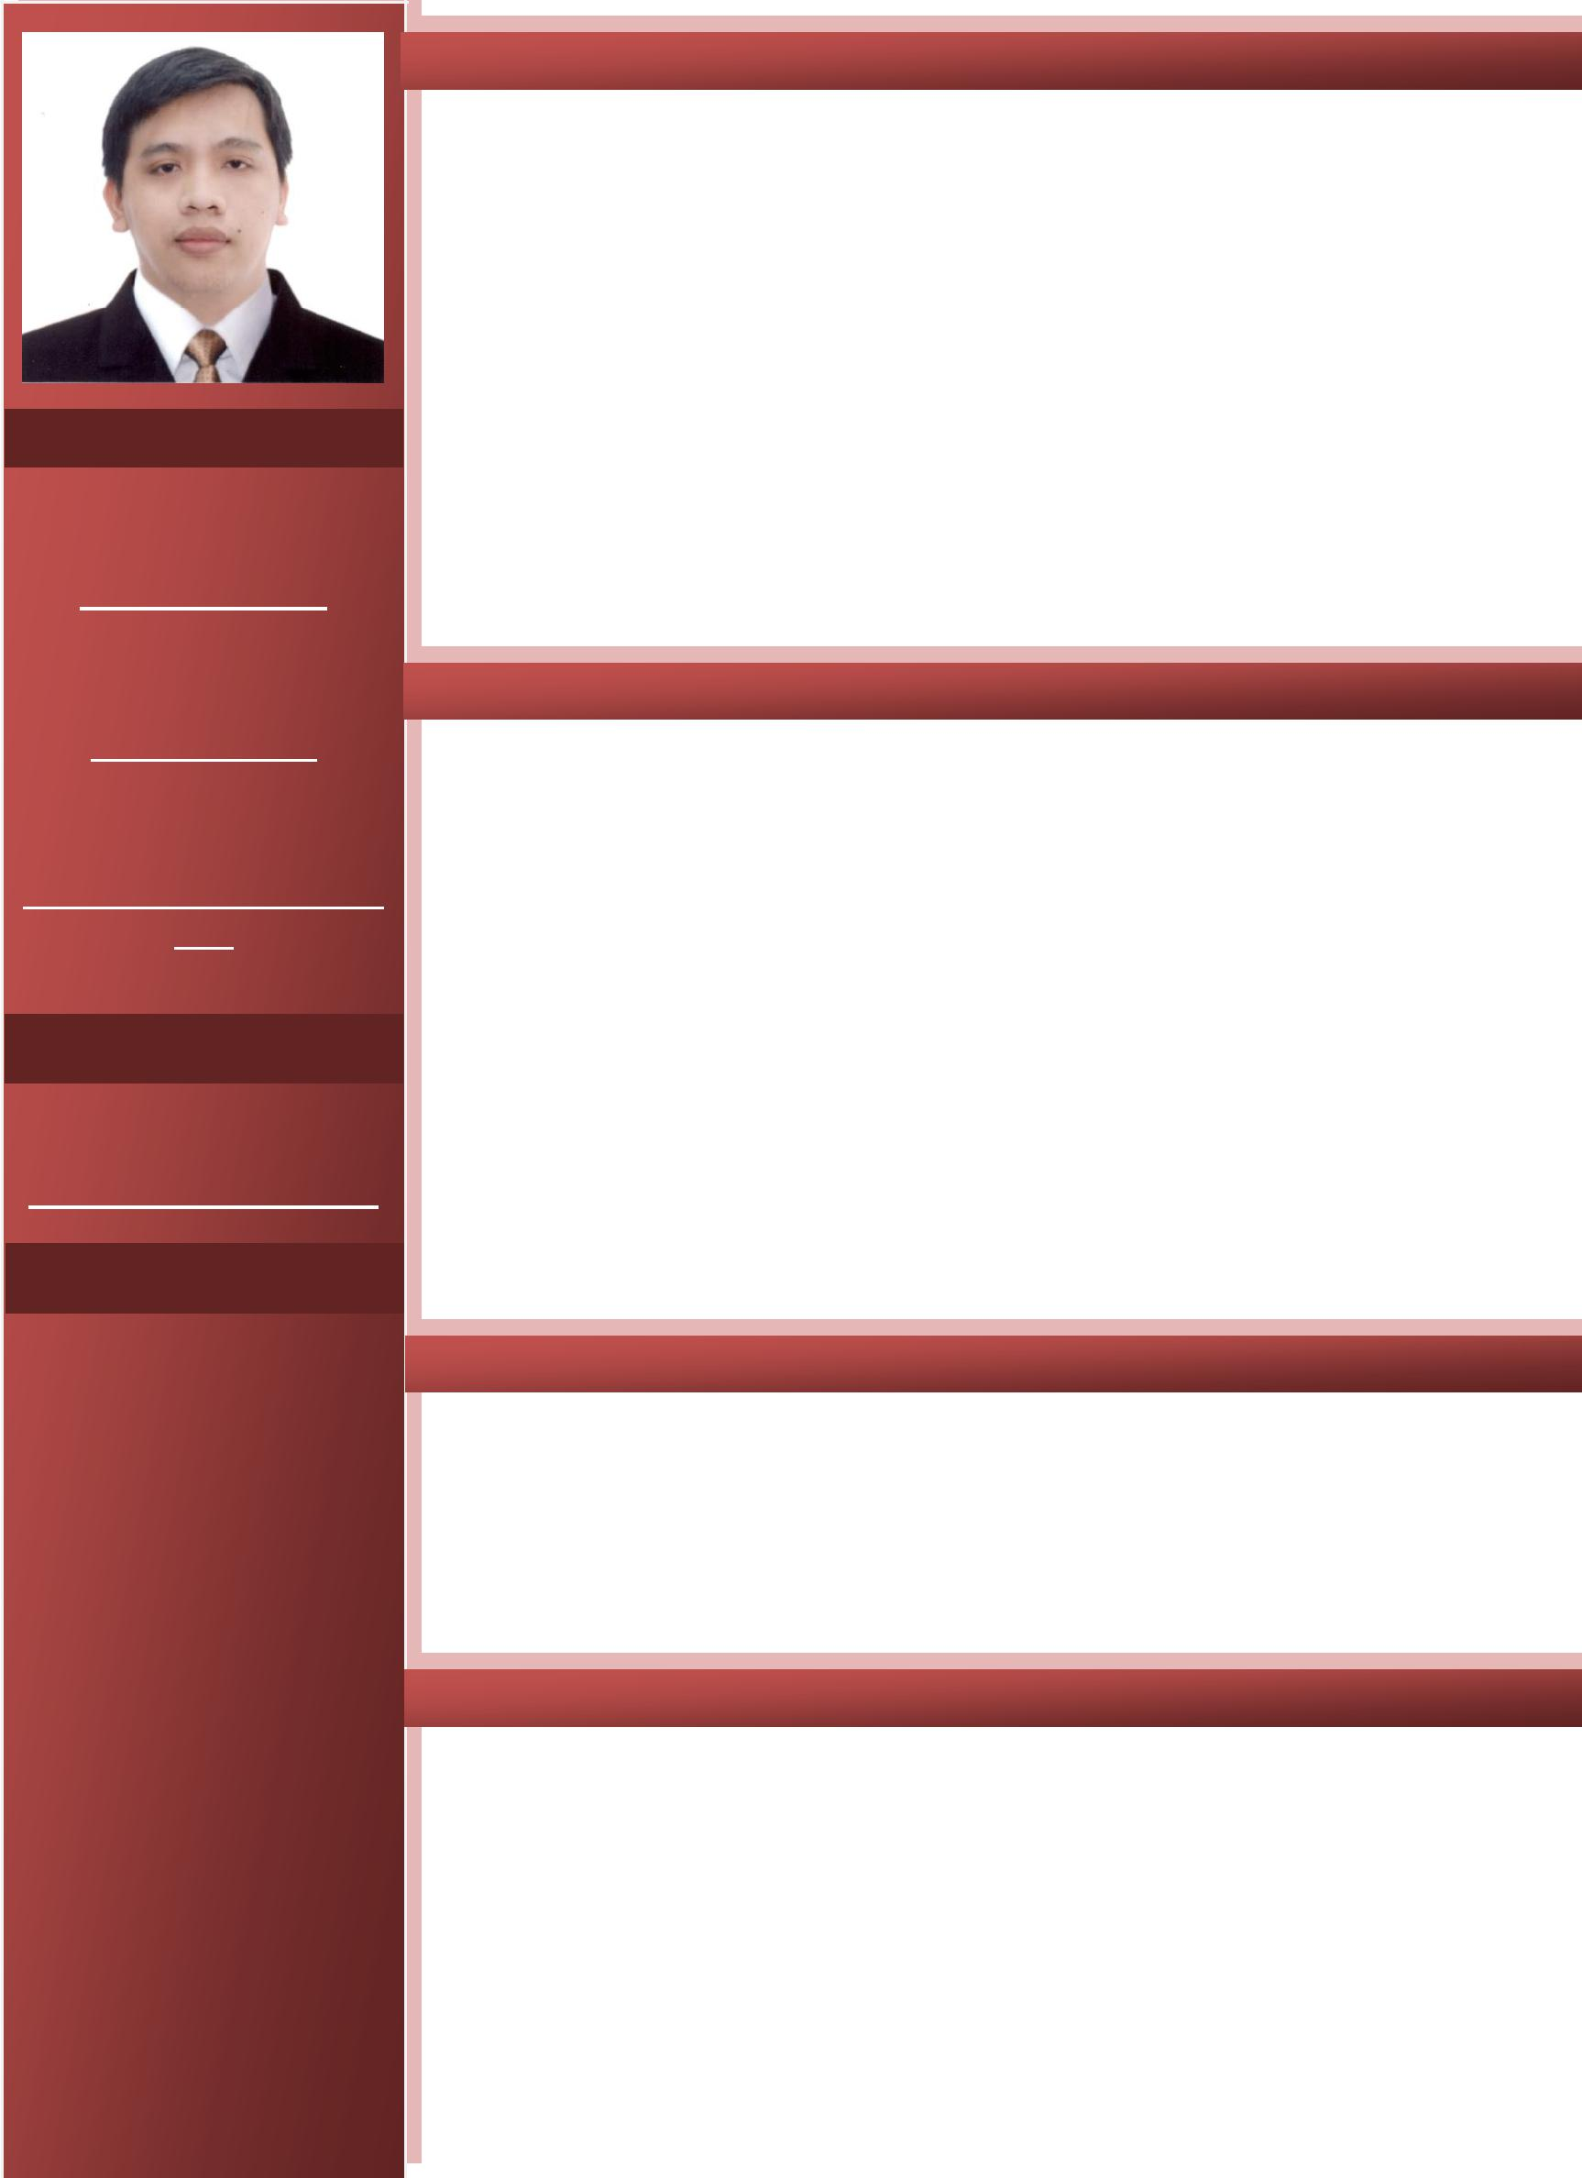
PERSONAL | PROFESSIONAL ORGANIZATION
INFORMATION |  | Saudi Council of Engineers
 | Accredited Kingdom of Saudi Arabia Organization
Name | Institute of Integrated Electrical Engineers of the Philippines
 | Accredited National Organization
JOEY
 | - Responsible for generator maintenance.
Birth Date | TRAINING ATTENDED
JUNE 2,1983 | July 26-Aug.13, 2010 | AUTOCAD II
Age |  | Advance Business Consultancy CenterPhils.Inc
 |  | Batangas City
33 YEARS OLD
 | June 28-July 16,2010 | AUTOCAD I
Religion |  | Advance Business Consultancy CenterPhils. Inc
CATHOLIC |  | Batangas City
 | June 23-June 27,2008 | Basic Marine Refrigeration & Air Conditioning
Civil Status |  | Magsaysay Training Center
 |  | 6th Floor Times Plaza Building,Ermita, Manila
MARRIED
Height | SEMINARD ATTENDED
5’5 | March 31, 2017 | Basic First Aid
 |  | GTSC
Weight |  | Taif, Saudi Arabia
63lbs | March 30, 2017 | Working at Heights
 |  | GTSC
 |  | Taif, Saudi Arabia
 | March 30, 2017 | Fall Protection
 |  | GTSC
 |  | Taif, Saudi Arabia
 | October 2-3, 2011 | Internal Quality Auditing
 |  | SRMCO-Saudi Refrigerator Mfg. Co. Ltd
 |  | Jeddah, Saudi Arabia
 | October 1, 2011 | ISO 9001 Awareness (Year 2008 Version)
 |  | SRMCO-Saudi Refrigerator Mfg. Co. Ltd
 |  | Jeddah, Saudi Arabia
 | July 6-10, 2011 | Workshop Instruction
 |  | Juffali Training CenterJeddah, KSA
 | I hereby certify that the above information is true and correct to the best of my
 | knowledge and belief.
 |  | ENGR. JOEY
