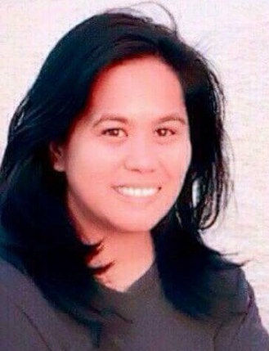
C/o- Mobile: +971501685421
Princess.378709@2freemail.com
PRINCESS

OBJECTIVE
An accomplished professional with 10+ years experience in the engineering (construction) industry. I am seeking to use my background in planning, overseeing, and implementing organizational objectives to take on a role as technical staff in any of the areas, PROCUREMENT/ QUANTITY SURVEYING/ DOCUMENT CONTROL/ PROJECT COORDINATION/ PROJECT MANAGEMENT. I have been proven to be creative and effective at implementing any task that I have been assigned.

CORE STRENGTH & COMPETENCIES
- Great at interpersonal communication: Effective coordinator, excellent verbal and written communication skills. Ability to interact effectively with organizational members, stakeholders, clients and vendors. Ability to operate successfully in assigned environment. Ability take control over any task at hand.
- Conceptual Skills: Ability to see “the big picture” and envision how work units and teams are best organized which translate to contribution of project and/or organization success.
- Problem Solving Skill: Ability to identify and investigate problems, decide on a remedy, and propose or implement solution. Ability to make quick decision when needed.

PROFESSIONAL EXPERIENCE
Total Professional Work Experience: 15 Years (4 years in UAE)

- Civil Engineer cum Office Engineer in Musium Contracting LLC, Dubai, UAE
from July 2014 – present
Projects:
- Construction of various farm facilities for Sheikh Mohammad Bin Rashed & Sheikh Hamdan, Falcon farm in various areas in Dubai
- G+1 or B+G+1 Villas

Duties & Responsibilities
• Prepare BOQ/ Tender submission
• Prepare/ Follow-up invoice/ claims
• Sourcing out qualified and reasonable priced subcontractors/
suppliers
• Inspect/monitor/evaluate sub-contractors workmanship
and accomplishments
• Monitor & Manage DM Portal
• Train & guide new engineers/ staffs
• Technical correspondence
• Document organization, filing, safekeeping.
• DM, DCD, RTA, DEWA submission and coordination

2. Regional Engineer at P & EL Realty Corporation (PJLI Group),
Makati City, Philippines from June 2009 – January 2013
Projects:
1500 branches of Jewelry/Money Exchange shops, Stores, Condominium Residential, Corporate Offices

3. Quantity Surveyor in Makati Development Corporation – First Balfour
Joint Venture MDC-FB JV from June 2006 – June 2009
Project:
Saint Luke’s Medical Center in Global City, Taguig

4. Division Engineer/ Coordinator (JDEC) in Mohri & PA Associates Inc (MPAAI)
November, 2002 – May 2006 and February 2013 - April 2014
Projects:
(1) Construction, renovation of School Buildings to poorest provinces in the Philippines known as the Third Elementary Education Project of the Department of Education of Philippines in Partnership with World Bank & JBIC. (2) Implementation of Public - Private - Partnership (PPP) for Construction of Public School Buildings.

EDUCATION

Graduated Bachelor of Science in Civil Engineering in Cebu Institute of Technology (CIT), Cebu City, Philippines on year 2000

CERTIFICATION

Dubai, G+1 Certified Engineer since 2014
Philippines, Licensed Civil Engineer since 2002

TRAININGS/ CERTIFICATION COURSES

HR & ADMIN at Filipino Institute, Dubai (On-going)
Accounting (Basic + Intermediate) at Filipino Institute, Dubai (On-going)
Quantity Surveying Certificate at Chicago Institute, Dubai

COMPUTER LITERACY
Proficient in AutoCAD, Sketchup, MS Office, MS Project

LANGUAGES
Filipino & English

NATIONALITY

Filipino

