OMAR | HOSPITAL  COO

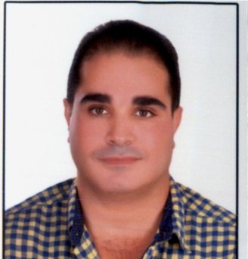 | Phone  C/o 0501685421  E-mail  Omar.378814@2freemail.com |  | EMPLOYMENT  COO of Al Salama One Day Surgery Center  October 2017 till now.  CLINICAL PATHOLOGY SPECIALIST  November 2015 – till Oct 2017.  AL SALAMA HOSPITAL, ABU DHABI.  Duties:  -Laboratory Director of Al Salama One Day Surgery Center.  - Head of Infection Control Department of Al Salama One Day Surgery Center.  CLINICAL PATHOLOGY SPECIALIST |April 2015 - till October 2015.  AL NOOR HOSPITAL, ABU DHABI.  PATHOLOGY SPECIALIST| Aug 2011 – Feb 2015.  OMANMINISTRY OF HEALTH.  -Head Of Ibra Regional Hospital Laboratory Department.  PATHOLOGY SPECIALIST| Mar 2007 – Jan 2011.  SAUDI MINISTRY OF HEALTH.  CLINICAL PATHOLOGY REGISTRAR | 2005 – 2007.  DAR AL FOUAD HOSPITAL, EGYPT.

ABOUT ME

Throughout my studies, I have dedicated myself for a career as a physician. Given my eagerness to learn and solid academic record, I believe that I am a well-suited candidate to work in any organization.

The opportunity to obtain employment in an established and reputable health system clearly would further my abilities as a physician. In doing so, I hope to work with and learn from accomplished individuals in the medical field, which would be a positive step toward accomplishing my goal of becoming a medical provider who is dedicated, enthusiastic, knowledgeable and compassionate

EDUCATION
- Master Degree of Clinical and Chemical Pathology , |(2001 – 2004)
Ain Shams University, Cairo, Egypt

-Bachelor of Medicine and Surgery (MB-BCH) |(1993 – 2000)
Ain Shams University, Cairo, Egypt

LICENSE AND CERTIFICATION
-HAAD, DHA,MOH licensed Clinical Pathology Specialist.
HAAD (License No: GD18195),DHA(DHA/LS/452016/590525),MOH (Certificate No: 150302).
- 2011, Pathology Specialist Registration Certificate,Oman Ministry of Health.
- 2009, Professional Accreditation Certificate as Registrar in Clinical Pathology fromSaudi
Commission for health Specialties.
- 2006, Clinical Pathologist Registration Certificate, Egypt Ministry of Health.
MEMBERSHIP
NAHQ(National Association for Healthcare Quality), Member number00316290.
Clinical Laboratory Standards Institute (CLSI).
COURSES & WORKSHOPS

Certificate of Laboratory Management University, ASCP, 2014.
Basic Laboratory Quality Control Concepts Workshop, BIO-RAD Middle East, Sept 2013.
Quality Management Solutions- External & Internal Quality Control for Laboratories Workshop- RANDOX, May 2013.
Regional Intestinal Parasites Workshop, Oman Ministry of Health, Sep 2013.
Appropriate Clinical Use of Blood and Blood Products, Oman Ministry of Health, Jan 2013.
Inherited Blood Disorders Workshop, Oman Ministry of Health, Nov 2012.
GCC Surveillance Methodology of Health Care Associated Infections, Oman Ministry of Health, June 2012.
Regional Semen Analysis Workshop, Oman Ministry of Health, Mar 2012.
5th National Infection Control Awareness Workshop, Oman Ministry of Health, Oct 2011.
Patient safety Culture Workshop, Oman Ministry of Health, Oct 2011.

