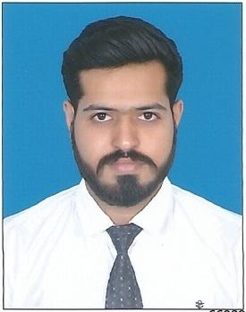
MANISH

D.O.B: 10th November 1993
Nationality: India
Mobile: C/o 0502360357
Email: manish.378829@2freemail.com

OBJECTIVE
Dedicated Web Developer with +2 years of experience. Seeking to leverage my technical and interpersonal expertise to grow your company.

PROFILE
I am an open-minded individual with a proven track record in designing websites and creating databases. I have strong technical skills as well as excellent interpersonal skills. I am eager to be challenged in order to grow and improve my communication and professional IT skills gained through previous experiences in the IT sector.

EDUCATION
Sigma Institute of Technology & Engineer., Vadodara, Gujarat, India.
Diploma in Information Technology June 2013

LANGUAGES
English – Excellent reading, Writing and speaking.
Hindi - Excellent reading, Writing and speaking.
Gujarati - Excellent reading, Writing and speaking.
Marathi - Excellent reading and speaking.

SPECIALIZED SKILL
- Excellent interpersonal and communication skills
- Multi-tasking abilities with proficiency in organizing and managing different tasks
- Working Knowledge of Html and WordPress Web Development.
- Able to Manage and Handle Social media pages.
- Working knowledge of on page SEO.
- Knowledge of Android app Development.
- Proficient in Microsoft Office including Excel and Powerpoint.
- Excellent editing skill.
- Strong problem solver

PROFESSIONAL EXPERIENCE
Web Developer, Tech i-com (Aug. 2015 – Till Date)
Tech i-com is the growing IT Company Located in Akota, Vadodara, India.

Roles and Responsibilities:
- Write well designed, testable code by using best software development practices.
- Create website layout/user interface by using standard HTML/CSS practice.
- Gather and refine specification and requirements based on technical needs.
- Be responsible for maintaining, expanding, and scaling our site.
- Stay plugged into emerging technologies/industry trends and apply them into operation and activities.
- Co-operate with Graphic designer to match visual design intent.
- Be responsible for social Media Page Handling.
- Creating android app for the website using Android tools.
- Create HTML Email Template for email marketing.

ACHIEVEMENTS & CERTIFICATES
- Successfully completed 1-day training of Networking from Scientech Learning (Indore).
- Successfully completed short term course (2 Weeks) in JAVA PROGRAMING form ITC
- (Tarsali, Vadodara).
- Successfully completed short term course (3 Weeks) in ANDROID from ITC
- (Tarsali, Vadodara).

OTHER INTERESTS
Cook Food, Workout in Gym, Exploring new places.

I hereby declared that all the information provided by me is as per my knowledge and it is
unbiased

Thanking You!
Manish

