SABITH

Dubai-UAE
Mob no: C/o 0501685421 ; Email: Sabith.378900@2freemail.com

Dear Sir,

I am submitting here with my resume for your perusal for the suitable position in your organization.

I am systematic, organized, hardworking and dedicated team player with an analytical bent of mind with excellent academic credentials. I having experiences across Production execution, Man power handling, Root cause analysis, Quality system, MS Office, Mechanical Maintenance, Preventive maintenance.

I am proficient in Team management, Plan and scheduling, maintain records and Documentation. accented with the latest trends and techniques of the field, having an inborn quantitative aptitude, determined to carve a successful and satisfying career in the Industry.

A hard working & talented individual seeking a challenging job that would synergize my skills and knowledge with the objectives of the organization, dedicated and focused individual, determined to add value to the organization I work for, through my exceptional knowledge and learning ability.

The above credentials along with my enclosed resume make me ideally suitable for a position in your organization. I would appreciate an opportunity for a personal interview.

Thanking You,

Yours sincerely
SABITH

CURRICULUM VITAE

SABITH
MECHANICAL ENGINEER

PROFILE:
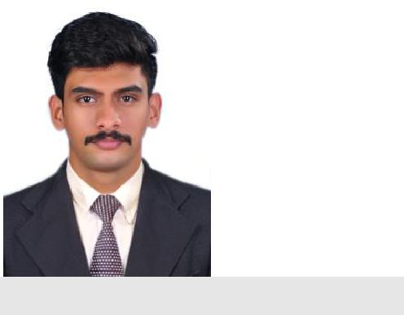

Email:

Sabith.378900@2freemail.com

Contact:

C/o 0501685421

Personal Data:

.

Date of Birth : 13/02/1994
Gender : Male

Marital Status : Single

Nationality : Indian

Visa status : Visit visa

Visa expiry : 30 April 2018

CAREER OBJECTIVE:

To be an active employee who contributes to the mission, vision and values of the company, on a professional level with other employees. To give excellent performance, and to translate my knowledge experience, skills and abilities into value for the organization.

EDUCATIONAL QUALIFICATIONS

Bachelor of Engineering in MECHANICAL ENGINEERING ANNA UNIVERSITY, TAMIL NADU, India, 2011- 2015

12th Board Exam
STATE BOARD, KERALA 2009-2011

PROFESSIONAL/TRAINING CERTIFICATES

- MS Office, Internet , Ms Excel

- Certificate course in basics HEAT VENTILATION AND AIR CONDITIONING.

WORK EXPERIENCE

MAINTAINENCE ENGINEER
PHA Automotive Pvt Ltd, sriperumbuthur.

(May2017- Oct 17)

DUTIES AND RESPONSIBILITIES:

- Plan and schedule projects, estimate time and materials, supervise subordinates, maintain records and Prepare reports.
- Plan and supervise the work of the electrician.

- Maintain records on Mechanical jobs and assign to appropriate personnel.

- Assist in coordinating job assignments with the other trades.

- Assist contractors on jobs.

- Determine procedures for maintenance, installation, modification and repair of mechanical assignments.

- Assemble, Install, Test and Maintain mechanical Equipment, and Appliances.

MECHANICAL MAINTENANCE ENGINEERING TRAINEE.
(May2016- April 17)
RUBCO INDUSTRIAL COMPLEX,
KERALA STATE RUBBER CO-OPERATIVE LTD, Kuthuparamba.

DUTIES AND RESPONSIBILITIES:

Maintain systems and equipment by completing preventive maintenance schedules; restoring, repairing, rebuilding, or replacing faulty or inoperative components and parts; supervising staff

To meet maintenance operational standards by contributing maintenance information to strategic plans and reviews; implementing production, productivity, quality, and customer-service standards; resolving problems.

To meet maintenance financial standards by providing annual budget information; monitoring expenditures; identifying variances; implementing corrective actions.

Evaluate functionality and reliability of facility systems and associated equipment by conferring with operating departments; identifying problems and requirements.

Maintain safe and healthy work environment by following standards and procedures; complying with legal codes and regulations.

Accomplish maintenance and organization mission by completing related results as needed.

REFERENCES:

Available as per request.

DECLARATION:

I hereby declare that the information provided is true to the best of my knowledge.

SABITH

