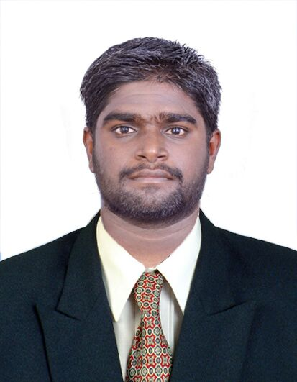
RESUME

(Apply for MECHANICAL QA/QC ENGINEER)

RAJAGANAPATHY
Dubai, UAE.
Mobile: C/o 0501685421
E-mail:-
rajaganapathy.378902@2freemail.com

Objective
To pursue a career where I can use my skills meticulously to develop further more towards professional status and position technologically excel in the field of Quality assurance. To utilize the knowledge and experience gained during my studies and work and to pursue a challenging career in the field Quality assurance, where my technical knowledge and abilities can be implemented.
Personal Details
Name : RAJAGANAPATHY
Date of Birth : 07 July 1994
Sex : Male
Nationality : Indian
Marital Status : Unmarried
Religion : Hindu
Languages Known : English, Tamil, Hindi and Malayalam

Passport Details
Date of Issue : 13-03-2017
Date of Expiry : 12-03-2027
Place of Issue : Madurai

Academics

- Bachelor of Mechanical Engineering in SACS MAVMM Engg college, Madurai 2016. (64% of Marks).
- Higher secondary passed in 2012 with distinction (60% of marks).
- SSLC passed in 2012 with distinction (86% of marks).

Computer Proficiency

- Auto cad 2017
- Autodesk Revit MEP 2017
- CREO
- MS Office

Professional Synopsis

1 year 8 Months of experience as QA/QC Mechanical Engineer in India.

- Review the Material technical Data sheet
- Preparation of method statement
- Review method of statement approval
- Submit inspection request for Engineers inspection
- Issue internal NCR
- Contact Regular material inspection
- Prepare QA/QC reports

Career Highlights

Elkayem Auto ancillaries, Hosur, India (Since July 2016 to Feb 2018)
Position: QA/QC Mechanical Engineer
During this period our company did the supply of Main frames for two wheelers, Foot rest block,
Crash guards, Cross tubes, Back hooks to TVS Motors & this items are checked & inspected by me & our team.

PROJECTS WORKED FOR:
- TVS Apache Two wheeler - Swing Arm checked & inspected
- TVS Jupiter Main frame Checked & Inspected

TECHNICAL JOB RESPONSIBILLITIES:

- To check the produced material & Purchased materials
- To ensure the material sizes
- To find the defects in the produced material & to instruct the production team to rectify the defects
- To check the defected materials can be rework, if not the materials need to be shift to the NC area.
- To prepare the Non conformance Report (NCR)
- Periodical quality audit done as per the procedure.

PERSONAL SKILLS:
- Strong organizational & co-ordination skills.
- Ability to communicate well.
- Willingness to learn
- Good skills at knowledge sharing.
- A Quick and Keen learner with ability to gather and Improve new knowledge with ease

I hereby declare that the above-mentioned information is correct up to my knowledge and I bear the responsibility for the correctness above-mentioned particulars.

Place : Dubai Yours Truly,
Date : Rajaganapathy

