SADAF
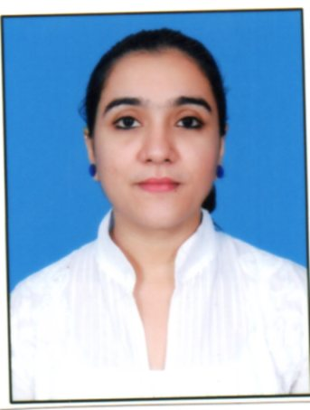
Address:-
Dubai, UAE.
Mobile no: - C/o 0505891826
Email ID: - sadaf.378919@2freemail.com
Visa Status: - Visit-Visa

Career Objective: - To work sincerely and diligently for my organization, taking my organization towards sustainable grow by using my academic, technical and inter-personal skills which will not only provide me with ample opportunities to learn but also to grow with the organization.
Strength: - Effective Leadership Tactics, Managerial ability, Strong Reasoning, Self – Confident and ability to communicate successfully with the variety of people within & outside the organization, Good learner and Optimist.
WORKING HISTORY:-
WORKING AS RECEPTIONIST IN POWERZONE GYM (SALES)
Responsibility whereas follows:-
- Convincing the customer for admission.
- Handling walk- in enquiries.
- Tele calling and follow ups.
- Maintaining daily cash flow.
- Conducting Workshops and Seminars.
- Preparing salary for the employees.
- Conducting meeting with the owner of gym.
- Looking after the maintenance of gym etc.

Worked as an Educational Counselor in Indian School of Management & Studies Taking a person's education level, work history, personality, interests and skills into account and suggest careers that match his or her background and abilities.
Responsibility whereas follows:-
- Generating the leads by making fresh calls from the data.
- Call on the enquiries made by the student and counsel appropriately.
- Mailing student the entire details regarding the course & solving the queries.
- Handling walk-in students and counsel them.
- Follow up the leads by calling.
- Maintain a record of the calls made per day.
- Other office work.
- Verifying and completing the formalities for the admission closed.
- Make sure the books and other things reach to student on time.
- Counseling & provide a better option.

Worked with HDFC BANK Ltd as a customer sales executive premiere acquisition channel (pam)
Aproach potencial Customer with the aim of winning new bussiness, as well as maintaining good relationships with clients, also making repeat sales to employer’s existing customers
Responsibility whereas follow:-
- Generating the leads by making fresh calls from the data.
- Follow up the leads by calling.
- Maintain a record of the calls made per day.
- Opening Imperia/ Preferred/ Classic/ Saving/ Current/ Demat/ Fixed Deposit Account.
- Pitching for various loans.
- Mainly into Imperia/ Preferred/ Classic account.
- Filling and Processing Account Opening forms.
- Documentation work.
- Handling Customer Queries and attending Telephonic Queries.
- Maintaining cordial relations with Customers.
- Handle walk-in customers.
- Follow up customers by calling.
- Maintaining daily sales report.
- Maintaining Audit.
.
ACADEMIC CREDENTIALS
- Completed Masters Of Business Administration (MBA) in International Business from Institute of Chartered Financial Analysts of India (ICFAI).SIKKIM
- SEMESTER 1 :- BUSINESS BASICS
- SEMESTER 2 :- DIPLOMA IN MANAGEMNET
- SEMESTER 3 :- POST GRADUATE IN INTERNATIONAL BUSINESS
- SEMESTER 4:- MASTERS OF BUSINESS ADMINISTRARTION IN INTERNATIONAL BUSINESS.
- Completed Bachelor in Banking and Insurance (BBI) from Shri Chinai College of Commerce & Economics, (Mumbai University, 2010) secured 75%
- H.S.C., Commerce, Sheth Vidya Mandir School & Collage of Science and commerce,(Maharashtra Board, 2007) secured 65%
- S.S.C., J. B. Ludhani High School, (Maharashtra Board, 2005) secured 55%

COMPUTER SKILL: Basic Computer Concept (B.C.C), Basic of Windows 98, MSDOS through Windows Explorer, Microsoft Office 2000 (Word, Excel, PowerPoint), Internet and Email.
PERSONAL DETAILS:-
- Date of Birth : 15th February 1989
- Gender : Female
- Height :5.1
- Marital Status : Single
- Nationality : Indian
- Languages known : English, Hindi, Marathi, Guajarati and Kuchchi.

HOBBIES: - Playing outdoor & indoor games, Socializing, Watching movies, Listening Music.
REFERENCE: To be furnished on request.

