CURRICULUM VITAE

THUSHAR
Sharjah, UAE
Email: thushar.378926@2freemail.com
Mobile No: C/o 0502360357
Visiting Visa: 29-01-2018 to 28-04-2018

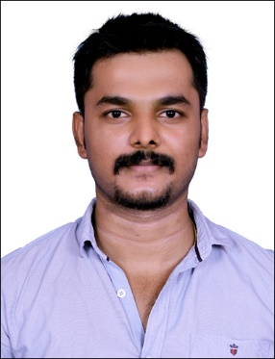

CAREER OBJECTIVE
To gain employment with a company that offers me a consistently positive atmosphere to learn new technologies and implement them for the betterment of the business.

SUMMARY OF SKILLS AND QUALIFICATIONS
- Two years of Experience as a Technical support interacting with customers and have experience in sales.
- Undergone internship training in Java and working as a Software developer.
- Good knowledge in Java, C++ and object oriented programming
- Experience in Eclipse, net beans ,SQL ,JDBC ,JSP ,Servlets ,HTML ,XML.
- Team player with ability to work under stressful environment
- Punctual, hardworking, with efficient time management skills
- Quick learner with a passion towards new technologies
- Possess effective communication abilities to deal efficiently with the clients

EMPLOYERS PROFILE

Employer :Focaloid Technologies
Position : Java Developer

Period of work:From April2017 to October 2017

Company Profile

Completed internship as Java Developer in FocaloidTechnologies. I got good knowledge in Java ,object oriented programming. I have worked and got experience with Java, JSP, HTML, XML, SQL, Servlets, JDBC.

Last Employer :XLR8 IT solutions
Position : Technical support

Period of work:From April 2012 to March 2014

Company Profile

I got experience as a technical support, undergone troubleshooting and my role is to interact with customers, I got experience in sales.

ACHIEVEMENTS

- Published a survey paper for Efficient file retrieval from cloud server in IJPT presented a research paper entitled EFFICIENT FILE RETRIEVAL FROM CLOUD SERVER USING MULTI SEARCH in National Conference on “Recent Innovations In Software Engineering And Computer Technologies”

EDUCATION

Program | Institution | Period | Performance (SGPA/%)
M.Tech in Computer Science and Engineering | SRM University | 2015 -2017 | 6.27
B.Tech inInformation Technology | Anna  University | 2007 - 2011 | 62%

PROJECT AND TRAINING UNDERTAKEN DURING COURSE OF STUDY

- Project on Online shopping mall in IBM Websphere (B.tech Project)
I have made the project ONLINE SHOPPING MALL USING HTML and J2EE.It provide user to shop online,Provide opportunity for registered login, Exclusively hyperlinked pages provide users vast shopping experience.
- Project on Efficient file retrieval from cloud server using multi-search(M.techproject)
- Project which enhance the searching efficiency of the files in cloud server
PERSONAL DETAILS

 | Name | : Thushar
Date of Birth |  | : 19th February 1990
Gender |  | : Male
Religion :Christian
Nationality :Indian
Marital Status :Married
Language Known :English, Hindi, Malayalam and Tamil

DECLARATION

I reaffirm that the information furnished in this document are true and many thanks for your valuable time given to my CV. I look forward to seeing you soon.

Place: Sharjah With best regards,
Date : 03-03-2018 THUSHAR

