CURRICULUM VITAE
INSTRUMENTATION ENGINEER

ZUNED
Contact Information:

Email: zuned.378967@2freemail.com
C/o-Contac no- +971501685421

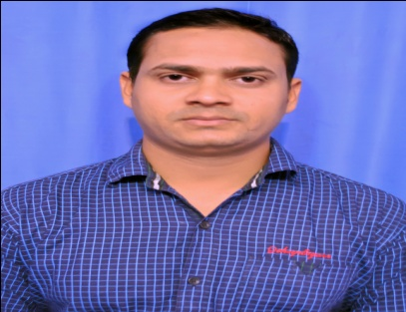

CAREER OBJECTIVE

Provide Excellence in the job by knowledge and hard work and willing to assume a challenging position in the field of Instrumentation engineer level in the field of instrumentation with opportunities for personal, technical and professional achievement.
SUMMARY
- Instrumentation having more than 5 years 1 month of experience as a Engineer in Indian oil Refinery Project (India) under m/s Rohini industrial and Electricals Ltd (A Voltas subsidiary).
- Instrumentation having 1 Year experience in power plant project as a Engineer in THERMAX LTD (Power Division).
EDUCATION PROFILE

Technical:

Post- B.Tech in Electronics & Instrumentation Engineering from Biju Patnaik University of Technology (India).
Academic:
1. The Bachelor of Technology in Electronics & Instrumentation Engineering from Biju Patnaik University of Technology.
2. Certificate in (ISC) from Board of secondary Education, Bhubaneswar.
3. Diploma computer application (Excel,Ms word,Power point,Internet).
WORKING EXPERIENCE

- Worked in Indian oil Refinery Project, paradeep, Odisha (India) from Feb 2012 to March 2017 under m/s Rohini industrial and electrical Ltd (A Voltas subsidiary).
- worked in Rashtriya Chemical and Fertilizer Ltd, Power plant project, Mumbai India from April 2017 to Feb 2018 under THERMAX LTD.
JOB PROFILE

- Loop checks and commissioning of all field Smart Instruments.
- Experience with functional checks of all types of Smart Instruments and sensors .
- Interpretation of loop drawing, Instrument cabling & terminations, Cable schedule, Hook-up drawing, and P&ID drawings.
- Extensive troubleshooting experience for all fields instruments during loop check,calibration, startup and commissioning activities.
- Generation and maintenance of all types of records for Quality control checks , leak checks and other inspections.
- Handling the commissioning and operation of Mov,Sov.
- Have sound Knowledge on Fire & Gas Detection Instruments, e.g. HC Detector,flame detector, H2S Detector,H2 Detector and Smoke Detector.
- Possesses HSE Knowledge and aquanted with Permit to work like Hot & Cold jobs and Confined Space Entry.

JOB RESPONSIBLE

Leading multinational workforce of Instrument Engineer, Coordinating with Planning, Operations, Process and Support Engineers , Interacting with Vendors, Contractors for loop checking, validation, punch listing and acceptance tests, attend Call out Duties.

PERSONAL DETAILS

Date of Birth 18 April 1987
Marital Status Unmarried
Gender Male
Nationality Indian

Languages Known English, Hindi

DECLARATION

I hereby declare that all the above mentioned information is true as per best of my knowledge.

