Richard
Registered Electrical Engineer/Registered Master Electrician
Mobile Number : C/o 0501685421
E-mail Address : Richard.378987@2freemail.com

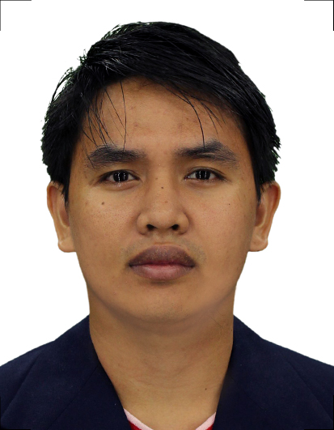

PROFESSIONAL PROFILE

Highly motivated, hardworking, and enthusiastic individual with total 3 years experience in design and estimation capacities with concentration in Electrical Engineering discipline.Self motivated, able to implement decisions and set effective priorities to achieve both immediate and long-term goals. Proven abilities to complete projects according to specifications on time, and within the budget.Easily adaptable to changes with eagerness towards learning and expanding capabilities. Possess excellent presentation and communication skills, unparalleled work ethic and strong attention to detail.

WORK HISTORY FROM THE PRESENT DATE DOWN TO THE DATE OF GRADUATION

POSITION: ESTIMATION AND DESIGN ENGINEER
Date Inclusive: June 26, 2015 – December 29, 2017
Name of Company: KC Industrial Corporation
Cordillera St. Quezon City Manila Philippines

Brief Description of Company:
KC Industrial Corporation is one of the top 10 major electrical equipment suppliers in the Philippines involved in the importation, marketing and distribution of its products. The company has gained a reputation of professionalism in the electrical industry due to a well-organized dealership network operating in every region of the country and well-trained technical staff and engineers who provide excellent sales support and maintenance services.

Duties and Responsibilities:
- Coordinate with Client/Business Development team to understand project specifications and requirements and to acquire technical information, data, plans and drawings for the site;
- Perform desktop design and cost analysis based on Client's data and information to demonstrate cost viability of different solutions to the Business Development team;
- Working together with the Business Development team to prepare competitive tenders and proposals with compliance to tender specifications and the relevant statutory and regulatory requirements;
- Review costing of proposals and aid the introduction of new technologies to reduce costs and improve performance.
- Povides BOQ for required electrical equipments on the given load schedule and SLD.

POSITION: CADET ENGINEER (Estimation and Design)
Date Inclusive: November 24, 2014 – June 25, 2015
Company Name: System PowerMark Corporation
Carmona, Cavite, Philippines

- Evaluating tender documents, drawings, & schedules
- Perform desktop design and cost analysis
- Carrying out Value engineering studies.
- Delegating Draftsmen for quantity take offs, cross checking quantities.
- Pricing for electrical systems
- Assisting in compiling of tenders.
- Making Pre-Qualification documents, both standards as well project specific questionnaires

EDUCATION

COLLEGE
Diploma : Bachelor of Science in Electrical Engineering
University : Isabela State University – Ilagan Campus
Full Address :Calamagui 2nd Ilagan City Isabela
Period Attended : June 2008 – April 2014
Date of Graduation : June 2014

SECONDARY
School : San Antonio National High School
Full Address : San Antonio, Delfin Albano, Isabela
Period Attended : : June 2004 – March 2008

ELEMENTARY
School : Aga Elementary School
Full Address : Aga, Delfin Albano, Isabela
Period Attended : 1998 – 2004

LICENSING/CERTIFICATION

Registered Electrical Engineer
PRC ID No.:0054571
Date of Issue of PRC license - 9/29/2014
Date of Expiration of current PRC license – 12/19/2020

Registered Master Electrician
PRC ID No.:0050824
Date of Issue of PRC license –01/20/2017
Date of Expiration of current PRC license – 12/19/2020

ORGANIZATIONAL AFFILIATIONS

Name: Institute of Integrated Electrical Engineers of the Philippines Inc. (IIEE)
Type of affiliation: Member

PERSONAL INFORMATION

Age : 26
Date of Birth : December 19, 1991
Civil Status : Single
Gender : Male

I hereby certify that all the above information and details are true and accurate according to my knowledge and belief.

RICHARD Applicant

