•C/o 0501685421 • nasser.379017@2freemail.com
Dr. Nasser

Objective

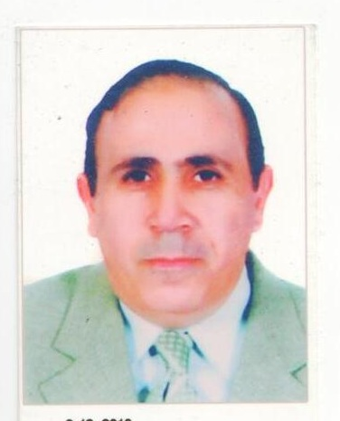

I am a consultant urology had my Experiences in end-urology and uro-surgery,, mainly the endoscopy on bladder for TRUR- T OF SUPPERFICIAL BLADDER TUMORS ,,.Intra-vesical Botox injection, Intravesical antireflux injections ,,laser therapy for stones PVP …TUR-P….ESWL-lithotripsy, URS diagnostic and therapeutic with laser(pulsating) in ureteric stone fragmentation,,,,TUR-P with laser and PVP…(vaporization)..ESWL. and renal surgeries as Nephrectomy,Pyeloplasty,pyelolithotomy

Professional Accomplishments
- Military hospital (kopri El Kopa MH) Cairo/Eygpt from 1989 1992 as urology SHO and then Register after Master degree
- AL Gallah FMH family military hospital Cairo/ Eygpt as urology register from 1993 to 2002
.AL Arish MH in north SinaiEgyptfrom 2002 to 2003 as urologist
Al Ismailia MH /Ismailia/Egyptas Urologist from 2003 to 2005Kopri El koppa MH /Cairo /Egyptas Urologist from 2004 to 2005
working as a consultant urology in Air force hospital .part time. Fifth District, Nasr city, Cairo
now in Kuwait

Sini

My
- Head of department and consultant urology in SGH-R Saudi german hospital –Ryiadh for 3 years from Feb 2o111 to Feb 2014

- Jeddah National Hospital /Jeddah/KSA as consultant urology from from 4/2009 to 6/ 2010
Zein Private ,Hospital Cairo/Egypt as consultant urology from 2008 to 2009
AL Safa Hospital Cairo/Egypt as urologist from 1996 to 2008
AL-Arief bwllah specialized hospital 1/3/2014 to 15/9/2016
Now in KUWAIIT

- MY CONTACT NUMBERS NOW
Kuwait
0965 99882651
Eygpt
00201152466631
- SHO UROLOGY: work as a responsible for in-patients and prepare them for operations following the all investigations needed, assess tent to the consultants in operations and check OP requirements and follow it,, OPD and ER duties
- Register: OPD in-Patient follow up with operative lists as first surgeon/and assistant of consultants in major operation as Radical cystectomy Radial Nephrectomy..

- Consultant Urology
Responsible for the department requirements… stuff as SHO,, and registers
OR lists…… OPD.. and follow up Patients
- All minor urology surgery as orchidopexy ,varicocelectomy . hydrocelectomy,
All major and moderate sugery as nephrectomy, pyeloplasty. Pyelolithotomy, ureterolithotomy
Endoscopies..
Cystoscopy, diagnostic and therapeutic, as injection of duflx, inravesicalbotox, TUR-BT Wwith intravesical chemotherapy
TUR P and PVP laser prostatic surgery
TUR UT of bladder tumors
Recalibration of stricture urethra endoscopicvisual internal urethrotomy
Endo-pyelotomy
Laser fragmentation of stone bladder ureter
ESWL of all urological stones

- researchs
Eassy UTI in chikdren
Theasis Collagen iii as immunofluorescence agent in bladder compliance in Urinary obstruction by prostatic enlargrment

Employment History
Feb2011 to feb 2014 | Head of urologydepartment --Consultant | SGH-R/.Saudi German Hospital Riyadh KSA,
Mars 2009 to July 2010 | Consultant urology | JNH- Jeddah National Hospital., Jeddah/KSA
6/2008 to 4/2009 | Consultant urology | Zien-Privat Hospital , Cairo /Egypt
1996 to 2007  2004 to 2005  2003 to 2004  2002 to 2003  1993 to 2002  1989 to 1992 | Urology Register  Urology Register  Urology Register  Urology Register  Urology Register  Urology SHO &register | AL sheaf Hospital , Cairo //Egypt  KopriELKoppa MH  CairoEgypt  AL ARISH MH. North Sinai/Egypt  AL Ismailia MH./.Ismailia, Egypt  Al Galla FMH Cairo Egypt  KopriELKoppa MH…Cairo Egypt

Education
Fall 2007  Fall 1989  Spring 1983 | Master Doctorate of medicine (MD) Urology  Master Degree in Urology  Bachelor Degree in Medicine (MBBCH) | Ain Shams University, Cairo, Egypt  Zagazig University, Cairo, Egypt  Ain Shams University, Cairo, Egypt

