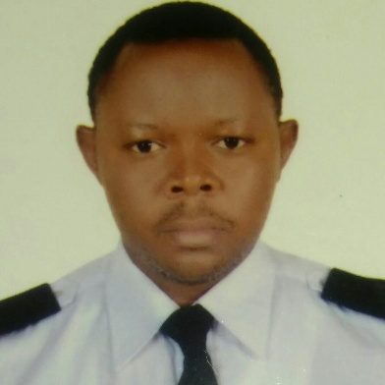
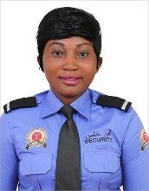

AREAS OF EXPERTISE

Emergency procedures

Customer service

Building evacuations

Public interaction

Report writing

Parking enforcement

Security escorts

Crowd control

Control procedures

Safety practices

CCTV

Investigating disturbances

Lost person search

Lockouts

CAREER STATEMENT

“I feel that my greatest strengths are firstly my willingness to take responsibility for all the security duties within my jurisdiction. Secondly my ability to quickly understand a member of the public’s needs, and thirdly my positive attitude to dealing with any problems that I may come across.”

Celestine

Security Guard

PERSONAL SUMMARY

A highly experienced Security Guard who is committed to complying to the highest-ranking work place standards in terms of attendance, health and safety, and conduct towards the public. I ammore than able to respond effectively to medical situations, and fire emergencies. I have a comprehensive working knowledge of all Security Guard orders and duties, and is physically fit enough to be able to walk around for long periods, stoop, kneel, crouch, push, pull and grasp things.

Right now I wants to join an ambitious company that is looking to recruit a Security Guard who has the bags of enthusiasm and motivation needed to ensure the highest levels of safety and security.

CAREER HISTORY

Tansguardgroup LLC, Dubai

SECURITY GUARD February 2016 – Present

Responsible for impeding criminal activity and ensuring the safety of the company, its employees and assets. Also involved in interacting with a variety of persons including clients, visitors and the general public.

Duties
- Providing assistance and guidance to managers, visitors and general staff.
I
- Contacting the police, authorities and other emergency services when necessary.

- Checking badges of employees and visitors, and verifying authorization of visitors to enter the facility.

- Responding to emergencies.

- Reporting all incidents, accidents or medical emergencies.

- Monitoring and patrolling business areas on a consistent basis.

- Performing any light maintenance work that may be required.

- Warning violators of rule infractions, such as loitering, smoking.
- Issuing parking violation citations.

- Investigating incidents and preparing written reports with the details of the incident.

- Checking emergency call boxes, staff radios, security lighting and alarms to ensure they are working correctly.
- Having a highly visible presence on the premises.

Mutengene Credit Union , Cameroon

- SECURITY OFFICER Feb 2011 –Feb 2016

Was responsible for providing protection for the physical assets of the company as well as the safety and security of its employees and patrons.

Duties:
- Conducted security checks and inspecting building entrances and exits.

- Responded quickly to all incidents of theft, fire, sabotage or unauthorized entry.

- Facilitated and ensured the safety of visitors and employees in the event of an emergency evacuation.

- Locked and unlocked doors according to schedule.

- Monitored entrances and exits.

- Coordinated badge access control and parking permits for staff & visitors.
- Made sure that all visitors signed in and out.

PERSONAL SKILLS

Service orientated

Responsiveness

Leadership skills

Professional judgement

Problem solving

Super organised

Decision making

Energetic

Self control

Excellent communicator

Tactful & articulate

Problem solving

Well organised

Influencing skills

PROFESSIONAL

Fire Safety Certificate
First Aids
French Speaker
DPS Certificate
Customer service
English Speaker

PERSONAL DETAILS

Celestine
Alain Road, Dubai UAE
- C/o 0503718643

- Celestine.379045@2freemail.com

Hospitality Company – Yabassi
EVENTS ASSISTANT | Aug 2011 – Feb 2012
Clothes Store – Douala
SALES ASSISTANT | Oct 2010 - May 2011
Buea Council – Cameroon
VOLUNTEER | Jul 2009 - Oct 2010
KEY COMPETENCIES AND SKILLS
Security
- Violation and hazard detection.
- Dealing with the exclusion of prohibited articles and/or contraband .

- Ability to select an effective course of action appropriate to any current situation while following company procedures.

- Can work outdoors in adverse weather conditions.

- Mediating in conflict situations.

- Warning people in a professional manner of rule infractions or violations .

- Dealing with unruly people in a diplomatic way.

Professional
- Ability to maintain composure when exposed to stress.
- Neat and professional appearance.
- Outstanding customer service skills and focus.
- Able to memorise different faces.

- Strong work ethic; self-starter; results orientated.

- Able to handle sensitive and confidential situations.

- Operating complex and standard office equipment.

- Providing direction and guidance to staff on security issues.

Personal

- Acting with the highest ethical standards, and always treating others fairly & with respect.

- An approachable & professional manner.

- Having a strong sense of urgency.

- Effectively maintaining interpersonal relations & diplomacy with people .

- A hands on individual who leads by example.

ACADEMIC QUALIFICATIONS
University of Buea |  | 2014 - 2016
BSc in | Microbiology
 |  | 2002 - 2003

REFERENCES –Available upon requests

