CURRICULUM VITAE
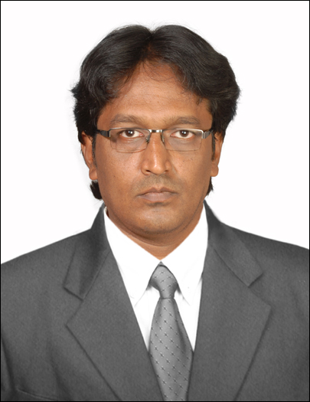
AJAZ
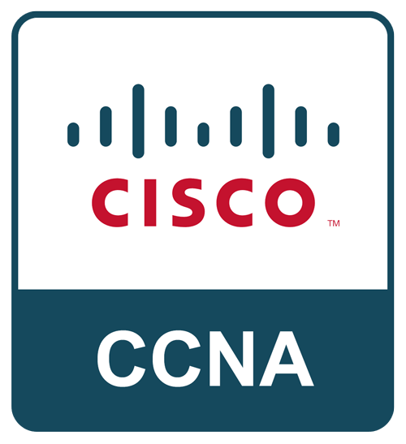
5 years of Gulf Experience
3 years of Indian Experience
Contact: C/o 0502360357
E-mail : ajaz.379048@2freemail.com
90 days Visit Visa
Valid up to 24th April-2018
Post Applied For :IT Support Engineer Immediate Joining

Objective:
A bright, talented and ambitious IT support Engineer with a strong technical background that possesses self-discipline and the ability to work with the minimum of supervision. Having exposure to a wide range of technologies & able to play a key role in diagnosing hardware and software problems and to ensure that quality solutions meet business objectives. Possessing a good team spirit, deadline orientated and having the ability to organize and present complex solutions clearly and accurately.
Technical Skills:
- CCNA, MCSE 2012.
- Digital Marketing.
- MS Office suite 2007, 2013.
- MS Access 2007 VBA.
- Strong Knowledge in Oracle Apps 11i and R12.
- Strong Knowledge in Oracle 11g.
- Oracle Developer 6i & 10g.
- Windows 7, Windows 8,10.
- Windows Server 2008, 2012
- AutoCAD 2010

Qualification:
- Master Degree in Computer Science with 64% ,Osmania University Hyderabad, India
- Bachelor Degree in Commerce in computers with 52%, Osmania University Hyderabad, India.

KEY SKILLS AND COMPETENCIES

- Efficient troubleshooter and problem solver.
- Customer service oriented: Ability to serve and communicate with different types of customers efficiently.
- Effective time management – Can solve complex system problems in minimum time.

History Of Experience.

Company Name : Techno World Computers India
Period : Aug-2014 to Jan-2018 and Nov-2010 to Mar-2012.

Responsibilities:
- Installation of Operating system in the Desktop and Laptops.
- Diagnosed and troubleshot Windows processing problems and applied solutions to increase company efficiency.
- Ensured network, system and data availability and integrity through preventative
- Windows (all versions); Windows Server 2003, 2008 R2 and 2012; macOS; Linux
- Microsoft Active Directory Services
- LAN, WAN and WiFi network technology (DNS, DHCP, NTP, SNMP and Nagios)
- Installed and updated GPS systems for ambulance maintenance to ensure accurate
- Work as a technical support engineer in PDH, SDH, Ethernet, MPLS-TP technologies
- Remedied customer computer hardware/software issues.
- TCP/IP networking and hardware maintenance and repair.
- Wrote network and hardware change managements, and efficiently completed
- Installation of LAN/WAN
- Installation of Printers.
- Installing and configuring computer hardware operating systems and application.

Company Name : Ral International Company KSA.
Period : July-2012 to May-2014.
Project : JCIIP (Jeddah City Cleaning Project, Municipality.

Responsibilities:
- Installing and configuring computer hardware operating systems and application.
- Monitoring and maintaining computer systems and networks.
- Talking staff or clients through a series of actions, either face to face or over the telephone to help set up - Systems or resolve issues.
- Faults Troubleshooting system and network problems and diagnosing and solving hardware or software replacing parts as required.
- Providing support, including procedural documentation and relevant reports.
- Following diagrams and written instructions to repair a fault or set up a system.
- Setting up new users' accounts and profiles and dealing with password issue.
- Working continuously on a task until completion (or referral to third parties, if appropriate).
- Prioritizing and managing many open cases at one time.
- Rapidly establishing a good working relationship with customers and other professionals, e.g., software developers.
- Testing and evaluating new technology.
- Supporting users and network administrators over the telephone and by email.
- Provided technical support to storage devices and maintained an antivirus system.

Company Name : Dar Al Riyadh, Kingdom of Saudi Arabia.
Period : June-2009 to Oct-2010.
Project : (MOMRA) Ministry of Municipal Rural Affairs, Riyadh Municipality.

Responsibilities:
- Responsible for networking, design, installation and maintenance services.
- Supporting users and network administrators over the telephone and by email.
- Maintain the company’s network infrastructure.
- Networking and providing support for Windows, Macintosh and Linux issues.
- Configuration and testing of any new hardware and software.
- Travelling to client sites to help with installs, deployment, and troubleshooting.
- Management of the daily data backup and retrieval scheme.
- Installing and operating Windows desktop and server operating systems.
- TCP/IP networking and hardware maintenance and repair.
- Training new employees. Assistance with training of staff and compiling procedural documentation.
Company Name : Seder Group, Kingdom of Saudi Arabia.
Period : April-2008 – Aug-2009.
Project :(MOMRA) Ministry of Municipal Rural Affairs, Riyadh Municipality.

Responsibilities:
- Monitored trouble tickets and performed troubleshoot on applications and identified problem and resolved it.
- Ensured that all alerts were catered to immediately and escalated issues to IT departments if required.
- Facilitated calls for production stages and provided accurate timelines for project.
- Inspected all application outages and tracked applications in which they were presented with help of reporting tools.
- Operated processes that were based on SOP documentation and run book.
- Maintained and configured system management tools.
- Wide knowledge of IT operations and IT enterprise applications
- Ability to troubleshoot and diagnosed problem and resolve it.
- Supporting users and network administrators over the telephone and by email.
- Provided technical support to storage devices and maintained an antivirus system.
- Configuration and testing of any new hardware and software.
Personal Profile

- Date of Birth : 15thJan1980.
- Nationality : Indian.
- Marital Status : Married.
- Languages Known : Arabic, English, Urdu, Hindi and Telugu.
- Period of Joining : Immediately.

