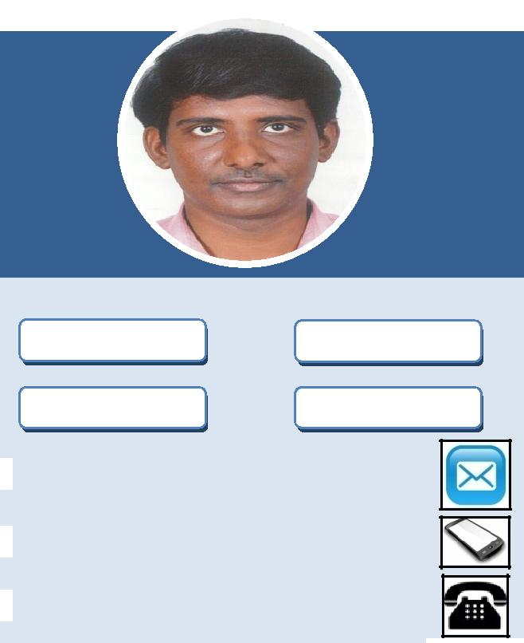
CAREER SUMMARY:

A M.Sc Software Systems degree holder with 80.68 aggregate percentage who was experienced as Assistant Professor, Computer Instructor and Systems Admin, but still looking for challenging opportunities in a path to good future.

SUNDAR

Assistant Professor Computer Instructor

System Admin Graphic Designer

sundar.379083@2freemail.com

971502360357

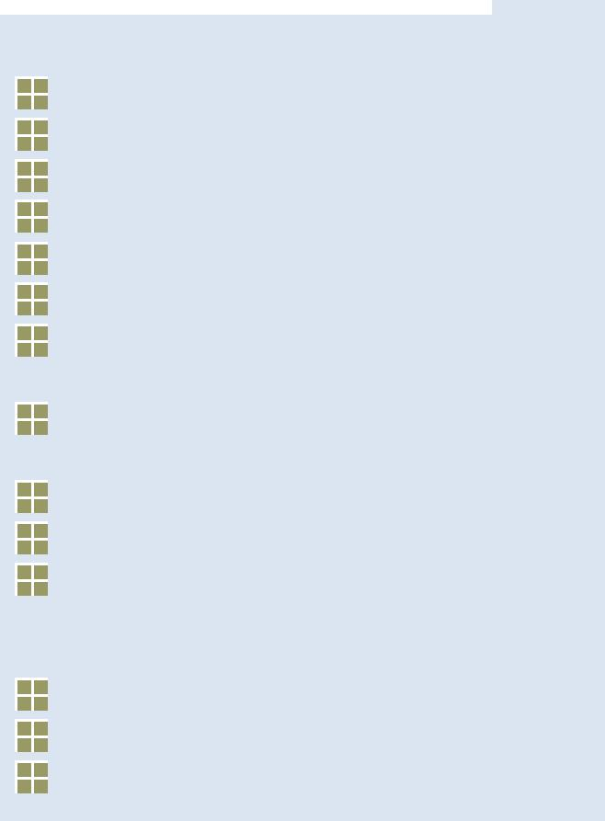

Key Skills:

Typing with 92% accuracy.

Customer Support & Telecalling.

Computer System Troubleshooting.

Teaching.

Software Project Guidance. Negotiation skill and Data Processing. Graphic Designing: Photoshop, Illustrator and Coreldraw.

Programming: .Net, Javascript, PHP, C, C++, Java and Web development. Database: Oracle and SQL Server. MS Office, Libreoffice and Staroffice.

Windows and Linux Operating Systems.

Languages:

Tamil: Native.

English: Full Proficiency.

Malayalam: Speak.

Personal Details:

Date of Birth: 01-November-1989.

Age: 28.

Blood Group: A1 Positive.

Marital Status: Married.

Hobbies: Photography & Music.

WORK EXPERIENCE:
June 2013 – April 2016 (ASSISTANT PROFESSOR)

- Company Name: Karpagam University, Coimbatore, India.

- Responsible for teaching web technology, office automation, software programming and networking subjects.

- Projects guidance was given to the students for their successful completion of their software projects.

- Assisted in successful completion of the department functions, guest lectures and symposiums by coordination works, graphic designing, data entry and report generation.

- Produced 100% result for all the three academic years.

June 2016 – March 2017 (COMPUTER INSTRUCTOR)

- Company Name: Kendriya Vidyalaya, Coimbatore, India.

- Responsible for teaching office automation, web development and graphic designing subjects.

- Recorded and maintained school data including students, library and all the other stocks.

- Gave technical support in the form of network maintenance, CCTV operating and computer system troubleshooting.

- Did photography for school events and maintained school website data.
April 2017 – January 2018 (SYSTEMS ADMIN)

- Company Name: GRD Public School, Coimbatore, India.

- Work involves control of electronic data and maintenance.

- Whenever data requisition was made by management they will be produced in the form of report.

- Graphic designing for school functions, magazine and website were done.

- Third party ERP was used for data storage and the data was fine tuned every month.

- Software modules were developed using .Net technology for additional functions apart from ERP.

- CCTV handling was done.

Visa Details:

Visa Type: Visit Visa.

SIGNATURE:

