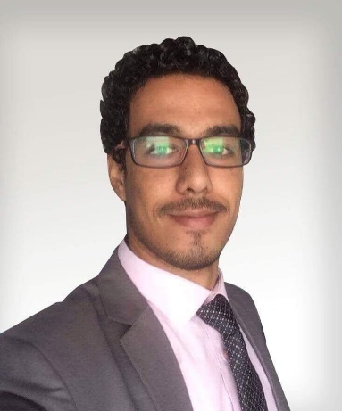
Moussa

C/o-Mobile: +971504753686
Moussa.379090@2freemail.com

Personal Information:

Nationality:Egyptian
Current Location:Dubai, UAE
Marital Status: Single
Date of birth: 04.04.1990
UAE valid Driving License

Key Qualifications:

My work as a public relations officer and business developer for Business Services Centers, provide directly to my experience and capabilities in building a trust relationship with clients.
And understanding the labour market conditions to develop strategic marketing plans achieve more sophisticated competitive advantages, in addition an in-depth knowledge for Ministries online systems and to relations with the relevant Government departments and private establishments, Alsousing my expertise in human resources and digital marketing to design Flexible and focused presentations of services to ensure easy reception for both company employees and customers.
Work Experience

Public Relations Officer/ Business DevelopmentOfficerMar2017 - until now
Hollandbizz Documents clearing servicesDubai_UAE

The company was new in the local market in the UAE, so my duties were divided into two
1- Developing the business of the company by expand the company's clients patterns to be able to provide various services to different business sectors.
2- Direct public relations tasks through dealing with government departments related to the services provided by the company or looking forward to providing.
• Maintaining relationships with clients and keeping up-to-date on their work progress.
• Writing reports and analyzing to determining the reasons for profits and losses.
• Educating team members on best business practices and techniques for increasing effectiveness.
• Finding new clients and promoting sales to them.
• Fostering familiar relationships between clients and the business development team.
• Following up on client leads.
• Raising the company profile by attending expositions and seminars.
• Suggesting new projects such as services development to tap into new markets.
• Being aware of market trends and competitors.
• Complying with regulations and laws of business development.
• Maintaining a positive attitude that inspires co-workers and clients to grow the business.
• Typing transactions online by Ministries systems.
• Have experience and know-how in the portal system usage (EDNRD, E-NETWASAL & TAS'HEEL system, Emirates ID and DHA).
• Submit documents for Visa and Work permits.
• Submit documents for Commercial and Trade Licenses business requirements.
• Provide continuous advice in regard to the new rules in the governmental departments.
• Providing PRO Daily Report to the HR executive to update the recruitment report.
• Represent the Company at locations such as the Police Station, Airport,Hotels, Embassies,Ministries Municipalities... etc.

Clients Services clerkMay2016 - Feb2017
GULF PEARL BUSINESS ADMINISTRATION & SECRETARIA Dubai_UAE

• Schedule staff’s visa, medical, coordinating with other internal and external departments.
• Collect all appropriate documentation necessary for visa and permits required to be processed.
• preparing all the transactions for the Public Relations Officer (PRO)
• Documents preparation for application via onlinesystems, submission to government departmentsup to the posting of residence visa to passport.

HR OfficerApr2015-Apr2016
Seagull Beach Resort Hurghada_ Egypt

• Preparation of correspondence, presentations and reports.
• Use a range of office software, including e-mail, spreadsheets, databases and file systems management.
• Support the development and implementation of HR initiatives and systems.
• Support the management of diplomatic and grievance issues.
• Maintain employee records (attendance, data etc.) according to policy and legal requirements.
• Prepare and place ads, check the application forms, interviews and selected candidates to organize and develop the plan to meet the personal, professional and organizational needs of company employees.
• Interpretation and advice on Labour law.
• Providing written references, conveying information through developed forms, brochures and procedures required for documentation activities.

Social Media SpecialistJul2012 - Mar2015
Arab Company for Mobile Services Luxor_ Egypt

• Identify, evaluate and monitor relevant social media channels.
• Implement strategies for using social media channels for marketing purposes.
• Establish relationships with online communities by identifying key influences.
• Manage social media properties such as Facebook, LinkedIn, Tumblr and twitter.

Education

Social work, Bachelor May 2012
Higher Institute for social work Egypt

Grade four student in faculty of law
Cairo universityEgypt

Other Certificate

Fundamentals of ManagementUniversity of California, Irvine on Coursera.

Successful Negotiation:University of Michigan on Coursera.
Essential Strategies and Skills

Effective leadershipHp life e-learning.

Introduction to ASP.NET Core 1.0Microsoft Virtual Academy.

Mastering Microsoft Certification Exam PrepMicrosoft Virtual Academy.

Social media marketingHp life e-learning.

Languages

Arabic Fluent

English Good

