CURICULAM VITAE

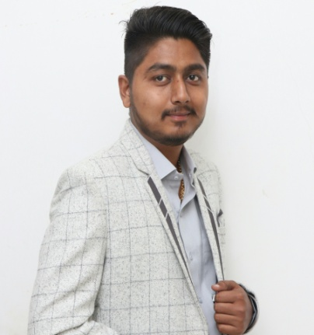
KARMRAJ

DUBAI- UAE
C/o-Mobile : +971 501685421
Email : karmraj.379093@2freemail.com

CAREER OBJECTIVE
AMechanicalengineer professional with1.5yearsexperienceintheindustrial project,seekingentrylevelassignmentsinEngineeringindustrywithareputedfirminUAE.

CAREER PROFILE
- Worked in industrial project in india as site engineer for installation of fire fighting systems. Successfully designed pipeline system for air, water and steam in ahmedabad india
- Well versed in wet pipe and dry pipe system installations,
- Well versed in project reporting, project estimation, site coordination, client meeting presentations and team supervision. Understand shop drawings, reveiw and check shop drawings and specifications
- Detailed quantity, BOM, invoicing, estimation, measurement of work, extra items with rate analysis and deviations etc.
- Excellent communication and administrative skills.
- Good work output in intense and load situation using time management and teamwork abilities.

PROFESSIONAL EXPERIENCE
July2016-jan.2018–Mechanical engineer.
Vishal fabrics ltd (Chiripal Group)-ahemdabad,Gujarat,India.

- Supervisingdaytodaysiteinstallationoperationsandsolvingproblemsarisedduringinstallationwork.
- Billingofmaterials,materialused,materialpurchasedandsendingreportstocontractoraboutdailyweeklyandmonthlyworkprogress
- MaintainingasystemofdocumentationformonitoringtheproductivityofteamsPreparingdailyweeklyandmonthlyworkprogressreporting
- Managing operations of a boiler, compressors, humidity plant, R.O. ,effullent treatment plant and organize staff of over 25 employees.
- Co-ordinate seniorengineers, production ,administration, staff and fitter-foremens.
- erection of new machining, pipelines,motors,pumps with my team and maintain all workers for that work.
- Recruiting and motivating staff and also learn from them.

EDUCATION QUALIFICATIONS

Qualification | Year | Institution
Becholer of engineering  Mechanical(6.53 CGPA) | 2012-2016 | Government engineering collage,Bhuj.
H.S.C  (74%) | 2011-2012 | Sardar padel vidhyalaya,surendranagar.
S.S.C(79.85%) | 2009-2010 | Saraswati vidhyalaya,dholka.

COMPUTER SKILLS
- I can work on operating systems like Win 8, Win 7, Win XP, 2000 ,98 and also MS office.
- I also known Auto cad 2D & 3D.
OTHER SKILLS
- Excellent interpersonal and communication skills
- Multi-tasking abilities with proficiency in organizing and managing different tasks
- Expert knowledge of handlingshift and paperwork.
- Skilled in maitaining a plant and preparing daily reports.
- Proficient in assigning duties and scheduling shifts.
- Excellent problem solving skills.
- Continuous learner and highly adaptable in quickly changing technical environments with very strong organizational and analytical skills.
- Extensive knowledge of technology terms and developments.
- Goal oriented and ability to work under pressure.

LANGUAGES
- English - Excellent reading, writing and speaking
- Hindi -Excellent reading, writing and speaking
- Gujarati - Excellent reading, writing and speaking
HOBBIES & INTERESTS
- Dancing
- Traveling
- Listening music
- Cricket

PERSONAL INFORMATION

1. | DATEOFBIRTH | 4thMay1995
2. | MARTIALSTATUS | Single
3. | NATIONALITY | Indian
4. | VISASTATUS | Visit

DECLARATION
- I consider myself familiar with Mechanical Engineering Aspects. I am also confident of my ability to work in a team.I hereby declare that the information furnished above is true to the best of my knowledge.

Hoping for the favourable reply.

