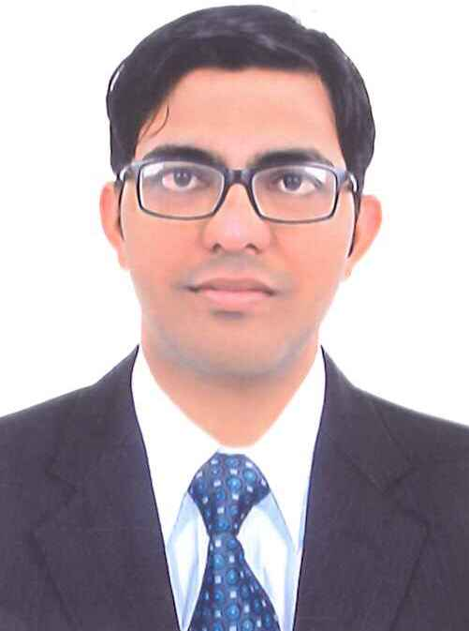
Rajnikumar
Dubai UAE
Mobile: C/o 0505891826
Email: rajnikumar.379110@2freemail.com

OBJECTIVE

My mission in life is to work hard, smart and continue on the growth path of mental social & economical development while being honest & committed.

EDUCATIONAL ATTAINMENT

- Bachelor of Education from Gujarat University, India in 2013
- Bachelor of Arts from Gujarat University, India in 2010

Computer knowledge:
- Ms Office – Ms Word, Ms Excel, Ms PowerPoint.
- Internet Browsing & Emailing

WORK EXPERIENCE

- Presently working as a Sales Executive in Popley Jewelers, Dubai – U.A.E, from June 2016 to till date.

Duties and Responsibilities:
- Welcoming customers by greeting them, answering or referring in queries.
- Showing and demonstrating the various feature of the jewelry to the customers.
- Managing sales of Gold & Diamond Jeweler.
- Listening to customer requirements and presenting appropriately to make sales.
- Checking quantities of goods on display in stock.
- Recording sales and order information and sending copies to the sales office or entering into a computer system.
- Take the order of customize jewelry by customer preference
- Read the rapport jewelry by customer preference.
- Reviewing own sales performance, aiming to meet or exceed targets.
- Maintain good relationship with customer and make them regular customer by good customer services.

- Worked as a Sales & Marketing in Idea Cellular Pvt. Ltd. Ahmadabad, India from 2013 to 2016

Duties and Responsibilities:
- Receiving and counting cash at the beginners of shift
- Always smile when handling customer to make good relationship and impression for the customer services.
- Receive order and provide services.
- Being with customer by telephone Fax, and email
- Responding with customer
- Plan and monitor storage delivery
- Listening with all customers.
- Lead a meeting program a team leader
- Visit the customer and monitor the quality of service that they receive from the company
- Send out information to customers the price catalogs and forms visit customer in near office, hotels, room to make site.

- Worked as a Luggage Trolley Dept. in Ahmadabad Airport, India from 2011 to 2013

Duties and Responsibilities
- Load luggage on to convince in the air house hall
- Collect and short and check luggage against flight
- Transfer luggage from the check in areas to the departure
- Check security sticker of the baggage’s security gate as per the destination

SKILLS
- Flexible, adaptive & self – Motive
- Excellent interpersonal relationship
- Vision of achieving goals
- Sincere, honest and hard working
- Creative and challenging
- Processional sales approach

PERSONAL DETAILS
Name : Rajnikumar
Date of Birth : 24/12/1989
Gender : Male
Nationality : Indian
Marital Status : Single
Language Known : English, Hindi & Gujarati
DECLARATION

All information given above is true and correct to my best and sincere knowledge and have not been overstated, reference will be provided upon request.

Place: Dubai U.A.E Rajnikumar

