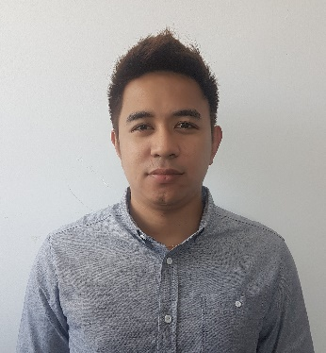
Richard
C/o- Mobile: +971502360357
Email: Richard.379152@2freemail.com ________________________________________________________________________
Willing to work in a dynamic, challenging and growth oriented company that allows me to utilize my knowledge and experience to contribute for the growth of organization. Skills/qualification includes.
- Time management skills
- Ability to work with minimal supervision
- Advance MS office skills
- Administrative writing skills
- Confidentiality
- Handle sales and Financing
- Typing skills

Education
Computer Hardware Servicing NCII
FL. Vargas College, Philippines
March 2010 (Graduated)

Professional Experience
Willy and Sons Corporation Tuguegarao
Branch Development Officer (BDO)/Manager 2016 - 2017 May
Philippines

Responsibility:
- Direct all operational aspects including distribution operations, customer service, human resources, administration and sales
- Meet goals and metrics.
- Manage budget and allocate funds appropriately.
- Bring out the best of branch’s personnel by providing training, coaching, development and motivation.
- Share knowledge with other branches and headquarters on effective practices, competitive intelligence, business opportunities and needs.
- Address customer and employee satisfaction issues promptly.
- Adhere to high ethical standards, and comply with all regulations/applicable laws.
- Network to improve the presence and reputation of the branch and company.
- Stay abreast of competing markets and provide reports on market movement and penetration.

Willy and Sons Corporation Tuguegarao
Computer Specialist / Technical Support 2010 - 2016 March
Philippines

Responsibility:
- Provide technical support, advice, and assistance to consumers and businesses with technical, hardware, and software system problems.
- Specialists generally deal directly with end users and must effectively communicate answers in a way they can understand.
- Modify, install, clean, and repair computer software and hardware.
- Test and evaluate existing network systems.
- Perform regular maintenance to ensure that networks operate correctly
- Troubleshoot local area networks (LANs), wide area networks (WANs), and Internet systems.
- Provide assistance to the organization’s computer users through phone, email, or in-person visits.
- Train users to work with new computer hardware or software, such as printers, word-processing software, and email

Technical Skills
- Microsoft Office
- Internet accessing
- Computer Hardware/Software Troubleshoots
- Install Computer System & Networks

Eligibility
NATIONAL TECHNICAL CERTIFICATE -Computer Hardware Servicing

Personal Data
Birth date: March, 1991
Language: English, Tagalog
Visa Status: Visit Visa-
Age: 27

