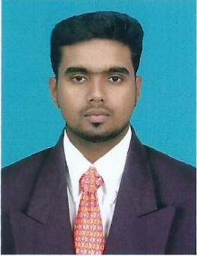
CURRICULUM VITAE

RAKESH.
E-Mail: rakesh.379191@2freemail.com
C/o-M-No.: +971502360357

Objective

To work in a challenging environment where my skills and knowledge are
Utilizing for the growth of the organization.

Educational qualification
- I.T.I (NCVT) Year:- 2011-2012
Govt.ITI,(Computer Operating and Programming Assistant)64%
Coimbatore-29.
- INFORMATION & COMMUNICATION TECHNOLOGH
- V.H.S.SYear:- 2008-2010 65%
Govt.Vocational High Secondary School.(Office Secretaryship)
- S.S.L.C
Govt.Hr.Sec. School, Kumaranellur Year: -2008 65%

technical skill
- CCTV Installation ,Configuration and Maintenance
- COAX 2+1 & 3+1, cat5e, cat6e cable management
- Camera I/O Configuration,
- NVR & DVR COMS Configuration.
- Basic AUTO CADD Drawing
- Camera Control and Managing through VMS software
- Crimping, punching modules and Terminating.
- Prepared purchase request of CCTV materials.
- Assured that all CCTV in the facility were running in good working conditions.
- Repaired CCTV cameras on site.
- Installed application software for Access System and NVR & DVR System.
- Learned new software programs and network systems.
- Computer Hardware and Networking.
- Operating System: WindowsXP, 7,8,8,10&still,Windows Server -2003 ,2008 Linux -5,6.

working experience
- BENTELY SECURITY & EQUIPMENTT TRADING LLC,
DUBAI (26-09-2016 and Still Working)
- Prepared purchase request of CCTV materials.
- Assisted on CCTV monitoring of events inside buildings and perimeter areas.
- Assured that all CCTV in the facility were running in good working conditions.
- Repaired CCTV cameras on site.
- Installed application software for Access System and DVR System.
- IT Support and CCTV Installation and maintenance.
- AD SYSTEMS, Coimbatore, India (12-10-2012 to 14-03-2015)
- Laptop & Desktop Hardware And Networking
- Operating systems: windows XP /vista/windows7/8 and still, LINUX.
- Back and recovery management
- Troubleshoots and resolves software hardware, windows- based operating systems and networking problems.
- Handling problems.
- Installation and configuration of network and local printers

key strength
- Willingness to learn
- Adapt to any situation
- Efficient with achievement working
- Team sprit
- Tem work
- Man power controlling with motivation ability
- Comprehensive Problem Solving Abilities
- Strong Positive Attitude

Personal profile
- DOB : 21.10.1992
- Gender : Male
- Nationality : Indian
- Religion : Hindu
- Marital status : Single
- Languages : English, Hindi, Malayalam & Tamil (read, write, speak)
- Blood group : A^{+Ve}
- Hobbies : Gym, Play &Hearing music Instruments, Reading books,

declaration,
I declare that the details furnished in this resume are true to the best of my knowledge.

