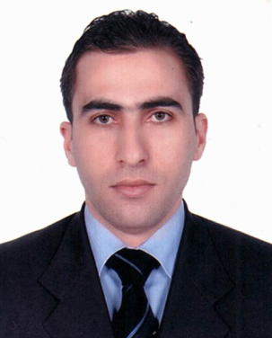
SABER
C/o-Mobile number: +971503718643
Email address: saber.379193@2freemail.com

OBJECTIVES:

I am keen competitor who always seeks new challenges for himself and likes to create valuable and unique offering for the customers. I am looking for an environment that enables me to grow both professional and personal by using my skills and knowledge. An experienced chef is looking for a job in a medium to large hotel and restaurant, willing to put culinary experience gained through years of hard work to good to use and bringing integrity, professionalism hospitality services. Offering dedicated culinary services record along with profound understanding of patients’ nutritional needs

WORK EXPERIENCE:

Company: Atlantis the Palm Dubai
Duration: May 19, 2013 to September 2017
Position: Chef De Partei

Company: Radisson Blu Hotel
Duration: April 25,2011 to April 25,2013
Position: Demi Chef

Company: Al sondos Suite by Le Meridian UAE, Dubai
Duration: October 1, 2009 to February 5 ,2011
Position: Chef de Partei

Company: Le Meridian Airport UAE,Dubai
Duration: June 1,2008 to September 5, 1 2009
Position: Comme one

Company: Movenpick , Al aqaba, Amman,Jordan
Duration: November 3, 2006 to January 5, 2008
Position: Comme one

Company: Cora Pay Hotel Amman, Jordan
Duration: April 3, 2006 to September 30, 2006
Position: Comme two

Company: Fanar Palace Hotel, Amman, Jordan
Duration: August 16, 2005 to March 30, 2006
Position: Comme two

Company: Toledo Hotel Amman, Jordan
Duration: April 9, 2004 to May 16, 2005
Position: Comme three

Company: Jerusalem International Hotel Amman
Duration: October 2002 to April 2004
Position: Trainee, Cooker assistant

DUTIES AND RESPONSIBILITIES:

- Learn different procedures of food preparation
- Assist in operating commercial cooking equipment such as stoves, cookers, ovens and fryers
- Set up food stations by following chef’s orders
- Maintain a clean as you go work ethic
- Prepare ingredients for dishes upon the instructions of chefs
- Responsible for high standards of food hygiene, health and safety
- Being public relations
- Ensuring the appropriate levels of hygiene and cleanliness are maintained in the kitchen
- Planning menus
- Estimate food requirements and maintain quality assurance on various dishes
- Oversee kitchen workers
- Recruiting, training and supervising junior staff
- Hiring staff
- Balancing a restaurant book
- Highly skilled in cooking and preparing a variety of cuisines
- Exceptional ability to develop a well tuned pallet
- Adept at using kitchen tools and knifes

EDUCATIONAL BACKGROUND:

Certificate OF Food Production from Industrial Institute
Level: Professional Cooker
Work Duration: 2800 HR
Tawjihi High School

SKILLSS:

- Basic in Computer
- Time Management
- Good Communication Skills
- Interpersonal Skill
- Able to lead and motivate a big team
- Proficient in resolving conflicts.

About Me:

- I am willing to improve my productivity and to make sure the best quality of service
- Cope with pressure
- Have a sweet sense of humor
- Have a desire to get more feedback

PERSONAL DATA:

Gender : Male
Date of birth : May 25, 1983
Place of birth : Amman, Jordan
Marital status : Single
Religion : Muslim

LANGUAGES:

- English (mother language)
- Arabic (very good)

REFERENCES:

Available upon request

SABER

