PERSONAL INFORMATION | Mayur
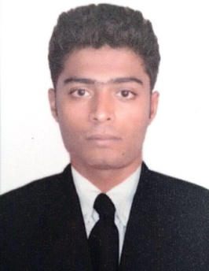 | Email: mayor.379194@2freemail.com  C/o-Mobile: +971505891826
 | Sex: Male | Date of birth:05-11-1993| Nationality:Indian
CURRICULUM VITAE

WORK EXPERIENCE

Sales ConsultantJuly 2016 -November 2017
Sharayu Toyota, Cortalim-Goa (India)

Key Responsibilities:
- Advice customers on buying cars most suited to their preference and budget.
- Check with customers, after sales to ensure satisfaction.
- Proficiently complete and submit all required documentation.
EDUCATIONAL QALIFICATION

 | Professional Diploma in Logistics and Shipping | July 2015- March2016
 | Indian Institute of Logistics (IILS), Chennai
 | Courses completed: International Business Management, Fundamentals of Logistics Introduction to shipping, Customs Procedures, Warehousing& Inventory Management,Transportation & Distribution Management, Stevedoring / Freight Forwarding & Port Operations, Liner Trade.
 | H.S.S.C (Science Stream)  Shiroda Higher Secondary School, Shiroda-Goa  Goa Board of Secondary and Higher Secondary Education  S.S.C  Shri Kamakshi High School, Shiroda-Goa  Goa Board of Secondary and Higher Secondary Education | May2012  Second Class  May 2009  Second Class

TRAINING AND INTERNSHIPS
- 3 months internship in logistics and shipping (Jan 2016 -March 2016)
Seaworld shipping and logistics Pvt Ltd, Goa
IGM and EGM updating, preparation of container and port passes, documents approval like D/O release, Export B/L release, Export telex release, Maintaining records of import-export documents, container master, container landing permit (CLP),T.P in Customs.

PERSONAL SKILLS  Mother tongue: | - Konkani
Other languages:  Core Competencies: | - English (Fluent), Hindi (Fluent), Marathi (Fluent)  - Good communication skills  - Good interpersonal skills and team player.  - Proficient with Sales and Marketing  - Result oriented
Computer skills: | - Good knowledge of all versions of Windows, MS Word, MS Excel and PowerPoint.  - 6 Months Certificatecourse in‘Diploma in office management’

ACIEVEMENTS AND AWARDS

- Participated and won several athletics competitions at Taluka and State level.
- 1st place in All Goa Handball competition (2012).
- Won 1st place on many occasions in running competitions since school level.

Declaration:

“I hereby declare that the above information is true to the best of my knowledge.”

