CURRICULUM VITAE
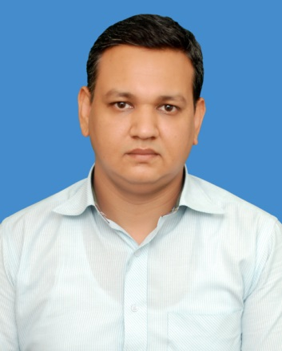
Ghaffar
E-mail: ghaffar.379208@2freemail.com
Cell # C/o 0501685421
Faisalabad, Pakistan

Professional Objective ____________________________________________

To pursue a career in an organization that offers challenge, recognition and opportunity to grow as a Professional Agricultural advisor and to exercise my skills in a challenging work environment. Seeking a challenging career, that enriches my knowledge and gives me a chance to be part of a team that contributes towards the growth of the organization. There by yielding the twin benefits of job satisfaction and convenient professional growth in a challenging and growth oriented environment which commensurate my professional and personal skills, helping me excel in my field of excellence.

I believe that I am more efficient when working under pressure and get things done fast and affectively. I also find working with people from different cultures and at corporate levels a challenge and it inspires me to do my best in my daily duties.

Education__________________________________________________________
Degree | Year | Institute Name | CGPA/ Percentage
MBA (Executive) | 2015 | COMSATS Institute of Information Technology Islamabad, Pakistan | 3.03
DVM (Hons.) | 2003 | University of Agriculture Faisalabad, Pakistan | 2.60
Intermediate (Pre-Medical) | 1999 | B.I.S.E Faisalabad ,Pakistan | 63%
Matriculation (Science Group) | 1997 | B.I.S.E Faisalabad ,Pakistan | 81%

Certification_______________________________________________________
- Diploma in Dairy Management Reaseheath College UK

- Diploma in Livestock & Dairy Management

- English Language Course

Work Experience___________________________________________________
- Technical Sales Manager (TSM) job in Veterinary Pharmaceutical Company SANNA Labs Pakistan Ltd. for 1 year.
- Agricultural Services Provider (ASP) job in Nestle Pakistan Ltd. for 1 year.
- Agricultural Services Executive (ASE) job in Nestle Pakistan Ltd. for 1 year.
- Agricultural Services Area Manager (ASAM) job in Nestle Pakistan Ltd. for 2 year.
- Large Farm Development Manager (LFDM) job in Nestle Pakistan Ltd. for 2 year.
- Senior Dairy Development Advisor (SDDA) job in Nestle Pakistan Ltd. for 2 year.
- Dairy Development Manager (DDM) job in Nestle Pakistan Ltd. for 3 year.
- Assistant Agricultural Sustainable Manager (AASM) job in Nestle Pakistan Ltd. for 1 year.

Projects___________________________________________________________
- Large Farms Development Project in 2010
- Commercial Dairy Farmers Development in 2013
- Water Saving Project in Dairy Sector in 2016
- Compliant Animals Feed & International Financing Company Project 2016

Technical Skills_____________________________________________________
- Good written & oral communication skills in both English & Urdu.
- Command in Windows Application & MS Office.
- Command in Web Browsing.

Personal Information________________________________________________
Date of Birth 02-Feburary-1982
Marital Status Married
Religion Islam

