Abdus

Abdus.379214@2freemail.com

COVER LETTER

Respected Sir,

“I am writing to outline of my excellent academic background and the skills, knowledge and experience that I have gained as a result. I believe that these will make me the ideal candidate for this job. The one of the best thing about myself that I will of course give benefit to organization after joining because I am a responsible person about my work. I use to complete tasks before given time that are assigned to me.
I am now looking to secure a challenging and rewarding role with you and I believe that these skills, together with my knowledge and expertise, would make me an asset within your organization, and I will work hard if you give me this opportunity.

Yours Faithfully,

Abdus
C/o 0502360357
Abdus

Cell No. C/o 0502360357
Email Id: abdus.379214@2freemail.com

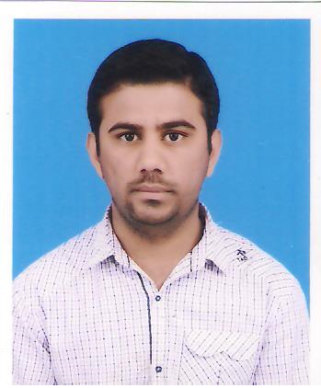
______________________________________________________________________________________

Objective
To join an organization with encouraging working environment towards achieving organization’s goal.

______________________________________________________________________________________
______________________________________________________________________________________

Personal

Domicile Certificate: Lahore, Punjab
Date of Birth: 10 February, 1995.
Nationality: Pakistani
Marital Status: Single
______________________________________________________________________________________

Scholastics

- BS Software Engineering (2013 – 2017)
University of Gujrat, Sub Campus Lahore;
Obtained Marks: 3.45/4.00

- F.Sc. – Pre Engineering (2010 – 2012)
Garrison Post Graduate College for Men, Lahore Cantt.
Major Subjects: Physics, Chemistry, Maths.

Obtained Marks: 823/1100

- Matriculation (2008 – 2010)
F.G Abid Majeed High School R.A Bazar Lahore Cantt, Lahore.

Major Subjects:Physics, Chemistry, Maths, Biology.

Obtained Marks: 818/1050

______________________________________________________________________________________

Technical Skill Set

- WordPress
- Web Programming Skills:
PHP,
ASP.Net,
HTML 5, CSS3,
Bootstrap,

- Command on MS office:

- Computer Operating:

______________________________________________________________________________________

Experience

- Teaching Experience: O level (Mathematics) ,
Matric, F.Sc (Computer, Mathematics) 2year experience
- Computer Operator & Data Entry 1.5 year Experience

______________________________________________________________________________________

Academic Projects

- Design and Implementation of “Library Management System” using UML Tools and Techniques and C++ Language Support.
- Implementation of “Chat Messenger” using C++ and SFML Library for Networking using LAN and TCP/IP Protocol.
- Database Design and Implementation of “Airline Ticket Reservation System” using Visual Basic
- Implementation of website of College Management system using PHP, AJAX, JQUERY, HTML, CSS, JavaScript, Bootstrap
______________________________________________________________________________________

Final Year Project: “Candidate Evolution Support Engine”

Tools Used: Notepad ++, Xampp,
Languages: HTML5, CSS, PHP, JAVA, Jquery
______________________________________________________________________________________

Awards and Honors

- Laptop awarded on merit Base by Prime Minister Laptop Distribution Scheme in Pakistan

______________________________________________________________________________________

References

- More available on demand

