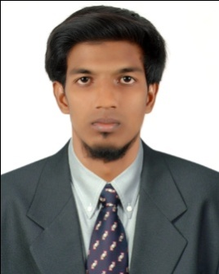
ARSHATH
Electrical & Electronics Engineer
Email : arshath.379233@2freemail.com
C/o-Mobile : +971501685421
Place : Dubai-UAE

Objective:

To associate myself with an organization that has the potential for future growth and explored my technical knowledge in the power projects. I would be able to deliver the best of my knowledge and utilize the skills and implement and contribute towards the betterment of organization.

Work Experience:
Project Management Services - Electrical Site Engineer
    - Chennai, India
    - June 2016 – December 2017
Roles:
- Implemented design drawings on site.
- Estimates, prepares and assigns the resources such as manpower, materials, consumables, equipment, tools, etc., required for all electrical and related works prior to execution.
- Interprets construction drawings and studies the contract documents and applicable standards or specifications prior to execution of any jobs.
- Manages directly and provide engineering and technical supports to all the electrical work groups at site.
- Plans the execution of all electrical related works and coordinates the works to mechanical and civil groups.
- Assign targets for accomplishments and ensure targets are met on daily basis for all electrical groups at site.
- Managed, supervised and lead the team of Technicians, Contractors and Organized materials at site.
- Maintained Documents, Drawings & other records clearly.
- Prepared Project Reports.
- Ensuring that all materials used and work performed are as per specification.
.
Professional and Educational Qualification:

Bachelor of Engineering – Electrical and Electronics Engineering.

Dhaanish Ahmed College of Engineering (Anna University, Chennai).

Year of completion – 2016.

Certifications:

  - Testing and Commissioning Of Electrical Equipment at Electrical Expert Engineer Testing And Commissioning (EEETC), Chennai (Year-2016).

Additional Skills:

  - To understand the electrical designs from AUTOCAD.
  - Skills such as MS Word,Excel,PowerPoint.

Personality Traits:
    - Quick learner, resourceful and productive.
    - Team player with good sense of humor.
    - Optimistic with “CAN DO” spirit.
    - Possess good leadership quality.
    - Adaptable to new technology at fast pace.
    - Eager to explore and learn.
    - Willing to take responsibilities.
    - Positive Thinking.

Personal Details:
D.O.B : 29-01-1994
Marital Status : Single
Nationality : Indian
Languages known : English & Tamil
Visa Status : Visit visa

Declaration:

I consider myself familiar with Electrical & Electronics Engineering aspects. I am also confident in my ability to work in a team. I do hereby declare that the information furnished above is true to the best of my knowledge and belief.

Yours Sincerely,
(ARSHATH)

