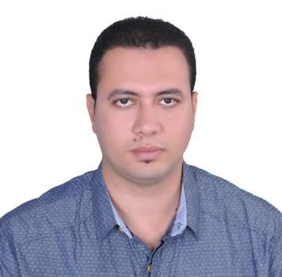
Amr
Project Engineer

Email Address:
Amr.379235@2freemail.com

TARGET JOB :

TARGET JOB LOCATION | Emirate; Bahrain; Kuwait; Qatar; Saudi Arabia
CAREER OBJECTIVE | Seeking a Position of a Civil Engineer where my
 | Analytical and Interpersonal skills could be used
 | for the benefit of the organization.
TARGET INDUSTRY | Construction/Civil Engineering
EMPLOYMENT TYPE | Employee
EMPLOYMENT STATUS | Full time

PERSONAL INFORMATION:

 | BIRTH DATE | 2 February 1985
 | GENDER | Male
 | NATIONALITY | Egyptian
 | VISA STATUS | Visiting Visa
 | RESIDENCE LOCATION | Emirate-Ajman
 | MARITAL STATUS | Married
 | DRIVING LICENSE ISSUED FROM | Egypt

OBJECTIVE:

I am a competent and proficient Civil Engineer with special interest in construction sector. Having always been the kind of person to ask how and why, I am very passionate about the built environment around us.

- Friendly and helpful.

- Highly organized.

- Sensible and practical.

- Good geographical knowledge.

- Analytical thinker.

- Calm under pressure.

- Flexible.

- Hard worker.

EDUCATION & QUALIFICATION :

BACHELOR OF CIVIL ENGINEER | Kafr El Sheikh University (May 2010)
GRADUATE PROJECT | Properties and testing material ( Fiber concrete )

PREVIOUS EXPERIENCE :

JAN 2017 TILL NOW | EGYPT (EMAAR AL BARAJ).TELE: +201025844495
As a Project Engineer Burj Al Arab Alexandrea
Several residential Facilities (B+G+3)
The Clint: Burj Al Arab New Urban Communities
The Consultant: Al Etihad Design & Consult
JAN 2015 TILL SEPTAMBER 2016 | EMIRATES DUBAI (TEAM ENGINEERING
As a project Engineer for Bentley Showroom in | ENTERPRISES) P.O.BOX.3963.
Umushef jumeirah (3B+G+2).
The Clint: AL HABTOOR MOTORS CO. (L.L.C.)
The consultant: ENG. ADNAN SAFFARINI.
MARCH 2012 TILL JULY 2014 | LIBYA (GARCO) EMAIL:
As a project Engineer for a project that repairing 12 | JAWHARET.ALRAI@YAHOO.COM.
water ground tanks.
The Clint: Ministry of Defense.
The consultant: Al Hindaz Design, Supervision &
Consult.
APRIL 2011 TILL JANNUARY 2012 | SAUDI ARIBIA (AL FAHD).
 | P.O.BOX (354) ENIZAH (51911).
As a Site Engineer for a several Residential
Facilities (G+6)
The Clint: The Affairs of the Buildings.
The Consultant: El Hamidi For Designing &
consulting.
JUNE 2010 TILL MARCH 2011 | EGYPT (DAR AL BINAA).
 | TELE: +201018819092.
As a Site Engineer for a several Residential
Facilities 3 Towers (2B+14).
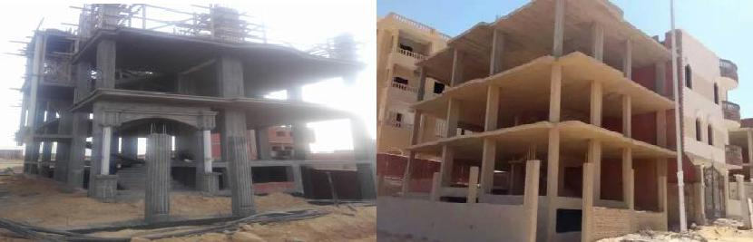
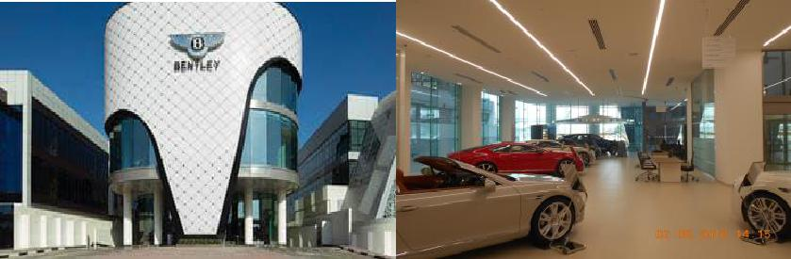
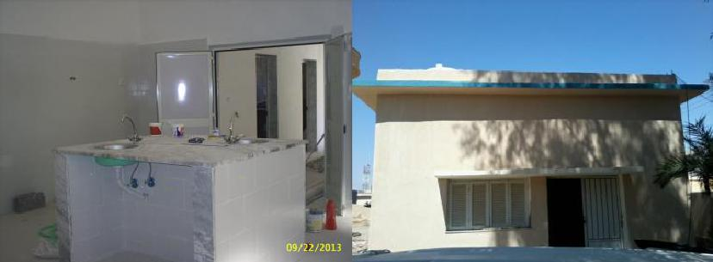
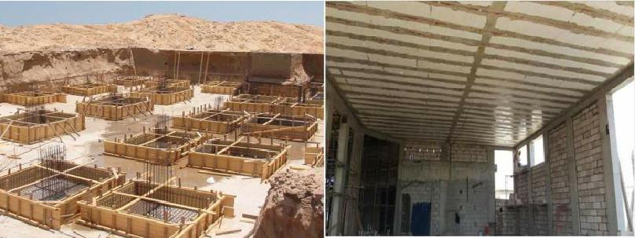
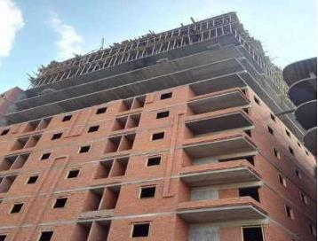

DUTIE AND RESPONSIBILITIES:

- Assist / reporting to project manager & construction manager

- Reviews structural /architectural drawings, bills of quantities, specifications and clarify the differences among them in coordination with architect engineer.
- Prepare, review and distribute RFIs. Maintain RFI Log.

- Co-ordinate with construction manager in analyzing and resolving field construction issues.

- Day-to-day management of the site in coordination with the site engineer and carrying out the required inspection with consultant.
- Provide and assists the site engineer and project holders in Technical issues.

- Direct Draftsman for preparing the required shop drawing in coordination with architect engineer.

- Overseeing the performance of sub-contractors.

- Overseeing the work done by the sub-contractors.

- Arranging weekly site meeting with the sub-contractors.

- Maintains project schedule by monitoring project progress; coordinating activities; resolving problems in coordination with construction manager.
- Ensuring that the project activities is completed within a specified time.

- Inspect/verify material deliveries.

- Contact with material testing laboratory to insure specifications are maintained

- Ensure company procedures and standards are maintained

- Contact with material testing laboratory to insure specifications are maintained in coordination with QA/QC engineer.
- Other duties assigned

COMPUTER SKILLS
• | AutoCAD 2018 | Excellent
• | SAP 2000 | Very good
• MS Office 2013 (excel, word) |  | Very good

LANGUAGE CAPABILITIES

•

Arabic

Excellent

•

English

V. good

