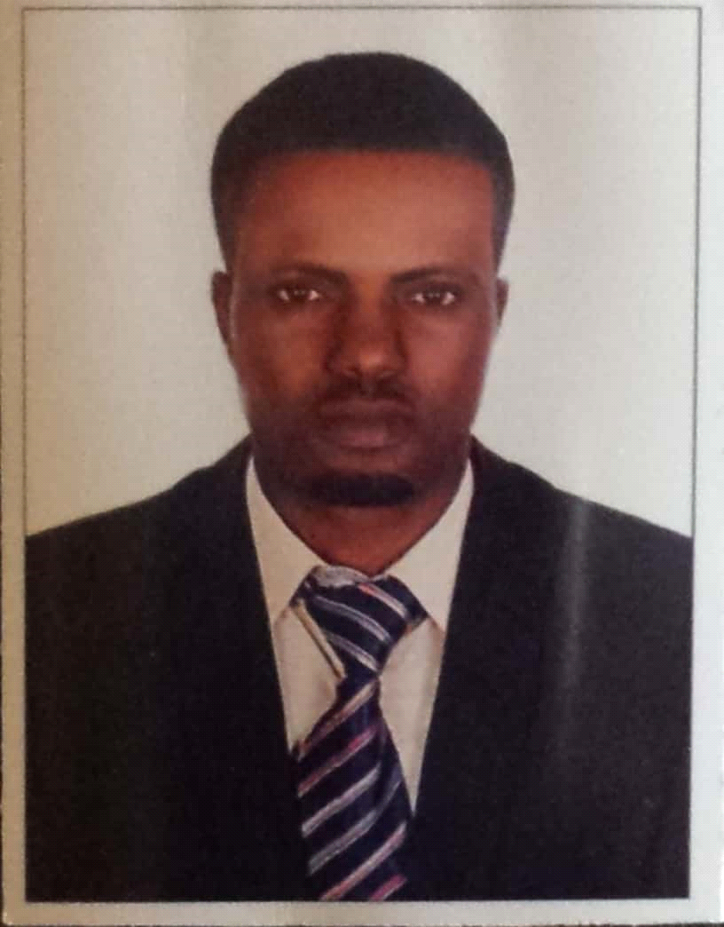
Curriculum vitae
MICHAEL
C/o-Tell: +971503718643
Email: Michael.379239@2freemail.com

PERSONAL DATA:

Date of Birth: 26th Octomber, 1984
Marital Status: Single
Sex: Male
Nationality: Nigerian
Religion: Christian

APPLICATION FOR A SECURITY GUARD POST

OBJECTIVE:
To work in an established and reputable company that recognizes loyalty, hard work and gives opportunity for personal development.

EDUCATIONAL INSTITUTIONS ATTENDED WITH DATES:
* SIRA ( Security Guard Training Course. Dubai ) PASSED 2017
* SAFER ( Basic Fire Safety Training Course. Dubai) PASSED 2017
* Quality, Health, Safety & Enforcement Internationa PASSED 2017 ( Fire Warden Training Course. Dubai
* SAFER ( Basic Life Support Training/ Security Guards ) PASSED 2017
* OLOFIN (ANGLICAN) GRAMMAR SCHOOL, IDANRE 1999-2005
(West African Examination Council)

* Olubusola International Nursery School 1990–1998
(First School Leaving Certificate)

WORKING EXPERIENCE WITH DATES:

- Godwill Security Company 2010–2012
Gbagi, Alakia, Oyo State
Post Held: Security

- Power Security Company 2013-2014
Ikorodu, Lagos State
Post Held: Security

- Easy Life Security Company 2014-2015
Sango Otta, Lagos
Post Held: Security

HOBBIES: Reading and Travelling

