SHAFEEL
FFICE ADMINISTRATOR
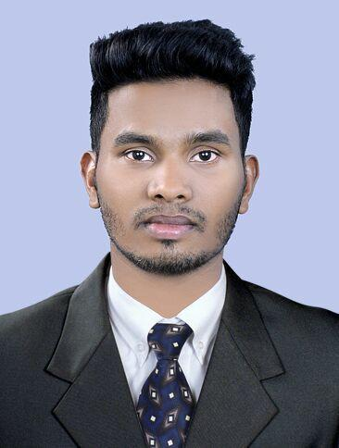

E-mail shafeel.379252@2freemail.com

C/o-Contact +971505891826

Deira-Dubai

CAREER OBJECTIVE

A challenging position in office administration/customer service with a progressive

Organization that values dedication, outstanding performance and offers potential for career growth

HIGHLIGHTS OF QUALIFICATIONS

- Extensive experience in office administration and customer service, in a wide range of challenging situations.

- Strong track record of delivering outstanding results.

- Proven ability designing, developing and managing office administration systems.

- Exceptional problem solving ability.

- Outstanding organizational and managerial skills.

- Enjoy fast paced, multi-task environments.

- Highly effective written and verbal communication skills; get along well with others.

- Highly motivated, results oriented, great attitude.

- Extensive experience in customer care and support in a diverse range of challenging situations.

- Excellent communications ability; active listener; bright and visually observant.

“Do what it takes to get the job done-with no excuses”

“A friendly and compassionate person naturally suited to customer care”

PROFESSIONAL EXPERIENCE

Office Administrator

Two years’ admin cum travel agent at Akbar Travels of India Pvt Ltd.

EDUCATION

Bachelor’s degree in Business Administration (University of Madras-2016)

Diploma in Travel and Tourism(IATA-2013)

Plus Two Computer Science (Higher Secondary Board Kerala-2008)

SSLC (Secondary Educational Board Kerala-2006)

DUTIES AND RESPONSIBILITIES

- Answering telephone calls and passing them on.
- Relying to email, telephone or face to face enquiries.
- Coordinating repairs to office equipment.

- Photocopying Carrying administrative duties such as filing, typing, copying, binding, scanning etc.
- Writing letters and emails on behalf of other office staff.

- Provide information to internal colleagues or external enquirers.
- Resolve administrative problems.
- Receiving, sorting and distributing the post.
- Greeting and assisting visitors to the office.
- Photo copying and printing out documents on behalf of other colleagues.
- Managing staff appointments
- Handling sensitive information in a confidential manner
- Covering the reception desk when required.

 | PERSONAL PROFILE
Date of Birth | 20/06/1990
Nationality | Indian
Religion | Islam
Gender | Male
Marital status | Single
Languages | English, Hindi and Malayalam
 | INTERESTS

- Football

- Travelling

- Music

- Spending with friends

- Spending with family

- Cricket

- Movies

- Puzzles

- Reading
DECLARATION

I hereby declare that information given above are true and correct to the best of my knowledge and belief.

SHAFEEL

