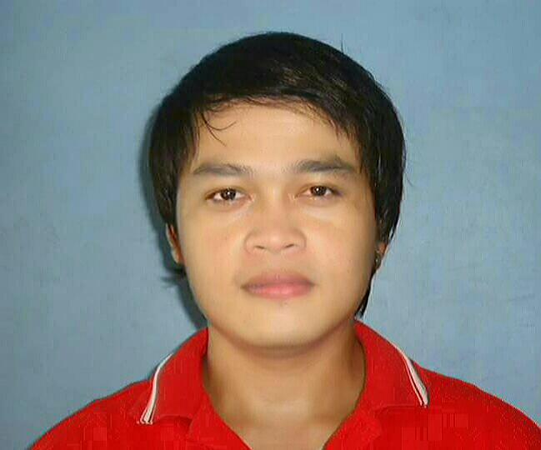
DOMANAIS
Domanais.379264@2freemail.com
C/o- +971505891826

Position applying for: Customer Service Representative/Biller/Call Center Agent
_____________________________________________________________________________________

JOB OBJECTIVE:
To be able to work and do my best job, one that is suited to my skills, talent and experience, and to be of service in my full ability for the benefit of my employer.

PERSONALDETAILS

Nationality:Filipino
Marital Status:Single
Visa Status:Visit Visa
Language:English / Tagalog

EDUCATIONAL BACKGROUND

Tertiary Far Eastern University 2003 - 2007
Nicanor Reyes St., Sampaloc Manila
Bachelor of Science in Nursing

Secondary The Sisters of Mary School 1997-2001
Bo. Biga, Silang, Cavite Philippines

Primary Gogon Elementary School 1991-1997
Gogon, Prieto-Diaz Sorsogon, Philippines

Vocational The Sisters of Mary School 1997-2001
Bo. Biga, Silang, Cavite

- Automotive Technology 350 hrs
- Computer Technology 150 hrs
- Mechanical Technology 500hrs

SKILLS
- Excellent Computer Knowledge
- Excellent Typing Skills
- Fluent in written and oral English communication

WORK EXPERIENCES

Customer Service Representative

IBEX Global Philippines
June, 2015 – April, 2017
Parañaque City, Philippines

- Create Snippets for clients’ services and productsand posted it online.

Teletech Philippines
March, 2013 – June, 2015
Mandaluyong City, Philippines

- Help customers resolve billing concerns, create new accounts, and set appointment for service issues.
- Assist customers on selecting best mobile plan.

Sitel Philippines
August, 2010 –March, 2013
Emerald Ave., Ortigas, Pasig City Philippines
- Assist and communicate with customers through chat
- Help customers decide on what package / service to order
- Assist customers in placing the order online

Transcom International
March, 2008 –September, 2010
Ortigas, Pasig City
- Process payment and resolve billing/service issues
- Assist customers in selecting services that best suits them
- Perform basic service trouble shooting steps and scheduled an appointment with the technician.

Teleperformance
September – December 2007
Shaw blvd., Mandaluyong City
- Assist queries from credit card holders
- Solve customer’s issues and concerns regarding monthly bills and payments
- Answer questions regarding credit card information
- Provide a hundred percent customer satisfaction

