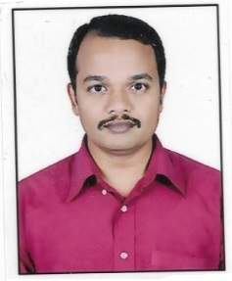
CURRICULUM VITAE

Raghavendra

C/o-MOBILE: +971501685421

EMAIL: raghavendra.379269@2freemail.com

SUMMARY
Professional Mechanical Engineer with experience in heating, ventilation and air conditioning (HVAC) design, construction and specification of commercial and residential buildings. Code compliance, ASHRAE compliance, and building performance compliance. Indoor air quality evaluations relating to HVAC, building envelope and environment. Forensic evaluations involving HVAC and refrigeration equipment and systems.
Coordination of all phases of HVAC projects from design through modeling. Including specifying equipment, calculating loads, ductwork and pipe sizing, selection of HVAC equipment including air handlers, pumps, chillers, cooling towers, exhaust fans and condensing units.
Possess in-depth knowledge of proposal and planning, detailed HVAC design as per ASHRAE Codes, HVAC load calculation, ventilation calculation, ducting and piping layout, developing drawings, issuing BOQ, equipment selection, site supervision, quality surveying, billing and verification, coordination & field engineering.

PROFESSIONAL EXPERIENCE
VEVRA Engineering & Consultants LLP, Bangalore. Dec-2016 to Present. (Current)
Professional HVAC Design Expert & MEP Coordinator: Responsible for HVAC design-builds ranging from large commercial new construction buildings to smaller tenant improvements. Design responsibilities included 3-D modeling of HVAC and plumbing systems, mechanical/ electrical/ plumbing plan coordination and conflict resolution, construction management, field coordination, and equipment selection. Also assisted in green building design compliant with LEED standards using building energy performance analysis software, increasing ventilation, indoor air quality needs, and reducing the use of hazardous refrigerants in building equipment.

DESAPEX Engineering & Consultants LLP, Bangalore. May-2015 to Dec-2016.
HVAC design engineer & design coordinator: Responsible for project conception, development, and final HVAC design for commercial, institutional, industrial & residential clients referring to the standards and codes. 3-D modeling of the design with imbibing the BIM model into it. Also included supervising the project design and coordination with clients, architects, vendors and contractors.

KLS’s VDRIT, Haliyal, JUL-2010 to May 2015.
Academics: Assistant. Professor, Dept of Mechanical Engg.

HCL Technologies, Bangalore. JUL-2007 to APR-2008
Design Engineer: Responsible for design & modeling of aircraft structural components using sophisticated cad/cam tools.

ARDC HAL, Bangalore. AUG-2005 to JUL-2007.
CAD Engineer: Responsible for design & modeling of aircraft structural components using sophisticated cad/cam tools. Drafting & detailing of the components for the purpose of production.

EDUCATION & TRAINING
- M.Tech in DESIGN ENGINEERING, (MECHANICAL ENGINEERING).
Vishveswaraiah Technological University, BELGAUM. Karnataka. (2010).
- B.E in INDUSTRIAL and PRODUCTION Engineering,
Vishveswaraiah Technological University, BELGAUM. Karnataka. (2005).
- Autodesk AU INDIA SAARC-2017 conference (2017)
- International Conference on Advances in Mechanical Engineering (2016).

OBJECTIVES
> To be associated with progressive organization that gives me the scope to implement my knowledge and expertise, also to involve as a part of the team to take up a challenging and rewarding career and excel in the field of design.
> To work in learning and challenging environment, utilizing my skills and knowledge to be the best of my abilities and contribute positively to my personal growth as well as growth of the organization.
> To build a challenging career with honesty and loyalty by translating my experience, knowledge, skills and abilities into value for an organization

EXECUTION
# Office building:
Software development building 10 floors, bangalore.
Software development building 6 floors, bangalore.
Role: Revit-HVAC modeling, BIM modeling, design of chiller plant layout & modeling, routing for ATCS, drafting & detailing.

# Factory building:
Food processing unit, 4 floors, bangalore.
Manufacturing of precision tools, 3 floors, bangalore.
Machining & processing, 2 floors, bangalore.
Role: Architecture modeling, Revit-HVAC design & modeling, coordination of MEPF, BOQ, drafting & detailing.

# Residential building:
Multipurpose residential, 4 floors, Pune.
Villa and cottage, UAE.
Role: Architecture modeling, Revit-HVAC design & modeling, coordination of MEPF, BOQ, drafting & detailing

RESPONSIBILITIES
> In detail study of layout plan provided by the client, equipment details, site related information and
Investigation report.
> Discussion with the client regarding project vision.
> Collecting the required data from Architect, Structural engineer Etc.
> Developing the Revit architectural model, as per the architectural drawing.
> Design of HVAC as per the location data & clients requirements referring the standards & codes.
> Incorporating the design into Revit HVAC model.
> Coordinating the model with other services i,e. MEPF.
> Verifying the coordinated model for clashes in NAVISWORKS & report generation.
> Drafting & detailing of the individual services.
> Listing of the BOQ.
> Reviewing the drawing for GFC

PERFORMANCE

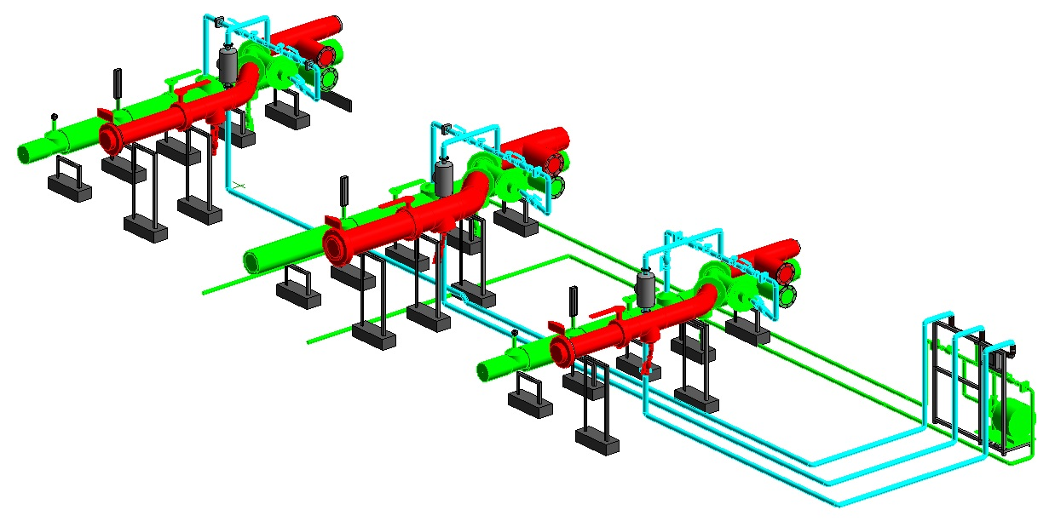

Routing of ATCS

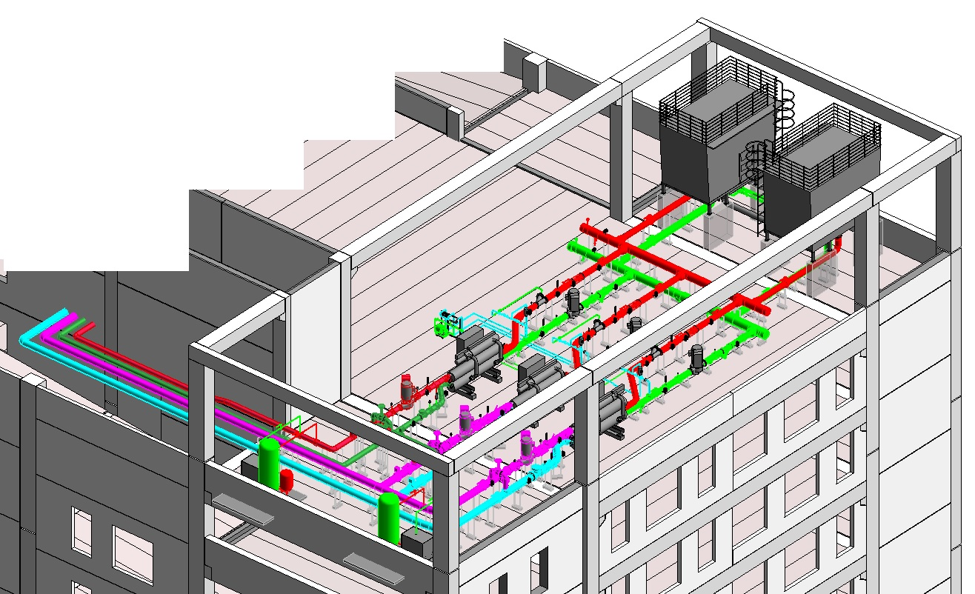

Design of chiller plant layout.

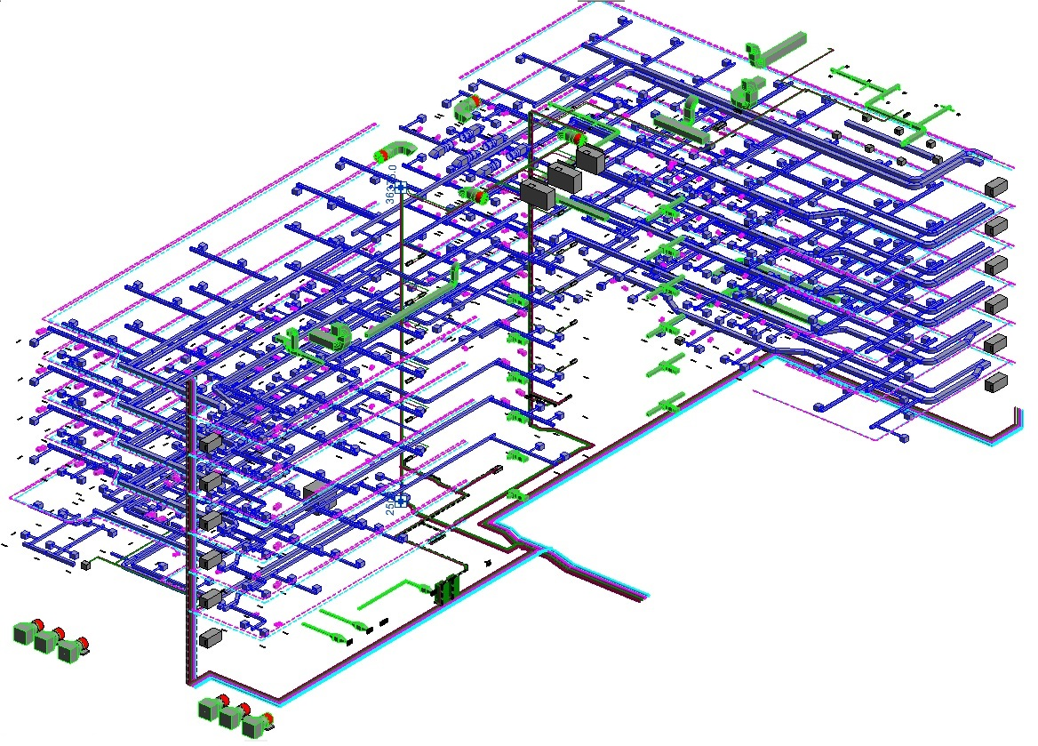

HVAC Model

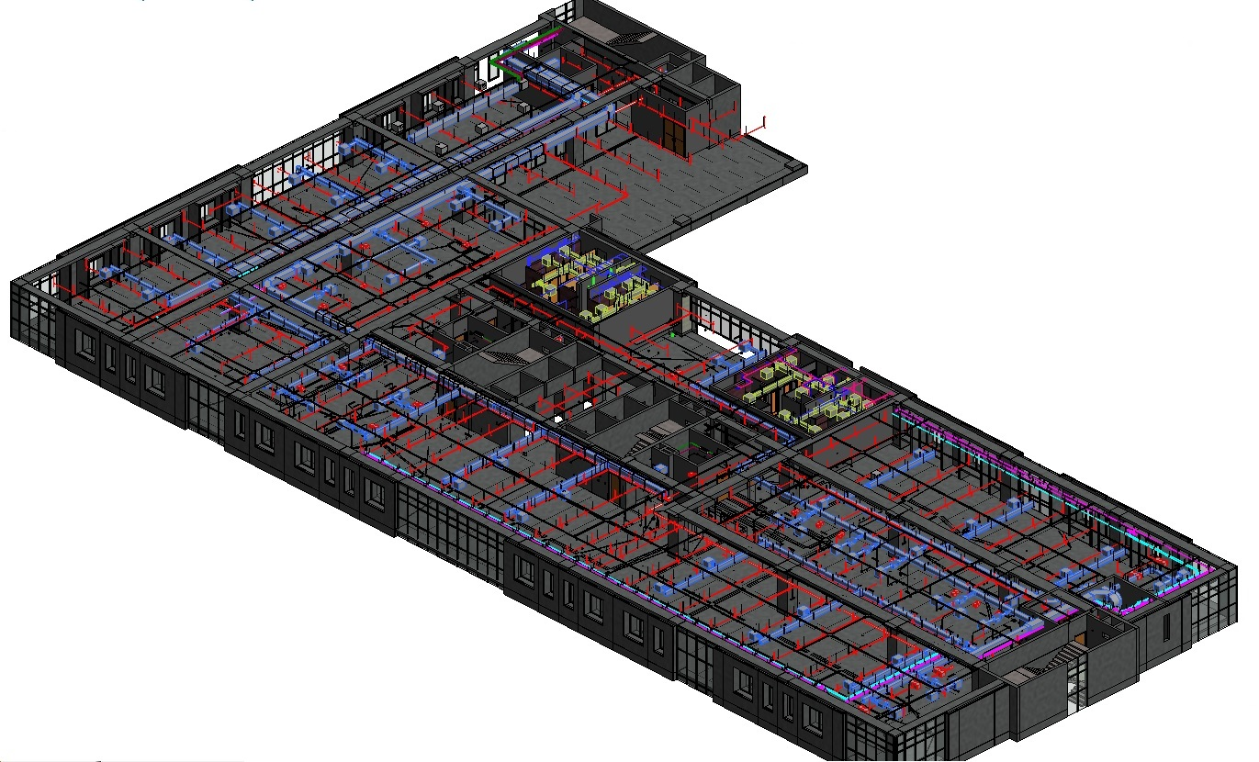

Coordination of the services

TECHNICAL SKILLS

* REVIT-2017
* Navisworks-2017
* Autocad-2017
* Ductsizer
* Pipesizer
* Ansys-12
* Microsoft office tools

GENERAL SKILLS

* Able to work well as team settings and independently.
* Excellent problem solving skills.
* Quality through hard work and dedication.
* Ability to learn and apply new ideas quickly.
* Great written and verbal communication skills.
* Planning & Execution.
PERSONAL DETAILS
Gender : Male
Marital Status : Married.
Nationality : Indian.
Languages :

Languages | Reed | Write | Speak | Fluency
English | √ | √ | √ | 95%
Hindi | √ | √ | √ | 98%
Kannada | √ | √ | √ | 99%
Marathi | √ | √ | √ | 99%
*Bahasa Malaysia | √ | -- | -- | 30%

Hobbies : Photography, Traveling, Driving, Riding, Adventure sports, Collecting information.

