MOHSEN

P R O J E C T S M A N A G E R , P M P ®

A R E A S O F E X P E R T I S E & S K I L L S
Projects Management Skills
Time Planning & Cost Control Skills Technical Office Skills
Site Supervision Skills

Project Manager With Background In Several Fields ( Projects Management , Technical Office , Planning & Site Supervision ) For Different Projects Scopes In Both Perspective Of Contractor & Consultant .

Aim To Have A Chance With A Leading Company Specially In Filed Of Projects Management

C O N T A C T
C E R T I F I C A T E S
PMP

PMI NO : 1903450

E D U C A T I O N

2011 Bsc Civil Engineering Fayoum University
-- Major : General Civil.
-- Graduation Grade : Good.
-- Graduation Project : Project Management Engineering .
-- Graduation Project Grade : Excellent.

Dubai, UAE

C/o 0501685421

Primavera

S O F T W A R E

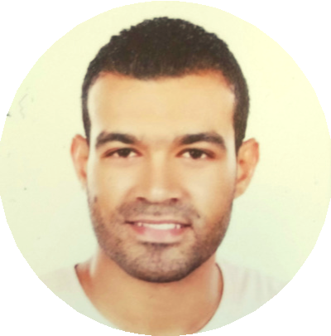mohsen.379282@2freemail.com

P E R S O N A L D A T A
Full Name:
Mohsen

Date Of Birth: 1-8-1989

Microsoft Office

Auto CAD 2D

Prezi

E X P E R I E N C E

Projects Manager AsBuilt Engineering Consultant 8/2016 TO 3/2018

As General Consulting :-
- Responsible For Directing And Coordinating The Different Projects That Our Bureau Has A General Consultant Role On It With Projects Managers , Planning Engineers And Cost Control Engineers.
- Guarantee Successful Communication Channel Between Sites , Owner Consultants , Stakeholders And Head Office.

As Management Consultant :-
Responsible Projects Manager Providing The Next For Our Clients

- Projects Time Management.
Prepare Client Projects Time Baselines , Updates and Requested Reports OR Direct and Control Client Planning Engineers.
- Projects Cost Management.
Prepare Client Projects Cost Baselines , Updates , Projects Or Bank Cash Flow and Requested Reports OR Direct and Control Client Cost Control Engineers.
- Projects Contract Administration Management.
Provide Contracts Control And Supervision Through Different Project Phases With Owners And Sub-Contractors For Our Client OR Direct and Control Client Contracts Engineers.
- Projects Procurement Management.
Supervise Client Procurement Engineers.
- Projects HR Management.
Supervise Client HR Department To Keep The Internal System On Track And To Be Sure That No Negative Reflection Will Happen On Projects Because Of HR System Error
- Projects Stakeholders Management.
Communicate With Projects Stakeholders During The Project Life Cycle To Keep Sure That All Requirements And Exceptions Needed Will Be Achieved

Technical Office Head Al Mohands Contracting 8-2013 / 8-2016

Joint Venture With Al-Hosam & Mahmoud El-Said Contracting For Technical Office Tasks in The Judge Men Club Association Towers , El-Fayoum City.
_Prepare Project Plan .
_Prepare All Required Shop Drawings.
_Prepare All Required B.O.Q & Invoices.
_Evaluate Sub-Contractors Proposals.
_Control Communications Throw The Project Between Main Contractor ,Sub-Contractors &Consultant .
_Monitor Work Tasks To Assure It Follows The Existing Plan & Quality Aspects

Planning & Site Engineer For Full Finished Buildings as a part of Youth Housing Project for The Organization Of Housing In Cairo
And Egyptian Steel Factory In Bni Swef

_ Site Supervision Tasks.
_ Develop Civil Works Required Schedules , Site Control Plans & Invoices.
_Monitor & Control Vendors and Sub-contractors Interactions To The Scheduled Work& Plans.
_Track Submittals For Shop Drawings & Materials With Consultants ,&Owners.
_Help In Keeping Work On Track Against Different Project Baselines ( Cost , Time Scope and Quality).
_Suggest Corrective And Preventive Actions If Needed .
_Arrange Project Resources To Gain More Benefits As Possible Against The Different Project Constrains.

Site Engineer Point Art Interior Design & Contracting 7-2012 / 7-2013

Sharm El Sheikh New Buses & Taxi Park.

_ Provide Supervision To Site Works ( Concrete Skeletons, Finish Works , landscape , etc…….) .
_Control Vendors and Sub-contractors
_Quantity Survey Works

Sharm El Sheikh New Traffic Police Station.

_ Provide Supervision To Site Works ( Concrete Skeletons, Finish Works , landscape , etc…….) .
_Control Vendors and Sub-contractors.
_Quantity Survey Works

Fayoum University Repair Works .

_ Provide Supervision To Site Works ( Repairing And Refinish Works )
_Control Vendors and Sub-contractors.
_Quantity Survey Works

Site Engineer Dar Amgad Contracting 9-2011 / 5-2012

_ Provide Supervision To Site Works ( Repairing And Refinish Works )
_Control Vendors and Sub-contractors.
_Quantity Survey Works

