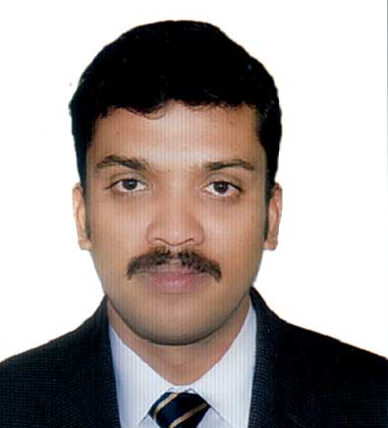 |  | SHYJU  (Administration / Accounting Executive)
 |  | Seeking a creative, challenging and growth oriented career to enhance my skills and excel it by hard work and determination. Looking forward a position that involves challenging projects with scope to contribute.
CMOBILE  +971 505891826  Email address:  Shyju.379289@2freemail.com |  | PROFILE SUMMARY
Highly positive, motivated, self – driven, technically proficient professional who combines excellent skills in Administration / Accounting with capability of perfect Clerical works.

Total Experience of 11 years, 10 years of experience in Saudi Arabia and 1 year of Indian experience.

SKILLS

- Interaction with teams | - Travel Arrangement Matters
- E-filing System | - Good communication skills
- Document Controls Archives | - Preparation of Various Reports
- Advance user of MS Office | - Invoicing /Billing
- Preparation of various Reports | - Expense management
- Purchase order creation,  - Invoice creation | - Factory/Office coordination  - Payment follow up
- Proficiency in computer, ability in various online flat forms and systems
- Strong attention to deadlines and priorities and ability to handle multi task

MAJOR JOB PROFILES

Service/Customer support :
- Purchase order creation, invoice creation, vendor creation
- Payment follow up, supplier follow up
- Project management, material collection,
Office activities:
- Manage electronics filing (E-File System).
- Support team throughout all aspect of the cycle with draft proposal and contracts.
- Maintain updated client relationship database.
- Good communication and inter personal skill.
- Booking of supplier invoices.
- Co-ordination and scheduling and ticket booking.
- Certificate creation for trainees and co-ordination
- Dealing with Distributors and Clients
- Intercompany co-ordination of Ingersoll-Rand business
- Payroll managements of time sheet and OT of Engineers
- Reporting to key account manager and accounts department

JOB EXPERIENCE

- Dhana Pallet Factory.Second Industrial City, Dammam, Saudi Arabia.

Position: Account / Admin Executive

(From Dec. 2012 to November 2017)

Job Responsibilities:.

- Assisting the Accounts manager in a variety of business roles.
- Petty cash, salary entry and reconciliation.
- Assisting with sales / purchase ledger duties, cash books and payroll.
- Assisting in the preparation of year end accounts for clients.
- Coordinates service resources.
- Assigns team members to project.
- Schedules personnel, materials, sub-contractors and equipment based on project needs, skill sets, and availability.
- Generates Work Order Documents, dispatches technicians, and notifies customers.
- Responsible for customer interaction/satisfaction.
- Maintains customer satisfaction by investigating concerns, routing them to the assigned staff, and responding to special requests.
- Logs service start-up and service work requirements in job tracking system.
- Responsible for generating, interpreting, and printing various assigned reports.
- Prepare Salary sheet.
- Prepare Salary slip of employee’s etc.
- Update Employee’s Database like visa expiry dates, Work permit card, passport expiry etc.

2.Majed Al Dossary Group of Company:
Al-Khobar, Saudi Arabia

Position: Administrative Executive / Customer Support Coordinator

(From 20-08-2008 to 05-11-2012)

I rendered my service as a Customer Service and Administrator at this company with following job responsibility.

Job Responsibilities:

- Responsible for all company secretarial functions, duties and responsibilities
- Take action on incoming mail and other material, and prepare answers to routine letters.
- Maintains records through filing, retrieval, retention, storage, compilation, coding, updating and destruction
- Prepare invoices, reports, memos, letters, financial statements and other documents related to company
- Creating and modifying documents using Microsoft Office.
- Attending phone calls
- Maintains bills
- Created database for keeping bills and records.
- Keep record of petty cash etc.
- Create commission tables & salary record of all the employees.
- Cybermatics India Associates.
Position: Computer Faculty.
(From 03.08-2007 to 20-07-2008)
- Computer Training on Different Accounting Packages.
- Teaching Office related Software.
- Computer related office works required for the institution.
- Perform other tasks as directed by Administration Manager.
EDUCTIONAL QUALIFICATIONS
- Bachelor Degree in Commerce (B.com) from Calicut University
KeralaState, India.

- Plus Two Main Subject Commerce from Board of Public Exam
Kerala State, India.

- Secondary school certificate (S.S.L.C) from Board of
Public Exam. Kerala State, India.

TECHNICAL QUALIFICATIONS
Advanced Diploma in Computerized Financial Accounting
(Practical Accounting With Tally, Peachtree, Quick Books)

Diploma in Office Automation (Windows and MS Office)

I hereby certify that all the above information is true and correct to the best of my knowledge.

SHYJU
NATIONALITY
Indian

DATE OF BIRTH AND AGE
17.05.1987.
30 Yrs

MARITAL STATUS
Married

VISA STATUS
On Visit Visa

LANGUAGES KNOWN
ENGLISH,MALAYAM,HINDI, ARABIC

DRIVING LICENSE:
Valid Indian and Saudi Driving Licesnes

