Venkatesh
C/o 0505891826
Venkatesh.379293@2freemail.com

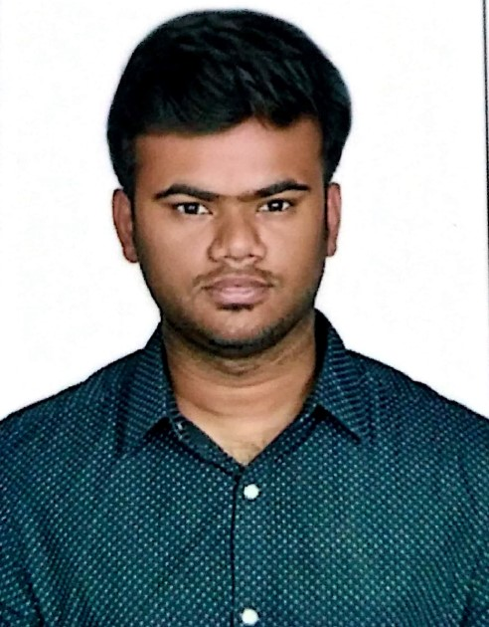

CAREER OBJECTIVE
To be associated with an organization that provides a platform to exhibit my knowledge and skills to achieve mutual growth

ACADEMIC QUALIFICATION

KCT Business School, Coimbatore — MBA

JUNE 2015 - 2017
CGPA: 7.0

RVS College of Arts and Science,

Coimbatore — B.com(Commerce)

2010 - 2013
CGPA: 5.9
University: Bharathiyar University

PROFESSIONAL EXPERIENCE

Jaro Educations - From December ,2016 to February 2018

- Business Development through deals (B2B and B2C)
- Relationship administration
- Lead age
- Sales introductions
- End to End deals

Tata Consultancy Services – 2 years (2013-2015)

- Vast experience in mortgage loans and loss mitigation management.
- Monitored and collected delinquent account data on a daily basis
- Performed borrower financial evaluations.
- Provided assistance to other loss mitigation specialists as needed.
- Ensured appropriate resolutions from problem area identification.
- Evaluated delinquent files in a timely manner to determine borrower options.
- Obtained and assessed loan records title endorsements and loan modifications.
- Planned repayment options in consultation with borrowers and realtors

PROJECT & INTERNSHIP DETAILS

- Internship
Company : KCT Alumni Relations.
Period : 2015

Achievements / Co Curricular Activities

- Successfully conducted Global Alumni Meet 2015
- Best service award from KCT Alumni relations
for handling digital marketing activities
of alumni meet.

Symposiums/ Conferences/ Paper Presentation

- Attended workshop on “Product development and Entering new markets”
- Promotional strategies for identified brands.
- Art of Selling.

Key Skills

- Good teamwork skills.
- Communication skills and networking ability.
- Adaptability.
- Strong attention to detail.

Certificate Courses
- Academic fundamentals of Business analytics.
- International hospitality and health care services marketing.
- International entertainment and sports marketing.

Personal Details

DOB - 16 December, 1992
Languages Known - Tamil ,English
Marital Status - Single
Nationality - Indian

Declaration
I hereby declare all the information furnished above is true and to the best of my knowledge.

Venkatesh

DATE
PLACE VENKATESH RAJA.C

