PREMSANKAR
Administrative Assistant
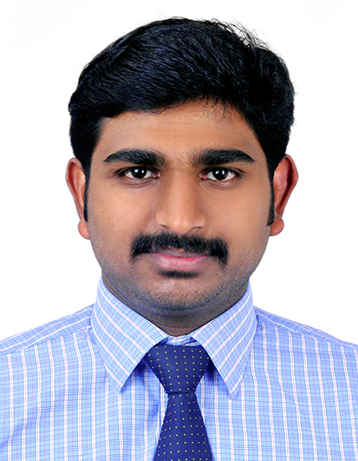
Premsankar.379295@2freemail.com
C/o 0505895826
Dubai

Date of Birth : 10th Nov. 1992
Age : 25
Sex : Male
Religion : Hindu
Nationality : Indian
Marital Status: Single
Visa : Visit (till June 7,2018)

English, Hindi & Malayalam
(Read, Write & Speak)
PROFESSIONAL SUMMARY
- Master of Business Administration with two years of experience in Office Administration
- Proactive, result oriented , devising and implementing business strategies
- Good exposure of working close with diverse cultured personal and hence developed strong interpersonal skills
- Knowledge on basic computer and experience in working with MS Office.
CAREER OBJECTIVE
to To secure a challenging position where I can effectively contribute my skills and multaneously simultaneously contribute to the growth and success of the organisation and at the same time jnnnnnnnnnnnnnnnnn acquiring knowledge on to the road success.
PERSONAL PROFILE

KEY SKILLS
- Good communication and Interpersonal skill
- Able to analysis information and have presentation skills
- Good team player and multi-tasking ability
- Team management skills
- Confident, Friendly, Hardworking
- Quickly adaptable to situations
LANGUAGES KNOWN

COMPUTER SKILLS

- Have good knowledge in MS word, Excel & PowerPoint
- Skills in Office automation and Data Entry

EXPERIENCE
- 2013-2014 Administrative Assistant
Rejith & Maju CA Co., Cochin, Kerala
- Coordinating day to day activities of the firm
- Managing and controlling the auditing team
- Maintain physical & digital documents of the company and clients
- Managing the phone calls and mails & petty cash management
- Preparing reports based on the audit

- 2016-2016 Office Assistant cum Business Development
(Jan-Aug) UAE Exchange , Cochin, Kerala
- Making plans and strategies for improving the business
- Conducting meetings with employees
- Organise company documents into update filing system
- Preparing and submitting weekly business report to the manager
- Preparing and implementing promotional strategies
- Meeting new and existing customers and maintain the relation

- 2016-2017 Guest Relation Executive
(Sep-Feb) Club Mahindra Resort, Kerala
- Providing guidelines to the guest and keeping good relationship
- Assists them and explains about the site scenes
- Educating the guest about company membership
- Sales of company membership
EDUCATION

- 2014-2016 Master of Business Administration
- MG University, Kerala
- Specialised in Marketing & International Business
- 2010-2013 Bachelor of Science
- MG University, Kerala
- Specialised in Physics

CERTIFICATION
- Certification in logistics and supply chain management
- Certification in Office Automation and Microsoft Excel
ACHIEVEMENTS
- Consistency in academics
- Paper presentation in National Seminar of Marketing
- Participated in Management Fest
- Worked as coordinator and team leader of the National fest conducted in the campus

DECLARATION

I consider myself familiar with management aspects. I am also confident of my ability to work sincerely as a team member hereby declares that the information furnished above is true to the best of my knowledge.

Date:
Place: PREMSANKAR

