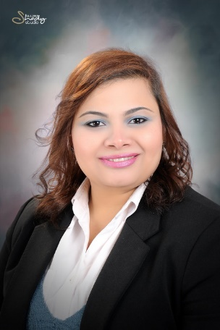
Inas
C/o-Mobile : +971505891826
Inas.379298@2freemail.com

CAREER OBJECTIVE:

Seeking a position that enables me to utilize my computer, communication and language skills, fulfills my personal ambitions.

EDUCATION:

June 2007 Bachelor
Faculty of Agriculture, Agricultural Economy
Department
Alexandria University

October 2015 University Diploma
Faculty of Education
Alexandria University

WORK EXPERIENCE:

- (March 2012 –September 2012)
- Financial consultant at ACE Life Insurance.
- (Feb. 2013- September 2013 )
- Financial planner at Egyptian Takaful Life.
- (November 2013 – April 2016)
- Teacher at Sidi Gaber Language School.
- (April 2016 –present )
- Administration clerk at A2Z Lingerie Company for clothing.

PERSONAL SKILLS:
- Creative , self-motivated , reliable and dynamic
- Good communication skills
- Good at meeting deadlines
- Ability to work individually and as a co-operative team member

TRAINING:
- (September 2011) Training at A2M group co. for tourism.
- (March 2012) Training at ACE Life Insurance.
- (Feb. 2013) Training at Egyptian life Takaful co.

EXTRA COURSES:
- English
- (excellent written,spoken,reading)
- Retail pro. (Oracle)
- Italian (fair )
- Selling Skills
- HR
- ICDL

COMPUTER SKILLS:
- Microsoft office (Excellent)
- Retail pro. (Oracle)
- Economic Views
- Internet (Excellent).

INTERESTS:
- Reading.
- Surfing the net.
- Acting.
- Listening to music.

PERSONAL INFORMATION:
Date of Birth : 2nd of November 1985
Marital status:Married.
Nationality : Egyptian.

